Helping Parish and Town Councils vote for 20mph
20’s Plenty for Us supports local councils that want 20mph where people live, work and play. Demonstrating widespread local community support helps to persuade [your local Highway Authority] to set 20mph as a local speed limit more widely and cost-effectively. Local Authorities in England such as Cornwall, Cambridgeshire, Oxfordshire and Lancashire, have agreed 20mph for every settlement, as has Wales in 2023 and as will Scotland by the end of 2025. In those places, 30mph is the exception and limited to roads that are demonstrably safe for all road users, particularly pedestrians, children and the elderly.
22 million people already live on 20mph streets
A motion in favour of 20mph helps to:
- Achieve a 20mph speed limit in your community where people and motor vehicles mix.
- Demonstrate to your Highway Authority the desire for 20mph county-wide, making it cheaper and easier to implement.
Motion
[Your Parish or Town council name]:
- Supports the 20’s Plenty for [your Highway Authority] campaign;
- Calls on [your Highway Authority] to implement 20mph in [your place]; and
- Will write to [your Highway Authority] to request 20mph speed limits on streets throughout the authority where people live, work, shop, play or learn, with 30mph as the exception on those roads, where full consideration of the needs of vulnerable road users allows a higher limit.

Why 20mph?
- Safer: The UK’s Department for Transport estimates that a 1mph lower average speed in built-up areas reduces casualties by 6%. 20mph in Wales led to 26% fewer casualties.
- Cleaner and quieter: 20mph reduces tail-pipe emissions in urban environments by 25% compared with 30mph and is 50% quieter.
- Healthier: Slower speeds help to build inclusive communities where people and their activities are prioritised.
- Popular: National and local surveys show 70% support for 20mph in residential streets. Support grows once it's introduced.
- Accepted: Already standard in many places in England, throughout Wales and (by end of 2025) in Scotland, 20mph is global best practice where people mix with motor traffic.
- Compliance: 20mph is as enforceable as any speed limit. Even without extra police enforcement, speeds can reduce by up to 6mph on faster roads.
- Cost effective: 20mph brings economic, social, and environmental benefits at a low cost. Signs are enough to remind drivers without physical changes or extra enforcement.
- Little impact on journey times for cars or buses: In built-up areas, 20mph limits don’t usually affect travel time or bus schedules; congestion and junctions have a bigger impact.
- Reduced insurance cost for drivers. Drivers in Wales with a national default of 20mph are saving around £45 per annum on their insurance premia.
Wide area 20mph benefits whole communities. Allowing exceptions where faster speeds are safe for all road users avoids the need to prove lack of safety in order to adopt 20mph.
While introducing 20mph outside a school may seem logical, it does not materially reduce risk. Families need a safe route for the whole journey to school, not just the last 100 metres. Also, 80% of child casualties do not occur when travelling to or from school.
Signed schemes with public engagement are successful and cost-effective!
More on wide area 20mph benefits
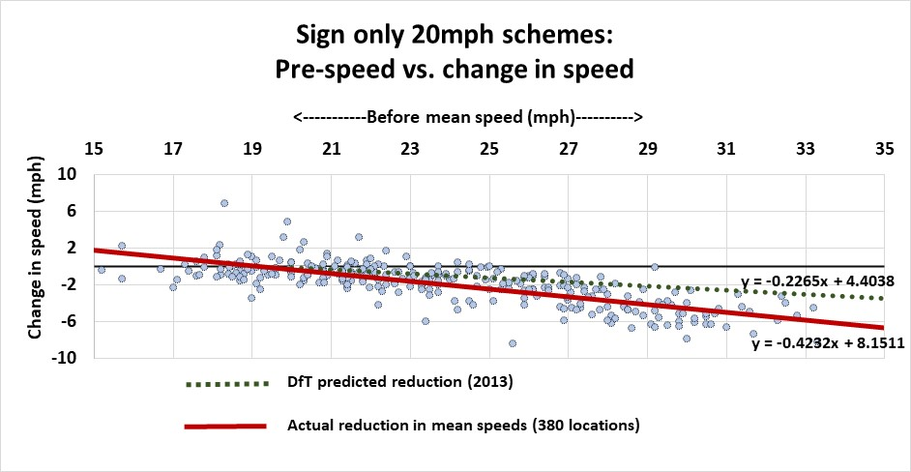
Signed only limits reduce road speeds even without 100% compliance. Small changes in average speeds bring large casualty savings (6% for each 1mph reduction in speed). Reductions of 3–6mph in mean speeds are achievable without physical traffic calming or enforcement. The chart shows the relationships between pre-scheme speeds and the impact of lowering the speed limit in nearly 400 locations, showing the biggest reductions on faster roads. As 20mph limits become more established and in-car speed limiters become more widespread, compliance levels will increase and average speeds will reduce further.
20mph means more time for pedestrians to see and be seen…
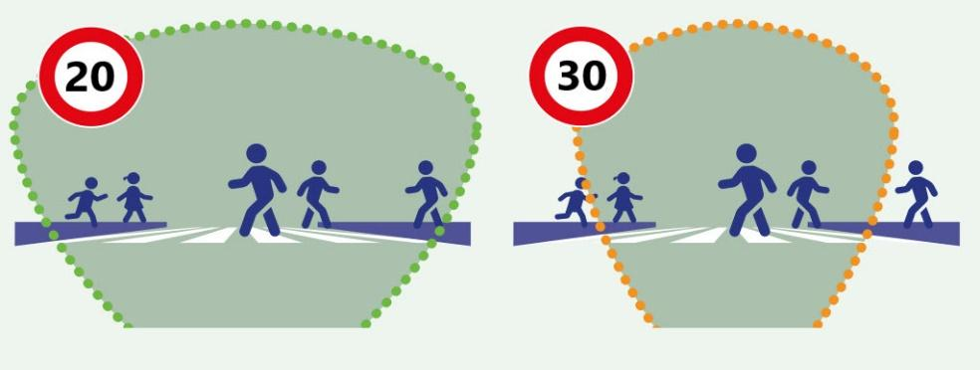
Children under 14 are unable to judge traffic speeds greater than 20mph reliably, putting them at greater risk when crossing the road.
A driver’s range of vision is greater at 20mph giving more time to spot potential danger and react in time to avoid a collision.
… and gives drivers more time to stop…
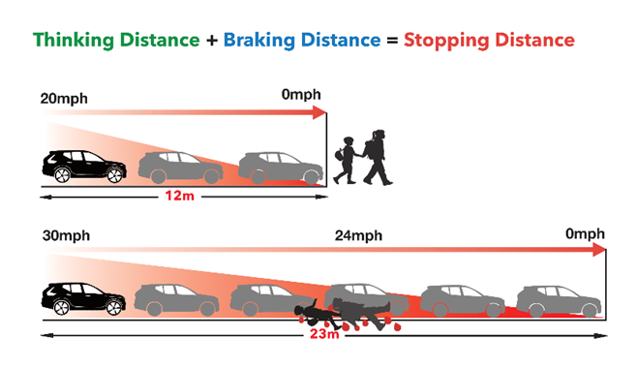
Travelling more slowly reduces stopping time. At the point at which a car travelling at 20mph has stopped, the 30mph car is still doing 24mph.
… but even if you can’t stop in time, the consequences are much less for everyone. Injuries are less severe for the pedestrian and there is less trauma for the driver. Everyone wins.
Cost effective for drivers … saving energy used and, therefore, cash. Research from Future Transport shows fuel efficiency peaks with speed capped at 20mph. This “real life” model factors in stop/start urban traffic.
Less acceleration means less fuel is used (whether carbon or electricity): getting to 30mph requires over twice as much energy as getting to 20mph. Drivers can save up to 10p per mile without trips taking longer. That's a 30% saving in urban fuel costs.
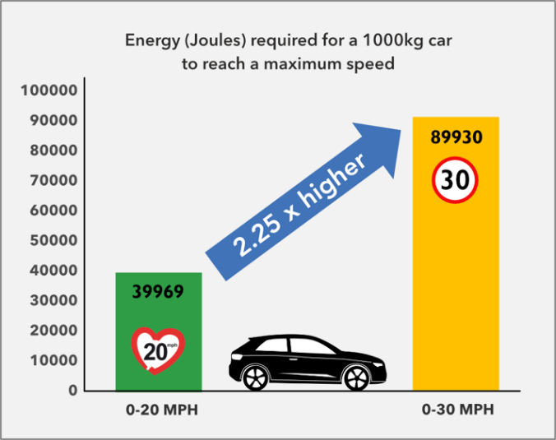
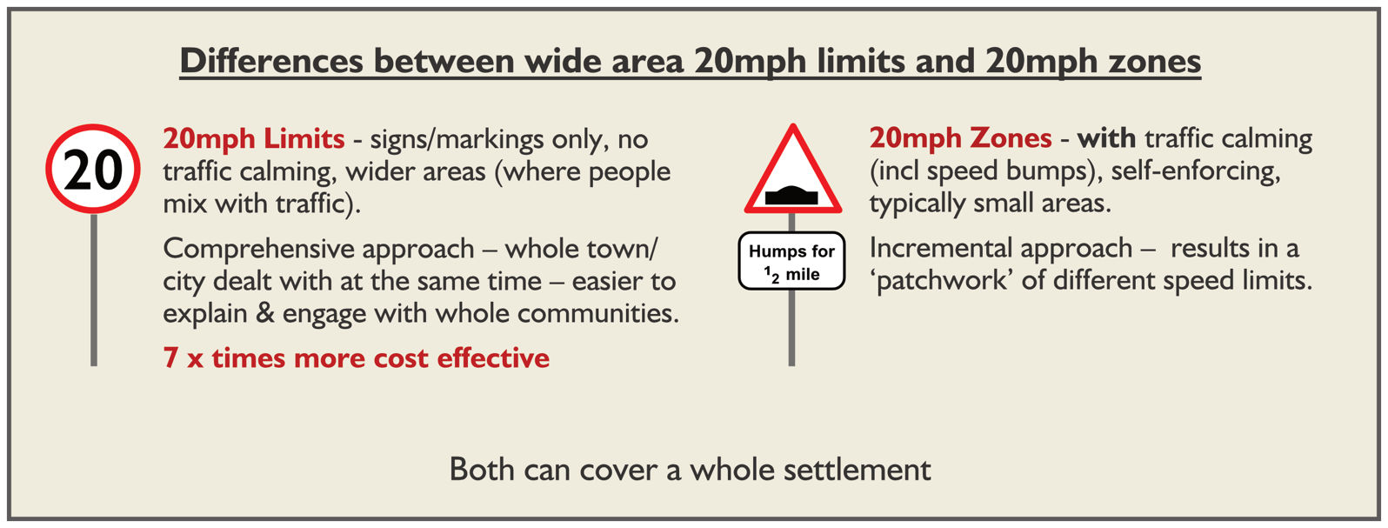
Local authorities benefit from implementing wide area 20mph with little costly engineering. While the historic 20mph zones which were implemented with lots of physical changes achieved significant reductions in speeds, it came at significant cost. More recent schemes, based on signs and education at lower cost (less than £10 per person) achieved reductions of up to 6mph on faster roads. This approach is 7x more cost effective than speed bumps.

Greater activity

20mph helps to enable walking, wheeling and cycling leading to reduced obesity, heart disease and loneliness and lower burden on the NHS. Retaining mobility enables the elderly to live independently for longer, which reduces social care costs. Children benefit through independent mobility and their parents and carers are released from taxi-duty. 20mph enables lifestyle changes, renewed community life and a positive atmosphere. Our towns and villages become more attractive, liveable and sustainable places.
Better physical and mental health
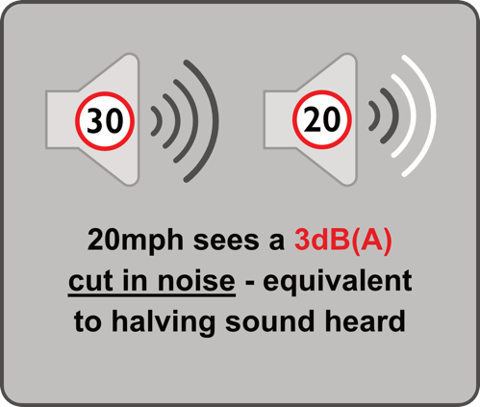
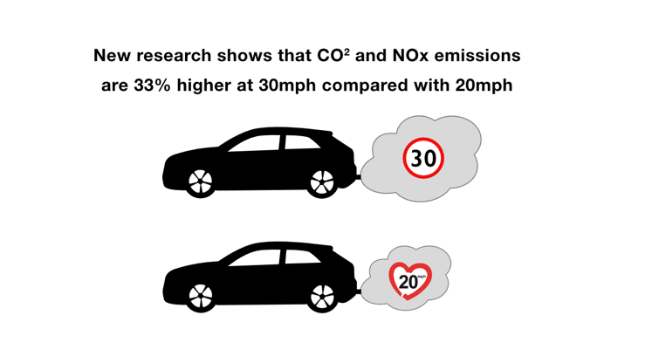
Inactivity and pollution are major causes of early death in the UK. 20mph is associated with greater activity and lower air and noise pollution: tailpipe emissions are a 1/3 higher at 30mph than 20mph and that 30mph is twice as noisy, leading to reduced health risks, improved sleep patterns and lower levels of anxiety. 20mph also helps sociability and reduces loneliness.
Better for business
There is evidence of retail sales increasing by up to 30% when people walk or cycle rather than use their car to visit their local high street. People also visit more often when they walk or cycle, on average, spending 40% more than those who drive (source: TfL 2013). The association of 20mph with increased walking and cycling shows the benefit to local businesses.
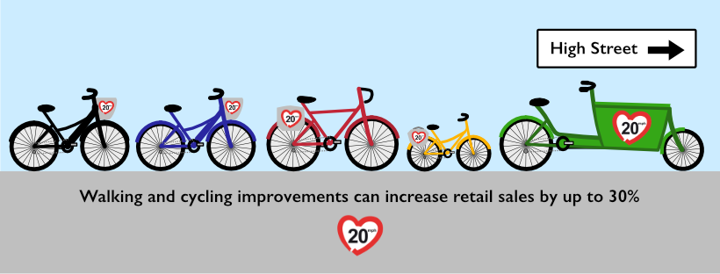
Lowering road casualty costs
Road casualties are predictable and preventable and cost the UK over 2% of GDP. With speed as a factor in nearly half of fatalities, and likely a cause in many more, 20mph reduces casualty costs, as well as pain and suffering.
Wide area 20mph limit schemes cost no more than £10 per head and typically pay back within months. Larger areas tend to be cheaper per person, since they need fewer signs. Smaller places can band together to share costs, such as the Traffic Regulation Orders.
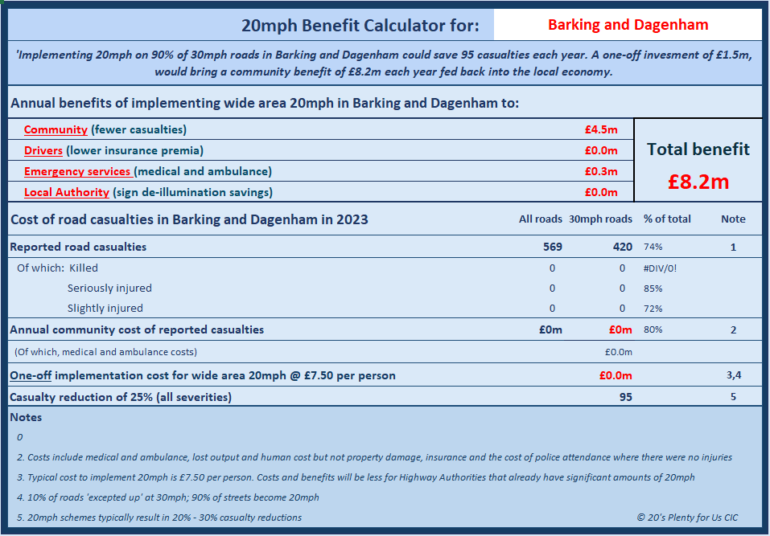
A calculator on the 20’s Plenty website shows the cost/benefit for your Highway Authority.
Speed enforcement and compliance
20mph is as enforceable as any speed limit and many police forces, such as Avon & Somerset and the Metropolitan Police prioritise enforcement. Even without regular enforcement, 20mph limits still reduce speeds, collisions and casualties.
Driver education and in-car technology will further increase compliance over time: many drivers welcome that Intelligent Speed Assistance ensures that they do not break the law inadvertently. Automatic recording of collision speeds will potentially determine liability for collisions.
CASE STUDY 1: A national 20mph default speed limit in Wales
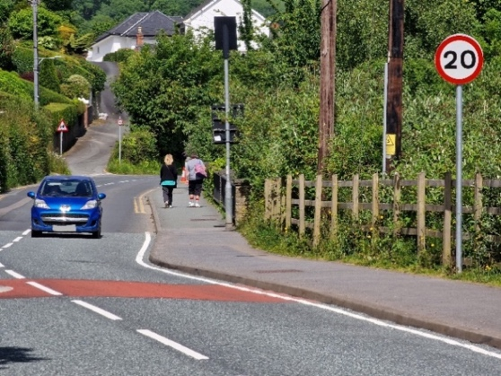
The new national default of 20mph in Wales is a unique case study, in that a single change occurred on a single day across an entire nation.
In September 2023, the Welsh Government reduced the default speed limit on restricted roads to 20mph. Guidance allows Local Authorities to except up to 30mph where it is demonstrably safe, particularly for vulnerable road users.
In reducing speeds by around 3mph overall – more on faster roads – the new national speed limit of 20mph resulted in 630 (26%) fewer casualties on 20/30mph roads in the first 12 months.
As well as the human benefit of 80 fewer deaths and serious injuries, 20mph has saved the public purse over £40m in a single year: more than the entire cost of implementing the scheme originally.
The change in casualties is unprecedented. At almost 3x the previous biggest annual fall in casualties seen in the UK, the change to 20mph is clearly the cause: during a similar period, casualties on other roads in Wales changed little.
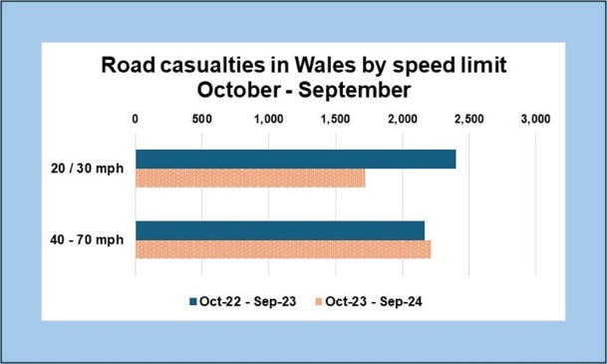
But the impact is not just human and societal. Drivers are benefitting to the tune of £45 per annum through lower insurance premia. Based on 1.5m private cars registered in Wales, this amounts to a saving to drivers of £70m per year. As well as the human benefit, the annual financial benefit to the people of Wales is over £110m: £44m from fewer casualties and £70m from lower insurance premia.

CASE STUDY 2: Speeds in Scottish Borders, Oxfordshire, Wales, Kent and Hampshire
In a scheme involving over 100 communities in the Scottish Borders, speeds reduced by an average of 3mph, without additional enforcement. Greater reductions - up to 6mph - were seen in places where higher mean speeds were recorded before 20mph was implemented. This pattern was repeated in Wales, Oxfordshire, Kent, Hampshire, Edinburgh and on TfL red routes.

Another significant finding was a fall in the number of places recording higher speeds. Out of nearly 400 sites, 68 had mean speeds above 28mph before 20mph was implemented. This reduced by 90% to just six after implementation.
The chart below shows 1) more low-speed roads and 2) a higher concentration of speeds around the 24mph enforcement threshold.
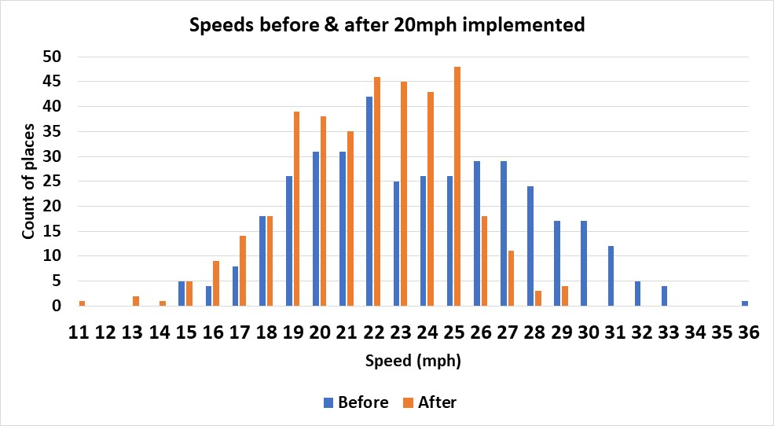
CASE STUDY 3: What happened in Edinburgh vs Belfast
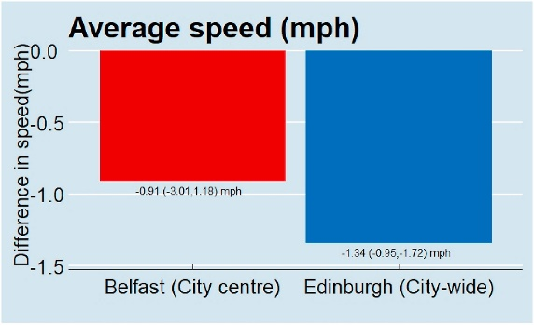
Two contrasting schemes show massive benefits of reduced casualties and speeds that come from implementing a wide area 20mph in Edinburgh versus a small-scale, limited scheme
in Belfast.
- The Belfast implementation on just 76 city-centre streets had speeds that were already below 20mph and included 27 partly pedestrianised streets. In addition, there was little community engagement or marketing of the scheme. Predictably, speeds and casualties changed little.
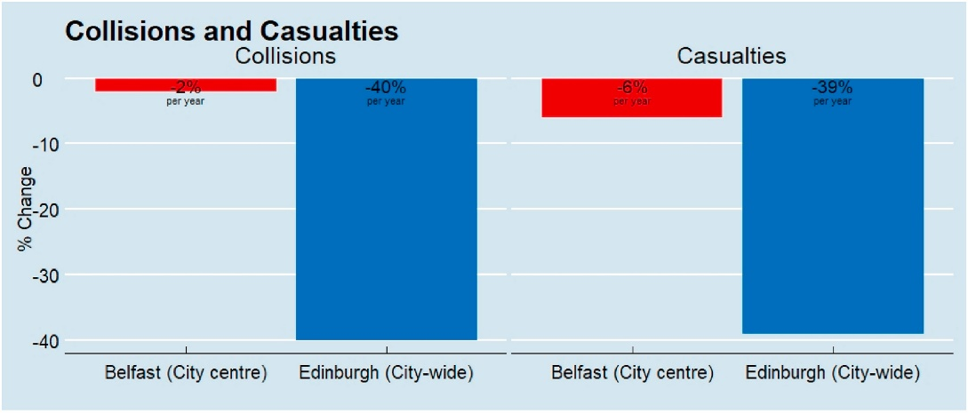
- In Edinburgh, by contrast, the widely publicised scheme covering the whole of the city resulted in lower speeds and casualties reduced by 39%, with fatalities down by a quarter.
The difference in outcomes is stark: a small and isolated 20mph scheme without publicity saw little change on congested city-centre streets where speeds were already low. A city-wide scheme with engagement and education and including the city-centre, suburbs, residential areas, shopping streets gained significant speed and casualty reductions.
CASE STUDY 4: Bristol as a 20mph city
Much of Bristol is now 20 mph. Studies found that speeds on 94% of surveyed roads had fallen, with an overall 2.7mph reduction in average speeds offering estimated casualty reductions per year of 4.53 fatalities, 11.3 serious injuries and 159.3 slight injuries.
These total an estimated cost saving of over £15 million per year - annual savings over 5 times greater than the one-off roll-out cost of £2.77m mostly funded by Government. Over a ten-year period, 20mph in Bristol will have saved 45 lives, 113 serious injuries, 1,593 minor injuries, and accrued savings of over £147m net - a fantastic return on a public health investment! 20mph also saves drivers on average £50 per vehicle per year on fuel.
CASE STUDY 5: A town-wide scheme in Faversham
In this historic market town of 20,000 people in Kent, 20’s Plenty for Faversham successfully campaigned for a town-wide 20mph limit, which went live in September 2020. As well as being popular, speeds reduced by 4–5 mph on the faster roads.
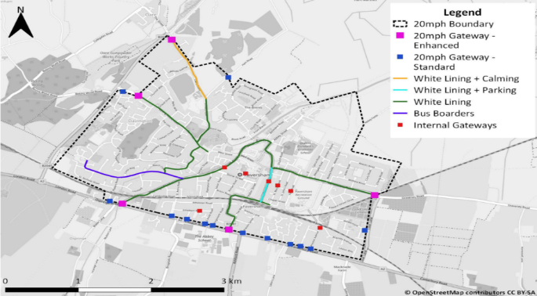
The strength of local support and the technical design led Kent County Council to accept a cost-effective a town-wide 20mph speed limit. The scheme included low-cost techniques to reduce traffic speeds: attractive gateways to the settlement announcing the speed limit change and resident-led ‘Community Corners’, as planters at key locations.
The scheme’s success led to further funding from Active Travel England for walking and cycling in the town and helped compliance with the new speed limit at specific locations.

https://www.20splenty.org/wales_1st_12_months
https://www.20splenty.org/scotgov_says_20splenty
https://www.20splenty.org/20mph_improves_traffic_flows
https://www.20splenty.org/20mph_brings_lower_car_insurance_costs_for_drivers
https://www.gov.uk/government/publications/setting-local-speed-limits/setting-local-speed-limits
https://www.20splenty.org/20mph_fuel_savings
https://www.20splenty.org/20mph_casualty_reduction
https://www.20splenty.org/20mph_vfm
https://www.20splenty.org/noise_and_speed
https://www.20splenty.org/tfl_20mph_data
https://www.20splenty.org/cost_benefit_calculator
https://www.gov.wales/introducing-default-20mph-speed-limits
https://www.gov.wales/setting-30mph-speed-limits-restricted-roads-guidance-highway-authorities
https://agilysis.co.uk/2024/01/22/wales-20mph-3months-on/
https://www.20splenty.org/welsh_accidental_damage_claims
https://www.20splenty.org/tfl_20mph_data
https://www.sciencedirect.com/science/article/pii/S2214140521001717?via%3Dihub
https://www.edinburghnews.scotsman.com/news/transport/edinburgh-20mph-speed-limits-deaths-crashes-and-casualties-reduced-by-20mph-limit-researchers-say-3861288
https://uwe-repository.worktribe.com/output/875541

