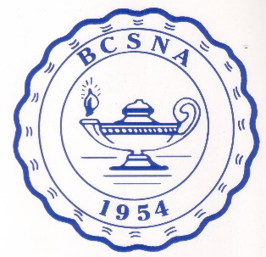BERGEN COUNTY SCHOOL NURSES’ ASSOCIATION

The Bergen County School Nurses’ Association (BCSNA) is committed to
advancing the high standards of School Nurse Practice and to encouraging the
professional advancement of all School Nurses.
BCSNA offers (2) two, $500 scholarships to candidates deemed qualified by the Executive Scholarship Committee.

Awards may be granted in each of these two categories:
- A current, New Jersey State registered professional nurse pursuing a career as a New Jersey certified school nurse through a state-accredited, certification program.
- A current New Jersey Certified School Nurse pursuing a Master’s Degree.
Eligibility Requirements
All applicants must:
- Live or work in Bergen County
- Have attained good academic standing
- Possess intellectual and compassionate attributes consistent with school nurse values
- Submit the following documents:
  - Biographical data information (see attached form)
  - Copy of registered, professional license (if applicable)
  - Character reference from someone you know for at least three years (guidance counselor, university professor, BCSNA member)
  - Essay-200 words (see attached form)
  - Transcripts-include grade point average from last/current school attended
  - Evidence that you have been accepted into an accredited school nurse certification or graduate program
  - A wallet sized photo of themselves
- Participate in a personal interview with the BCSNA Scholarship Committee.
- Shall be invited to attend the May meeting of the BCSNA to accept the award if selected.
Section Criteria
Recommendation for awards will be based on meeting all the above eligibility requirements, submitting the documentation in a timely fashion and at the discretion of the Scholarship Committee. Final decision will be made by the BCSNA Executive Committee.
All applicants will be notified.
It is understood that if the candidate withdraws from the intended program of study, the scholarship money will be returned to the BCSNA.
Submission
- All documents must be submitted electronically or postmarked no later than March 31, 2023
- Handwritten or incomplete applications will not be considered.
- Upon receipt of all documents, you will be notified of the interview date. The interview may be in person or virtual or phone.

Send via email to: dgallo@moonachieschool.org
Or postal delivery: Donna M. Gallo BSN, MEd, RN, NJ-CSN
900 Van Houten Avenue B-3
Clifton, NJ 07013

Biographical Data Date: __________________
Applicant’s Name:
_____________________________________________________________________________Last First
Address: _____________________________________________________________________

Phone: _______________________________________________________________________
Home Work Cell

Previous and Current Schools Attended:
_____________________________________________________________________________
_____________________________________________________________________________
Degrees Held:

GPA:

Special Honors or Awards:

Employment History (or attach a resume):
Please attach a wallet sized photo of yourself.
Essay
In 200 words or less, please answer the applicable question below.
Candidate Topic
Certification How do you plan to impact the lives of the children you care for?
Master’s Degree What do you see as your leadership role?

