Sweaty and Stressed:
Renting in an Australian Summer
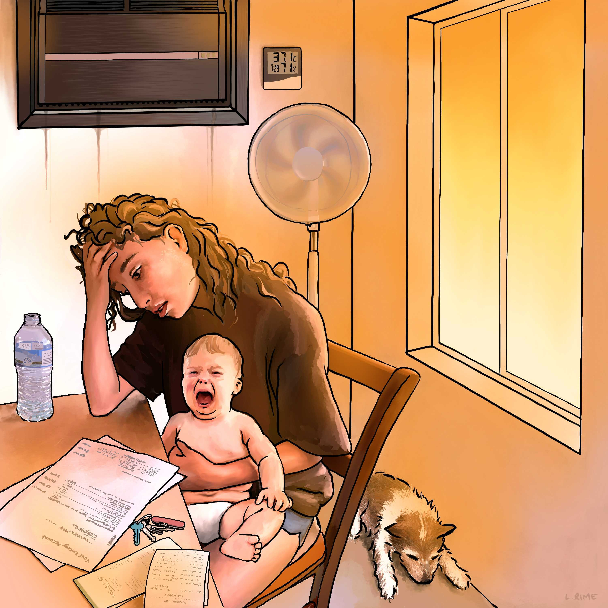

We respectfully acknowledge the traditional owners and custodians of the country on which we live and work. We pay our respects to elders past and present. It is a privilege to be able to learn from the example of the world's oldest ongoing civilisation.

Barrett, B., Catania, L., Dignam, J. "Sweaty and Stressed: Renting in an Australian Summer" Canberra: Better Renting, March 2023
This report is available online at: www.betterrenting.org.au/renter_researchers_summer_23
Better Renting is a community of renters working together for stable, affordable, and healthy homes. Find out more about Better Renting at www.betterrenting.org.au
With thanks to our Renter Researchers: Ada, Adam, Ajay, Alex, Alex, Alicia, Amity, Andrew, Anna, Archie, Bek, Ben, Bernie, Brendan, Briar, Caitlin, Cass, Cat, Charles, Cheryl, Christine, Claire, Damien, Dannielle, Dee, Devorah, Ellen, Em, Emily, Emma, Erika, Forest, Fred, Grace, Hamideh, Ian, Jarod, Jasmin, Jennifer, Jess, Juanita, Kate, Kayla, Kylee, Laura, Lily, Lisa, Luke, Madeline, Marissa, Matt, Meagan, Megan, Mel, Melika, Melissa-J, Mina, Minde, Mollie, Murray, Nicola, Riley, Ronald, Rowena, Sahra, Shantel, Shasha, Shaylee, Solange, Sophie, Susan, Tara, Tracey, Victoria, and William. Special thanks to Ben Kreunen for his assistance with data analysis.
We also appreciate the support of various organisations and donors across Australia: National Shelter, cohealth, Shelter WA, SACOSS, Climate Justice Union, and Shelter NSW.
Cover illustration by Lisa Rime.
This project was funded by Energy Consumers Australia Limited (www.energyconsumersaustralia.com.au) as part of its grants process for consumer advocacy projects and research projects for the benefit of consumers of electricity and natural gas.
The views expressed in this document do not necessarily reflect the views of Energy Consumers Australia.

Executive Summary
Australia’s latest summer was unusually cold, with most parts of the country slightly cooler than the long-term average. Despite this, people who rent still struggled with heat and humidity, due to a combination of the ongoing issue of substandard homes and the worsening issue of expensive energy. Indoor temperatures were above 25°C for 40% of the time, or over 9 hours a day, and above 30ºC for an hour a day on average.

From December 2022 through February 2023, Better Renting worked with 77 Renter Researchers across Australia to track temperature and humidity in rental homes. We also obtained qualitative data from participants through surveys and phone interviews. This paints a vivid picture of what renters are experiencing and how it affects them: not just the thermal conditions in their homes, but what this means for them and their families.

From this it is clear that substandard homes expose people who rent to a miserable experience during the hotter months. Well-designed energy-efficient homes heat up more slowly and are cheaper and easier to cool. In contrast, people who rent, especially the more vulnerable people within this community, tend to end up in the worst dwellings. In dwellings like these, uninsulated ceilings mean that renters cook from above as the roof space heats up. Unshaded and untreated windows function like radiant heaters. And inadequate, non-existent, or expensive cooling appliances mean that renters have few ways to deal with indoor heat. This has negative effects on physical and mental health: renters in hot homes are sweaty and stressed.

Cost of living concerns were another key feature this summer. Following record increases in energy costs and rents, many renters felt anxiety around energy costs, in some cases causing people to self-ration and simply try to put up with unlivable indoor temperatures. Energy debt is a fact of life for a growing number of renters, who simply cannot afford to maintain a healthy home temperature on a limited income as other costs increase.

From each jurisdiction, some key quantitative observations are:
- NSW had a median temperature of 23.9°C, meaning that temperatures were above this level 50% of the time. Researchers spent over 8 hours a day in temperatures above 25°C. NSW had high humidity, increasing apparent temperatures, with a maximum recorded humidity of 96%. The highest temperature recorded in NSW was 46.4°C on 26 December 2022, the second-highest in Australia.
- WA was one of the hottest jurisdictions. From December1 to February 9, renters recorded temperatures above 25°C for about 15 hours a day, with over 2 hours a day above 30°C. Researchers in WA did tend to record lower humidity, making it easier for people to feel cool.
- SA, despite lower temperatures in general, still had one renter reaching a maximum temperature in their home of 37.1°C. Renters spent over 9 hours a day above 25°C, on average. Social housing renters in SA were more likely than private renters to spend time in unhealthy temperature ranges, a relationship that wasn’t apparent in other areas.
- Renters in the NT endured indoor conditions that make everyday life almost unbearable. Renters spent virtually all their time above 25°C, and 5 hours a day above 30°C. Due to high humidity — above 70% more than half the time — these temperatures would have felt even hotter and been harder to deal with.
- Queensland had a similar profile to the NT, but not as extreme. The maximum temperature was 42.1°C, but, again, high humidity would increase the felt temperature experienced by renters (relative humidity was above 60% half the time). Over 3 hours a day on average were above 30°C.
- Victoria was generally a cooler state, with temperatures in a healthy range about 18 hours a day. However, even in these milder conditions temperatures exceeded 25°C about 21% of the time. One researcher recorded temperatures above 25°C a majority of the time, including 70% of the time overnight.
- ACT had a cooler summer, reflected in our data. Renters recorded healthy indoor temperatures most of the time. A notable trend in the ACT is that access to AC greatly increased the proportion of time spent in healthy temperature ranges.
- Tasmania was surprisingly warm, given its reputation, with an average median temperature of 22.8°C. Our researchers spent at least 29% of the time recording temperatures above 25°C. One unfortunate researcher recorded the highest temperature anywhere in the country, an indoor reading of 51.8°C.

The above findings are especially concerning given that future summers are likely to be hotter, with heatwaves becoming more frequent, more severe, and longer-lasting. Jurisdictions can respond to these growing risks by introducing minimum energy efficiency standards for rental homes, while action to end unfair evictions and limit rent increases will assist with enforcing regulations and avoiding energy poverty. With more people renting, energy costs increasing, and summer temperatures shooting up, action on these issues will help to ensure that people renting in Australia can afford to keep healthy and safe in their homes.

Introduction: “It’s hell”
Hell is a common description of renters’ homes during the summer months. Surrounded by an overwhelming heat there is no escape from. Even with air conditioners on or windows open, heat is an all-consuming experience in Australian rental homes.

Hot homes are not only uncomfortable: more and more evidence shows that substandard homes lead to poorer health for the people who live in them. To address this, the World Health Organisation recommends a healthy temperature range inside homes of between 18°C and 22°C.¹ Prolonged exposure to high temperatures above this recommended healthy range can lead to cardiovascular disease, respiratory disease, and cerebrovascular disease.² Exposure to high temperatures is also linked to increased mental health presentations at emergency departments, suicide risk, and instances of family and domestic violence.³

A healthy home is one that keeps people safe from the outside elements, it allows people to control their environment in a way that best suits their needs. This includes temperature and climate control. But this isn’t possible for renters who live in homes that are woefully substandard ⁠— homes that heat up rapidly and stay hot for long periods of time and require more intervention to be habitable. Renters are stuck in unhealthy, hot homes that leave them sweaty, distressed, and unwell.

The cost of living has been an increasing concern for Australian households with energy prices rapidly rising. Renters have a unique experience of this concern as they are denied any agency to make changes that would make their homes healthier and less expensive to heat and cool. When issues do arise, renters are scared to raise these with landlords and real estate agents due to the concern that they may face a retaliatory rent increase or eviction if they complain. So renters are forced to accept these substandard homes and suffer the consequences.

We released our first ‘Renter Researchers’ report, ‘Hot Homes’, in March 2022.⁴ ‘Hot Homes’ highlighted the negative impact of unhealthily high temperatures in rental homes and the lack of protection renters were getting from their rental homes from the rising outdoor temperatures. Our study found that many renters in Australia live in homes that provide them with limited options to stay cool, leaving them exposed to high temperatures for prolonged periods which had negative impacts on their health and quality of life.
Since the release of ‘Hot Homes’, there have been some policy changes in Australia. In Victoria a new minimum rental standard has come into effect that requires a fixed heater in the main living space. However, this will do little for renters in summer unless the fixed heater happens to be a reverse cycle air conditioner that can be used in both winter and summer. Victoria was followed by the ACT which introduced a minimum standard for ceiling insulation in rentals to come into effect from April 2023. However, across the rest of the country, changes to address the issue of unhealthy and uncomfortable rental homes have been lacking.

The two summers that we have studied thus far have both been fairly cool, with average temperatures around or below the historical average from 1961 to 1990.⁵ Despite these milder summer temperatures, renters have been enduring remarkable levels of indoor heat. This is concerning, because future summers are likely to be markedly hotter, with heat waves that are more frequent, more severe, and longer-lasting. As climate change worsens and maximum temperatures increase across the country, it is more important than ever to adapt our homes to ensure that they are climate resilient and healthy for those that live in them. This includes making sure they meet minimum energy efficiency standards. Otherwise, as the world continues to heat up, renters will continue to be pushed further and further into risk of poverty⁶, illness, and death⁷.

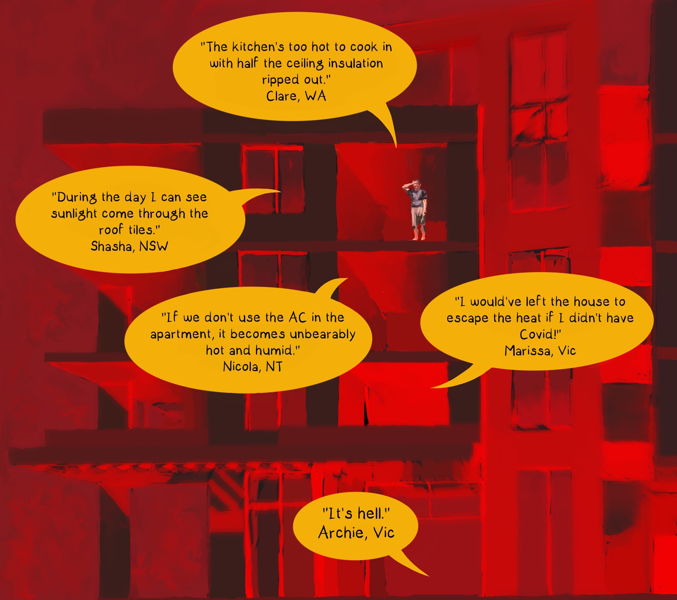

Method
We recruited renters from across the country to become ‘Renter Researchers’ to track minute-by-minute temperature data in their homes. We received 199 applications from renters wanting to take part in this research. We selected from applicants to get a diverse sample of renters across the country, with a particular interest in public housing, renters in NSW, and renters who would be able to commit for the duration of the project. Additional participants in public housing towers in Victoria also took part through the support of a project partner. Our aim here was to get an insight into the experiences of renters who have difficulty maintaining a comfortable temperature in their homes ⁠— this group is not, and is not intended to be, representative of the experience of all renters.

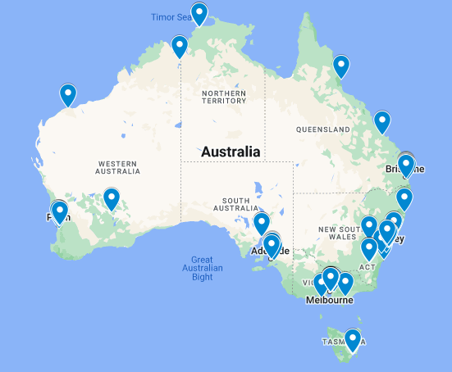
The location of Renter Researchers across Australia

We selected 80 applicants and sent them easy to use temperature trackers. Of those 80 participants, 78 commenced with recording data and 77 remained as active participants throughout the project. Some Researchers discontinued the project due to changes to their housing or life circumstances.

We sent each Researcher a Govee H5075 smart thermo-hygrometer (temperature tracker) and asked them to place it in the part of their home where heat was most relevant for them — this could have been a lounge, kitchen, or bedroom. Researchers were instructed to keep their tracker in place for the duration of temperature monitoring. Trackers were placed out of direct sunlight, around eye level, and out of the direct stream of conditioning appliances. We recorded qualitative data via three surveys, two general surveys about Researchers experiences and one snap survey during heatwaves across the country. We also recorded one-to-one phone interviews, and conversations via WhatsApp.

We analysed the qualitative data by analysing recurring themes. We combined data from surveys, interviews, and an ongoing WhatsApp conversation between Researchers. Reviewing this data, we grouped similar ideas and concepts together, also identifying representative quotations. We took an initial thematic overview to share with Renter Researchers in a codesign session, where attendees could review the themes and provide feedback on whether they accurately represented their experiences and perspectives. We then used this feedback to refine and finalise the key qualitative themes that were included in this report. This collaborative process helped to ensure that the report reflected the experiences and perspectives of the Renter Researcher in a meaningful and accurate way.

Quantitative findings
Our main period of data collection was from 1 December 2022 to 9 February 2023. Between these dates we obtained 77 datasets with an average completeness of 91% (ie, with 91% of 15 minute intervals having an associated recording). Each individual tracker provides the temperature and humidity for each interval of the analysis period, providing 96 recordings per day and over 490,000 recordings in total.

We matched datasets with binary variables including whether the renter researcher was in private rental or social housing, and whether they had access to air conditioning. We also calculated the proportion of time that each Researcher spent in different temperature ranges.

Below we review and discuss the quantitative data, covering:
- For each jurisdiction, the maximum temperature and humidity, and the average median temperature and humidity;
- By jurisdiction, time spent in different temperature ranges;
- Comparison of time in different temperature ranges for households with and without air conditioning; and
- Comparison of time spent in different ranges for households in private rental or social housing.

Overview
Our first table, below, gives a sense of how each jurisdiction stacks up and how they compare. Unsurprisingly, median temperatures are highest in the NT, Queensland, and WA. In these jurisdictions, renters spent more than 50% of the time above 25°C — a critical threshold above which the health risks from heat become most pronounced. Curiously, some cooler jurisdictions still had a very high maximum temperature. NSW, for example, had a maximum temperature of 46.4°C. This goes to show that regional climates are only one part of the story when it comes to indoor temperatures, with the standard of individual dwellings, including their siting, aspect, and local micro-climate, also contributing.

We can also see how humidity compares. Our data shows that NT and Queensland are predictably humid, but NSW also has a surprisingly high average median humidity: researchers were above 60% relative humidity more than half the time. Because higher humidity makes it harder for the body to cool itself, it increases the apparent temperature, worsening the experience of heat. Renters in WA, despite facing great heat, generally experience lower humidity, which meliorates the experience of heat somewhat.

Area | Max Temp (°C) | Max RH (%) | Avg Median Temp (°C) | Avg Median RH (%)
ACT | 32.5 | 88.4 | 22.2 | 54.6
NSW | 46.4 | 97 | 23.9 | 62.6
NT | 42.5 | 93.4 | 28.6 | 71.5
QLD | 42.1 | 91.8 | 27 | 61.3
SA | 37.1 | 89.1 | 24.2 | 46.9
TAS | 51.8 | 85.6 | 22.8 | 52.1
VIC | 38.1 | 90.2 | 22.7 | 54.1
WA | 38.2 | 81.8 | 25.8 | 46.8
Table 1: For each jurisdiction, the maximum temperature and relative humidity, as well as averages of median temperature and median humidity.

Time spent in different temperature ranges
Next we analyse each area by considering the proportion of time spent in different temperature ranges. Drawing on WHO guidelines, we identify temperatures below 25°C as not posing a heat-related health risk. Above 25°C the risk increases, with temperatures above 30°C especially concerning.

Area | Below 25°C | 25-30°C | Above 30°C
ACT | 83% | 17% | 0%
NSW | 63% | 36% | 1%
NT | 0% | 78% | 22%
QLD | 19% | 68% | 13%
SA | 60% | 37% | 4%
TAS | 71% | 23% | 6%
VIC | 77% | 21% | 2%
WA | 37% | 54% | 9%
National | 55% | 40% | 5%
Table 2: For each jurisdiction, the proportion of time spent in different temperature ranges.

Table 2 shows that renters across Australia generally spent most of their summer in temperatures below 25°C. However, some areas are clearly more vulnerable to heat. The NT, Queensland, and WA all had Researchers spending material amounts of time above 25°C and even above 30°C. Even SA and NSW have Researchers spending over 8 hours a day at above 25°C.

The national figure is especially concerning: on average, Renter Researchers spend almost half their time above 25°C, and about an hour a day above 30°C. This gives a sense of the experience of a renter chosen at random from all the renters in Australia.

Does air conditioning help?
Next we use our data to consider whether AC helps people to stay out of dangerous heat ranges. In some jurisdictions only a handful of people didn’t have AC, so we focused on those jurisdictions with a decent number either with or without access to air conditioning. Our data, below in Table 3, suggest that access to AC is correlated with a worse experience of heat: renters with AC generally spend more time with a temperature above 25°C. Although superficially surprising, this does make sense: where a climate is hotter and less bearable in summer, housing is more likely to have air conditioning.

Area | AC? | Below 25°C | 25-30°C | Above 30°C
ACT | No | 72% | 27% | 1%
ACT | Yes | 91% | 9% | 0%
NSW | No | 66% | 33% | 1%
NSW | Yes | 53% | 45% | 2%
QLD | No | 14% | 78% | 8%
QLD | Yes | 23% | 60% | 17%
VIC | No | 77% | 21% | 2%
VIC | Yes | 77% | 20% | 3%
Table 3: Time spent in different temperature ranges for households with or without AC, certain jurisdictions.

A noteworthy exception to this pattern is the ACT. The ACT has less climate variability and so the relationship of hot weather increasing the incidence of AC is less likely to result in a correlation between AC and higher temperatures. In the ACT, having access to aircon does result in a more liveable indoor environment. This suggests that, within any particular climate zone, increasing access to cooling appliances will reduce time spent in adverse apparent temperatures. However, AC is not a silver bullet, and cheaper and less energy-intensive cooling measures, such as ceiling fans, may be preferable.

The experience of social housing tenants
Many Renter Researchers in our study were in social housing and we were interested if this was a predictive variable for their experience of summer. Below are the results for NSW, SA, and Victoria, comparing the experiences of heat for private renters and renters in social housing. In other areas we did not have sufficient Researchers in social housing to make us feel confident making any comparison.

Area | Social housing? | Time below 25°C | Time above 25°C
NSW | No | 62% | 38%
NSW | Yes | 67% | 33%
SA | No | 62% | 38%
SA | Yes | 51% | 49%
Vic | No | 76% | 24%
Vic | Yes | 82% | 18%
Table 4: Time spent in different temperature ranges for households in social housing or private renting, in NSW, SA, and Victoria.

Our findings do not indicate a clear linear relationship between social housing tenure and the quality of the indoor environment. In Victoria and NSW social housing tenants seem to spend slightly more time in cooler temperatures — about an extra hour per day. In SA, social housing tenants record worse temperatures. However, similar to the discussion of AC above, it’s possible that social housing tenants are more likely to live in areas with milder climates within their state. Even if they had a worse experience than private renters in the same area, they might still do better than private renters in the state overall. To better understand this question we would have to compare within identical climate zones, or possibly incorporate outdoor temperature into the analysis to allow comparison across climate zones.

Qualitative findings
Through our surveys, interviews and conversations with Renter Researchers this summer, we have heard about the many issues renters are facing. Three key findings emerged:
- The foundational issue for renters is that the homes they live in are substandard, which creates a flow-on effect to our other findings
- Poor quality housing leads to a poor quality of health. Renters are suffering with mental and physical illness that is a direct consequence of the substandard homes they’re living in.
- Renters are facing a unique financial burden as a result of living in substandard homes. From excessive energy bills, and footing the bill to make improvements to make their homes liveable. Living in subpar homes is expensive.
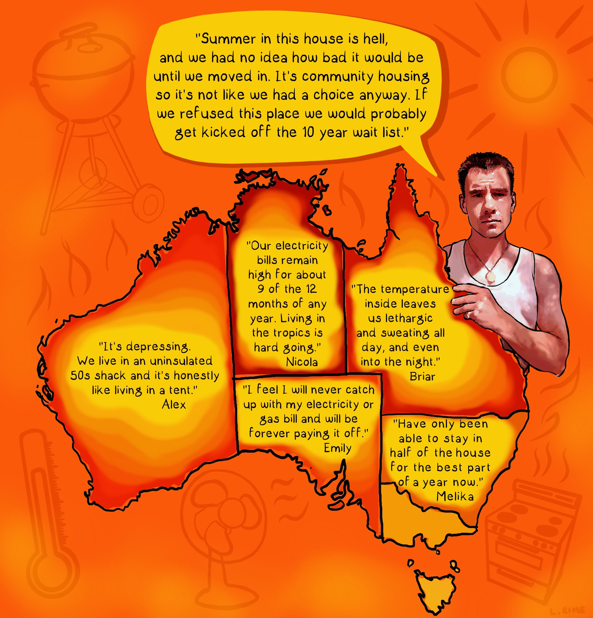

Bad housing — the root cause of the problem
Through Renter Researchers Summer 23 we set out to understand what renters’ experiences were during summer and why we were seeing such high temperatures in renters’ homes. While there were many contributing factors, what it all came down to was that many renters are living in housing that is fundamentally substandard.

Poor quality rental homes have been a growing concern for renters in Australia, particularly during summer. It has a profound impact on renters to be living in homes that are plagued by insufficient cooling, mould, and structural defects. These conditions not only cause discomfort and inconvenience, they also pose serious health and safety risks. During hotter months, the high temperatures in these poorly-maintained homes can be especially unbearable, exacerbating the already-unpleasant living conditions.

One factor raised by Researchers was the lack of insulation, causing their homes to heat up quickly and take a long time - even days - to cool down. In a good home, ceiling insulation means that if your roof space gets hot in summer, it doesn’t heat up the living space below. But in a bad home, the roof space becomes a broiler. Insulation makes a big difference in homes, about 25-35% of summer heat gain comes through the ceiling which is equal to the role of windows.⁸

Renters spoke about the lack of insulation in their ceiling causing this awful experience of feeling ‘cooked from above’ as heat radiated down towards them from their ceiling. This lack of insulation was a recurring issue for many of our Researchers. After a few hours of warm temperatures outside, their homes were nearly matching outdoor temperatures or in some instances exceeding them.

“I wish I could get some blinds on the windows, but the landlords haven't even fixed the broken aircon that's been broken since we moved in.”

Andrew, SA

In a good home, problems are addressed by the owners, the home is maintained to a reasonable standard — cracks are fixed, broken appliances are replaced. But what we saw with Researchers’ homes was a combination of poorly designed and maintained homes, lack of insulation, gaps and leaks throughout their homes — making it difficult to keep their homes at decent, liveable temperatures. Even those Researchers with air conditioners struggled to keep their temperatures down. Many Researchers described their homes as glorified tents.

"It’s depressing. We live in an uninsulated 50s shack and it’s honestly like living in a tent, except a tent would probably get a better cross-breeze."

Alex, WA

Even though renters are aware of the issues in their homes that make them so hot and uncomfortable, there is little they can do about it. Researchers expressed their frustration about this lack of agency ⁠— sharing their negative experiences with asking landlords for repairs or retrofits, or even small adjustments such as adequate window coverings.

“We requested our landlord to purchase curtains for our living area as it faces directly west and it can get so warm in summer that I've needed to wear sunscreen and sunglasses inside my house so I don't get burnt. Our landlord refused to do so….”

Bek, NSW

While various factors make summer challenging for many people in Australia, the fundamental and unique challenge facing renters in our study is that their homes are simply substandard and are in many cases impossible to cool to a healthy temperature.

Hot homes harm human health
Hot homes can seriously harm our health, especially when temperatures soar in the summer and our homes aren’t adequately protecting us from the outdoor heat. Renters who are forced to live in inefficient homes often endure overwhelming heat that can lead to severe health impacts in the short and long term. Researchers described how the heat in their homes left them physically and mentally exhausted, worsened their chronic health issues, and both caused and exacerbated poor mental health.

“Everything about the efficiency of this house plus more has ruined my life and my mental health. I hate living here, crazy how much where you live affects your quality of life and every single aspect of it. I’m constantly sick.”

Melika, NSW

Researchers described living in their homes as a "hellish" experience, especially during heatwaves, facing an inescapable and suffocating heat. As we see the welcome introduction of increased energy efficiency standards for new dwellings, and owner-occupiers in existing dwellings receive incentives to upgrade their own homes, governments continue to leave renters to struggle without useful support against extreme heat. Trapped in homes where they have no power to make the changes that would make their homes more comfortable, renters are let down by governments who fail to introduce the regulations that would offer them legislated protections and minimum energy efficiency standards.

“It’s hell. I feel extremely restricted in terms of what I can do and where I can go in the house. So the main living room, my bedroom and the kitchen are too hot to use. I have a portable AC that I put in my room and it’s the only way I can use the room and actually get some sleep.”

Archie, Vic

Despite the milder summer this year, renters are still facing challenges in hot homes. This is particularly concerning for those living in the worst homes, which are likely to become even more unbearable in the future as summer temperatures rise. It also presents an increasing risk for already vulnerable members of society such as elderly people, children and people with existing health conditions and disabilities.

“I’ll probably be doing hardship programs when I get the next bill. It’s destroying my health even with the damn air conditioner on for 20 days. It’s too expensive to be this disabled with no support. I have to choose between spending money or spending pain and fatigue.”

Claire, WA

With projected maximum summer temperatures continuing to rise in Australia⁹, it's crucial for us to address the issue of hot rental homes and their impact on human health. Research continues to demonstrate the importance of addressing energy efficiency in homes, with a 2011 analysis, for example, finding that the most effective housing interventions to improve health focused on energy efficiency and improving winter warmth.¹⁰ Such energy efficiency interventions not only enhance the quality of life for renters and owner occupiers alike, they also have the potential to save jurisdictions vast sums in public health expenditure. By investing in energy efficient homes, we can create healthier living environments for all and improve the functioning of the public health system. This highlights the significance of initiatives aimed at promoting energy efficient housing and the positive impact it can have on both individual wellbeing and the wider community.

Cost of living and financial stress — the inevitable consequence
Renters are dealing with a double whammy — not only are they paying more and more for rent, but they are also paying through the nose to live in homes that are lacking basic energy efficiency features. This pushes renters into a harsh reality, forcing them to make cruel choices, such as deciding between running an air conditioner to stay healthy and cool or buying groceries and paying their ever-increasing rent on time.

For many renters, the choice is not even a choice. The negative impacts of sitting in the heat for hours is too much to bear, and they turn on their air conditioners, even though they know they cannot afford the energy bills that will follow. Renters are caught in a bind, as they need to use the air conditioning to try to stay comfortable in an underinsulated home, but the cost of doing so is eating into their limited budget. To add insult to this, even with air conditioners running up huge bills, homes are still not cooling down enough to be healthy, or in some instances even comfortable.

“I’ve just been having to deal with the extra expense from electricity bills of running the AC nearly all the time during these rotating heatwaves and humid storms as I can't really afford to sacrifice my health either, but this isn't financially sustainable.”

Murray, NSW

Renters living in substandard homes are often unable to even use their entire home. Researchers told us of being forced to restrict themselves to only the parts of their home that have air conditioning, as the rest of the house is too hot and unbearable. Even though renters are going broke paying high rents, they’re missing out on the comfort and enjoyment of their own homes. Researchers also told us about escaping their homes to go to public spaces or the homes of friends and family just to be comfortable or to get a good night's sleep. The combination of high energy bills, uncomfortable conditions and the need to escape their own homes is having a significant impact on the quality of life of renters and their families.

“We have two liveable rooms with aircon and scurry between them like weird mole-people. SO much fun to pay for a whole house when you can only use less than half of it.”

Alex, WA

On top of all this additional financial stress, renters are sometimes left to pay out of their own pockets to try and fix the uncomfortable conditions in their homes. This includes buying expensive portable air conditioners, using bubble wrap on windows to block out the heat, or purchasing expensive window coverings that landlords refuse to supply. These costs add up quickly, putting a strain on renters' already tight budgets.

“In order to survive the heat and humidity, I needed to find a way to buy or get second hand my own portable air conditioner and then run it, and that is a huge expense that doubles the electricity bill. I particularly need to run it to make it possible to function with my disabilities. It means less money for food and rent.”

Rowena, Qld

These temporary fixes are some of the hidden costs for renters. They place undue burden on renters at a time when skyrocketing rents are being paid for homes that are impossible to cool and are leaving renters in extreme energy poverty. Renters are left to make the decision between food and bills, between paying for health related expenses or rent. It is a truly unfair and unjust existence we are forcing renters to experience.

Recommendations
In this section we present our recommendations for improving the state of rental homes in Australia. We find that introducing minimum energy efficiency standards for rental homes, abolishing no-cause terminations, and establishing rent caps are crucial steps to ensure that renters have access to safe and healthy housing, reduce the cost of living burden for renters, and promote social equity.

Introduce minimum energy efficiency standards for rental homes
The Renter Researchers project has shown us that mandatory minimum energy efficiency standards for rental homes are critical to ensure that renters have access to safe and healthy housing. Without these standards landlords have proven reluctant to invest in upgrades and maintenance that would improve the energy efficiency of their leased properties, despite government attempts to address the problem through incentives. By implementing mandatory minimum standards, state and territory governments can help to ensure that all rental homes meet basic standards of safety, health and comfort.

The introduction of mandatory minimum standards also promotes social equity by ensuring that low-income renters are not disproportionately affected by substandard housing. Without standards, landlords may be more likely to neglect properties in low-income areas, leading to a cycle of poverty and poor living conditions. By implementing these standards, state and territory governments can help to ensure that all renters have access to safe and comfortable housing, regardless of their income or location.

In late 2022 the Healthy Homes for Renters collaboration released the Community Sector Blueprint: a National Framework for Minimum Energy Efficiency Rental Requirements. We recommend the Blueprint as a foundation document for any government looking to introduce a framework for minimum energy efficiency standards for rental homes.

Abolish no-cause terminations
For a framework of minimum energy efficiency standards to be effective, it must be a viable option for renters to self-advocate, for example by requesting that their landlord install ceiling insulation to comply with the standard. This requires abolishing no-cause terminations.

No-cause terminations, currently legal in every Australian jurisdiction, allow a landlord to terminate a tenancy without having to provide a reason. This gives landlords carte blanche to end a tenancy as retaliation against a tenant who may have insisted upon their legal rights. In practice, the existence of no-cause terminations, whether or not exercised by landlords, has a silencing effect on renters, discouraging people from questioning their landlord or speaking up for themselves.

Any minimum standards scheme should rely upon government enforcement. But, this will be more effective if tenants can self-advocate, or report a non-compliant property, without facing the risk of a retaliatory eviction. Ending no-cause terminations is essential to facilitate compliance with energy efficiency standards.

Cap rent increases
Governments should introduce caps on rent increases to help improve rental affordability in the short-term so that skyrocketing housing costs don’t force people to cut back on energy usage that is essential for a healthy home.

Many Renter Researchers in this study, and many people renting across Australia, balance household budgets by reducing energy consumption. While some energy consumption is discretionary, using energy to cool (or heat) a home to a healthy temperature is essential for human wellbeing. Yet we saw how increases in costs and reductions in real incomes have forced people to cut back, even to the detriment of their own health.

Housing costs are the single greatest expense for most households. Of renters in the bottom two income quintiles, two-thirds are in housing stress, spending more than 30 percent of their income on rent.¹¹ With the last 12 months seeing increases to advertised rents of over 10%, renters are increasingly stressed.¹² This is caused when landlords use low vacancy rates to engage in profiteering behaviour, leveraging monopolistic control over a scarce resource to extract economic rents above what would be possible in a fully competitive market.

Governments can address this by introducing caps on rent increases, for example by limiting annual increases to 3%. This limits the sheer scale of increases as well as giving renters greater transparency and predictability around potential changes to their housing costs. In effect this is a transfer from rentier landlords to people in rental homes, which would mean that people have more left over after paying rent to cover other essential costs, such as groceries and energy. This will make it easier for people to keep their homes at a healthy temperature, improving physical and mental health outcomes across society.

A healthy place to call home
The summer can be a living nightmare for renters in Australia, turning their homes into a personal hell. The unrelenting heat is nearly impossible to escape, even with air conditioners on or windows open at night — indoor heat lasts for days at a time even once temperatures outside have dropped.

Through Renter Researchers Summer 23, we found that the root cause of the problem is subpar housing. Many renters are living in homes with poor or no insulation, a lack of cooling devices, and structural defects that landlords refuse to repair — all of which lead to unbearable indoor temperatures in hot weather. A lack of government intervention has allowed poor performing homes to become the norm for Australian renters, at a terrible cost.

The low quality of these homes causes and exacerbates poor mental health for the people in them. Renters expressed helplessness and hopelessness and reported both depression and anxiety as a direct result of the condition of their homes over summer. As well as mental health, renters’ physical health suffers, with renters with chronic health conditions and/or disabilities suffering the most. People end up fighting a constant battle to make their homes healthy and safe — one they sadly often lose.

Renters face non-financial costs from this, but increasingly the financial burden is also becoming too much to bear. Inaction is leaving renters sweaty and stressed: forced to spend money themselves on fixing their homes and adapting to heat, even as they struggle with the impact of rising rent and other cost increases. Renters should not have to bear the financial burden of fixing substandard housing conditions that are beyond their control or paying excessive bills because landlords and governments refuse to act. When landlords fail in their responsibility to provide healthy homes, it's up to governments to step in and enforce regulations to protect renters' wellbeing.

With summer heat projected to become more intense in years to come, minimum energy efficiency standards are necessary to make rental homes safe. Too many Australian rental properties lack the essentials to make them liveable, which can cause serious physical and mental health problems, as well as the growing financial stress from sky-high energy bills ⁠— it’s expensive to live in a crappy home. The government needs to establish minimum standards to ensure landlords, who have chosen to provide an essential service, are providing safe living conditions for their tenants. It’s time for governments to hold property investors responsible and make sure everyone has a safe and healthy place to call home.

Bibliography
1. World Health Organization. WHO housing and health guidelines. 149 https://www.who.int/publications/i/item/9789241550376 (2018).
2. Ebi, K. L. et al. Hot weather and heat extremes: health risks. The Lancet 398, 698–708 (2021).
3. How Climate Change Affects Mental Health In Australia. (2021).
4. Dignam, J. & Barrett, B. Hot homes: Renter Researchers’ experiences of summer 21-22. https://www.betterrenting.org.au/renter_researchers_summer21-22 (2022).
5. Bureau of Meteorology. Australian 12-monthly mean temperature anomalies since 1911. Bureau of Meteorology http://www.bom.gov.au/climate/history/temperature/.
6. Chandrashekeran, S., Ritter, D., McConnell, D., Cludius, J. & Noka, V. Energy poverty in the climate crisis: what Australia and the European Union can learn from each other. The Conversation https://theconversation.com/energy-poverty-in-the-climate-crisis-what-australia-and-the-european-union-can-learn-from-each-other-177316 (2022).
7. Gasparrini, A. et al. Mortality risk attributable to high and low ambient temperature: a multicountry observational study. The Lancet 386, 369–375 (2015).
8. Mosher, M. & McGee, C. Insulation. YourHome http://www.yourhome.gov.au/passive-design/insulation (2020).
9. CSIRO & The Bureau of Meteorology. State of the Climate 2020. http://www.bom.gov.au/state-of-the-climate/index.shtml (2020).
10. Gibson, M. et al. Housing and health inequalities: A synthesis of systematic reviews of interventions aimed at different pathways linking housing and health. Health Place 17, 175–184 (2011).
11. Productivity Commission. Vulnerable Private Renters: Evidence and Options Productivity Commission Research Paper. https://www.pc.gov.au/research/completed/renters (2019).
12. Williams, S. Australia’s rental market clocks up fastest annual price increases on record. Domain https://www.domain.com.au/news/australias-rental-market-clocks-fastest-annual-price-increases-on-record-1189345/ (2023).

