tour of the school
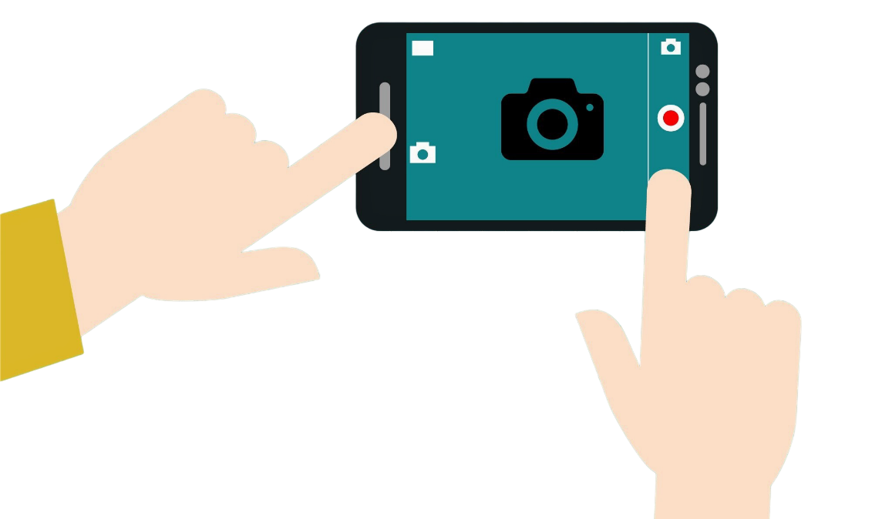

Ask the child’s buddy or an EAL ambassador or Young Interpreter to take the child on a tour of the school. Stop at the key locations listed (editable to match your setting) and take a photo. The buddy can explain information about each location (in English or first language if capable). During induction, stick the photos to the sheet and children can add details in their first language if they want to. They can take it home to show family!
Instructions
Ask a school buddy to take the new arrival around the school to show them key places and areas. Get the new arrival to take photos. After the tour, print out the images and stick them on the next pages, add the name of the area in the image and a first language translation if applicable. The new arrival can keep the photo tour for their reference.
Photo  (Stick the printed photos here) | Location | Add the location name, or more details, in your first language
 | Dining Room
 | Library
 | Hall
 | My Classroom
 | Headteacher’s Office
 | Playground
 | Toilets
 | First Aid

Space to make notes, doodle or write to help remember key spaces and places.

