







My Least Favourite Things
Add text here
ABOUT ME
Name:
My Likes and Interests
Add text here
My Strengths
Add text here
How I Communicate
Add text here
Other
Add text
Date written: Updated by:
Things I Need Help With
Add text here
Keeping Me Safe and Well
Add text here
My Culture
Add text here



ME

Everyday Information/My Daily Routine
Add text here
My Home
Languages spoken at home? who do they live with? Temporary or permanet accomodation?
My Diet
Add text here
My Journey
When arrived in the UK? Prior Schooling? Favourite subject? What age started school? Proficiency in home language?Familiar to english?
Please scan the QR code to find:
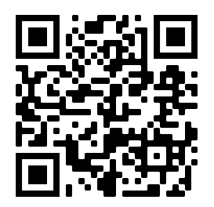
- More ‘About Me’ templates
Young Person/Parent/ Carer Consent: I am happy for this profile to be shared on my behalf with
other services as appropriate
❒
- A guide to help you complete an About Me profile
- A survey to tell us what you think of ‘About Me’

