[School Name]
Welcome Guide

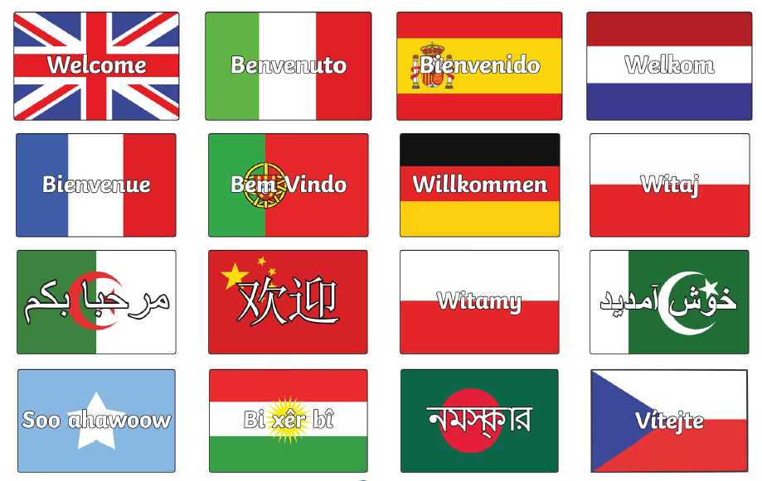

For Parents &
Pupils with English as an
Additional Language (EAL)

Contents

Page
3-4 | Welcomes
5 | Our School Day
6 | Our Holiday Dates
7 | Equipment
8-9 | Uniform
10-12 | The English School System
13-15 | Curriculum & Subjects
16-17 | Pastoral Support System
18-20 | Support in the Community
21 | Homework & Rewards (Epraise)  Behaviour & Discipline
22-23 | Bus Routes / Transport
24 | ParentPay & School Meals
25 | Map of School
26 | Contact Details

[Edit According to your school setting]
Welcome from the Ambassador for Welcome and Belonging
Include a brief welcome message and introduction about what the ambassador does in school. Also include the name (pictures also encouraged) and contact details for the ambassador as they key worker for INA families in school.
Welcome from the Headteacher

Include a brief welcome message and the names (pictures also encouraged) off the headteacher.
Welcome from our Student Support Teams
Include a brief welcome message and introduction about what the team do in school. Also include the names (pictures also encouraged) off the staff in this team.
Welcome from the Office / Admin Staff
Include a brief welcome message and introduction about what the team do in school. Also include the names (pictures also encouraged) off the staff in this team.
The School Day
[Edit According to your school setting]
School starts at
School finishes at
Your child must attend school Monday – Friday.


If your child is ill, please ring the office and let the school know.


[Insert School Phone Number]
Timetable. We have a 1-week/2-week timetable. Each day looks like this:
[Amend daily schedule below]
8.25am Warning Bell
8.30am – 08.45am REGISTRATION in Tutor Groups (or ASSEMBLY)
8.45am – 9.45am Lesson One
9.45am – 10.45am Lesson Two
10.45am – 11.00am BREAK
11.00am – 12.00pm Lesson Three
12.00pm – 12.45pm LUNCHTIME (for Year 7, Year 8 & Year 9)
12.00pm – 1pm Lesson 4 (for Year 9, Year 10 & Year 11)
12.45pm – 13.45pm Lesson 4 (for Year 7 & Year 8)
1.00pm – 1.45pm LUNCHTIME (for Year 10 & Year 11)
13.45pm – 14.45pm Lesson Five
14.45pm END OF SCHOOL DAY / CLUBS, etc
Holiday Dates [Academic year]
[Edit According to your school setting]

AUTUMN TERM [Year]
School re-opens:
Break up: Half-term:
School Training Day:
School re-opens:
School Training Day:
School closes:

SPRING TERM 2026
School re-opens:
Break up: Half-term:
School re-opens:
School closes:

SUMMER TERM 2026
School re-opens:
Bank Holiday:
Break up: Half-term:
School re-opens:
School Closes:

Equipment
[Edit According to your school setting]
Every day your child MUST have a school bag big enough for all their books and equipment. These are examples of suitable bags.

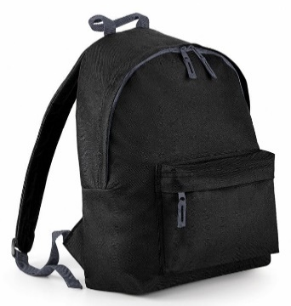


Every lesson your child MUST have:

✔ Black or blue pen (preferably with one or two spares)
✔ Purple pen (for corrections / improvements to your work)
✔ Pencil
✔ Ruler
✔ Rubber

If possible, you should also have:
✔ Pencil sharpener
✔ Highlighter
✔ Colouring pencils
For Maths and Science your child needs special equipment:
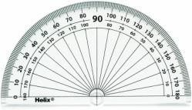


Protractor

Compass

Scientific Calculator. Examples:





Uniform
[Edit According to your school setting]
Pupils wear uniform every day to school. Your child will need:
[Insert uniform for school with images]

PE Kit:
Girls:

Boys:

You can buy our school uniform from:
[Insert names of uniform shops and links to websites where appropriate]

The English Secondary School System *
[Edit According to your school setting]
What age will my child start secondary school?
In England, children start secondary school in the September immediately after their 11th birthday. Secondary school begins in Year 7 (Years 1-6 are in primary school) and ends in Year 11.
The academic year always starts in September and usually ends in July. It is usually divided into three terms of approximately 13 weeks.

What can I expect from school?
We have a website, here: [Insert website link] our most up-to-date information and news about the school (there is also a link on the menu to different languages, so you can translate all of the information):
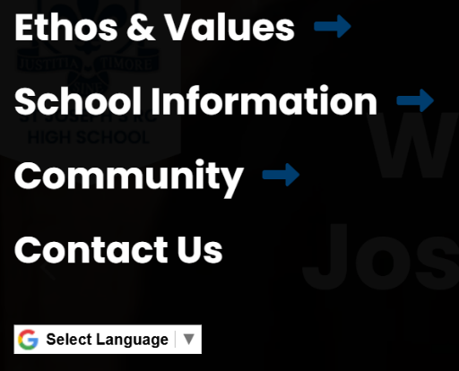
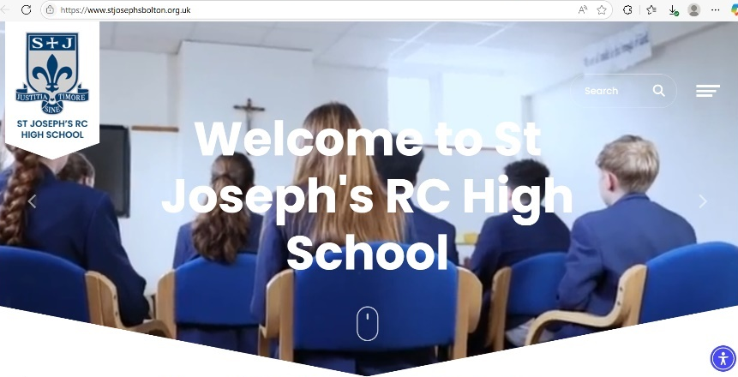

We also have our School Prospectus, which you can download from our website, here:

For your child, there will be:

[Inset information about what parents can expect child to access at school consider academic (school based and homework), language and pastoral support]

- What else will my child do at school?
[Edit According to your school setting]
Your child will be able to take part in activities, school trips and other events.

These might include:
[Add school specific information e.g. Assemblies, extra-curricular, school trips, school productions, social events, careers support.]

How will I know what is happening at school?
[Edit According to your school setting]
Your school will communicate regularly with you. Schools will use different forms of communication including:

[Insert school specific information on communication methods e.g. website, texts, phone calls, letters, emails, school apps, social media, face to face (drop off/pick up, parents eventing, parent meetings) with a brief summary of what information may be shared via these mechanisms.

- Direct communication: you can contact school by phone or email at
Telephone:
Email:
What will school expect from me?
[Edit According to your school setting]
As a parent, you will be expected to:
- Send your child to school every day and on time, unless they are ill, have an appointment or it is a religious holiday. Contact the school to tell them why your child is absent (if possible, in advance).
- Take your children on holiday in the school holidays only. If you decide to take your children on holiday during term time, you may have to pay a fine. Look at this website to find out more: https://www.gov.uk/school-attendance-absence
- Tell us about any important events or circumstances for your child or family. We will try their best to support you if you need help.
- Provide information such as medical details and contact details. It is important that you tell the school if this information changes.
- Complete consent forms to say if your child is allowed to go on school trips, have photographs taken, etc.
- Support school policies, eg: behaviour and appropriate use of the internet. You can find information about school policies on the school’s website [add school links]. You and your child will be told about rewards and sanctions.
• Help your child with their school and homework. *
*More information about the English Secondary/Primary School System and how to help your child learn can be found on The Bell Foundation

Curriculum & Subjects
[Edit According to your school setting]

If your child is in Year 7 or Year 8 (ages 11-13) they will study the following subjects:

In Year 9, Year 10 or Year 11, they will study the Core subjects of:

At the end of Key Stage 3 (Year 8) we will help your child choose which other subjects to continue studying for their final exams.
Talk to your child about their interests and their plans for the future. It is important to choose subjects that interest them and that will be useful for their future.

They will choose 3 “Options” subjects from these to study for Exams:
They may choose from:
We also arrange for students to sit a GCSE in their first language if they wish.
Ask us if this is something you want your child to do.
Languages GCSEs are available in:
Arabic Panjabi
Bengali Persian
Chinese (Mandarin / Cantonese) Polish
German Portuguese
Greek Russian
Gujarati Turkish
Italian Urdu
Japanese

Pastoral Care & Support
[Edit According to your school setting]
Pastoral System

Your child will see their form tutor at the start of every day. They will check your child is happy in school and make sure they are ready for all their lessons each day. If you or your child have any worries or problems, please speak to their form tutor for help.
Your child also has a Head of Year who looks after all pupils in the year group. The Head of Year will see your child once a week in an assembly and they will also be there to help you and your child if you have any worries or problems.
All schools have a Designated Safeguarding Lead who will support your child if there are any serious concerns about their safety in or out of school. Information about these staff can be found on page 4.

We also have lots of other support for your child – in school:
- English language support:
- Learning support: we provide extra support with learning when it is needed. Tell the SENDCo, [insert name], if you think your child needs support with their learning. [She/He] will meet with your child, assess their needs and provide the best support. [She/He] will tell you if your child has any needs and talk to you about how the school can help your child. There is a helpful SEND guide for parents and carers here: https://www.gov.uk/government/publications/send-guide-for-parents-and-carers
- Financial support:
- Careers advice and further education:
[She/He] will help your child to:
- Choose which subjects to study at GCSE. Options are chosen at the end of Year [8/9].
- Find a suitable work experience placement in Year 10.
- Find information about colleges and courses for after Year 11.
Young people are expected to be in education or training until they are 18. You can find more information at: https://www.gov.uk/browse/education/find-course

We also have lots of other support for your child:
We work with lots of external agencies and professionals such as doctors, refugee agencies and educational specialists to support children who need extra help.
We work closely with:
[Add in refugee/asylum seeker service closely linked with school such as ACIS]

Name of the service
They can help with:
Find out more at: [website link]
Contact:
Email:

Support in the Community
[Edit According to your school setting]

Name of the service
They can help with:
Find out more at: [website link]
Contact:
Email:

Homework & Rewards
[Edit According to your school setting]

We use “EPraise” to set your child’s homework. You – parents - can also login to “EPraise” to see your child’s homework and they should check this every day.
We also use “EPraise” to send home messages from school to you and your child, so please check it regularly.
EPraise is also used to reward our pupils. Staff award points for doing things well, eg: completing homework to a high standard, effort and achievement in lessons, and extra things such as sporting activities and helping staff, etc.
You can use these points in the EPraise shop to get stationery or rewards (eg: early lunch passes). We also have rewards assemblies to celebrate academic achievements and progress.

Behaviour and Discipline
[Edit According to your school setting]
[School Name] is a calm community where pupils can learn in a safe, secure and purposeful environment.
Our Mission Statement says

We expect high standards of behaviour from our pupils, and we follow the [School Name] way

Buses
[Edit According to your school setting]

Bus Numbers and Locations
Please check the school and transport websites below to find the correct route for you.
This is the link to our school website information about buses:
[Insert school link] Weekly tickets can be bought on buses.
Dedicated school buses provide transport to [School name] from the surrounding areas where our feeder schools are located. Local service buses, mainly the [Bus Number] , also run regularly between [locations]
The buses and their times are allocated to the school by TfGM. You can visit the TfGM website https://tfgm.com/ to find the best bus route for you.
Contact details for all transport providers:

TfGM Services Planning Department:
0161 244 1640 or 0161 244 1652
TfGM Local Bus and Train Information Helpline:
0871 200 22 33
(calls cost 10p per minute from landlines, lines open 7am – 8pm Monday to Friday, 8am – 8pm Saturday, Sundays and Bank Holidays) or visit: www.tfgm.com

LCC School Bus Services – School Traveline:
01772 849111

Igo Travel Pass
If you are between 11-to-16 you need an Igo pass to pay the discounted fare on buses in Greater Manchester.

Why do I need an Igo Travel Pass?
Your Igo pass proves that you are 16 (or under) and will be valid until 31 August after your 16th birthday.
How much does it cost?
The igo pass costs £5 and you can only get one if you live or go to school in Greater Manchester. Your igo pass also allows you to buy money-saving travel tickets such as the System One Junior Bus Saver season ticket.
Applying for the Igo Pass
You can only get an Igo pass if you live or go to school in Greater Manchester. You should receive your Igo pass by post in 10 working days. If you don’t receive it, please phone 0161 244 1050.
How to use your Igo Pass
Always show your Igo pass to the driver when getting on the bus, and to any other official who asks to see it during your journey. Please look after your Igo pass, as damaged, defaced or out-of-date passes will not be accepted and may even be confiscated. Replacements will be charged for. Never allow anyone else to use your Igo pass as it will be confiscated. Your Igo pass will be taken off you if you are caught misbehaving when using public transport.
Where can Igo?
You can use your Igo pass to travel anywhere on buses in Greater Manchester for the concessionary fare. If part of your bus journey is outside Greater Manchester you will pay the concessionary fare for the part of the journey in Greater Manchester and a higher fare* for the part of your journey that is not in Greater Manchester. *Costs vary depending on the bus company.
If you’re using Metrolink in Greater Manchester, you can also use your igo as a proof-of-age card for child fares. Visit http://igo.tfgm.com/for more information.

ParentPay - School Meals
[Edit According to your school setting]

At [School Name], we use a cashless payment system so there is no need for your child to bring money into school – you can top up their balance of school meals by using one of the payment methods accepted or pay for trips and other activities.
The balance will be updated daily based on the meals your child selects.
This is a biometric system: your child will have their fingerprint taken when they start with us, and they will use this to pay for food and drink at breaks and lunchtimes.
You can find out more about it on our website, here: [School website link]
The machines to pay and top up your money in school look like this:
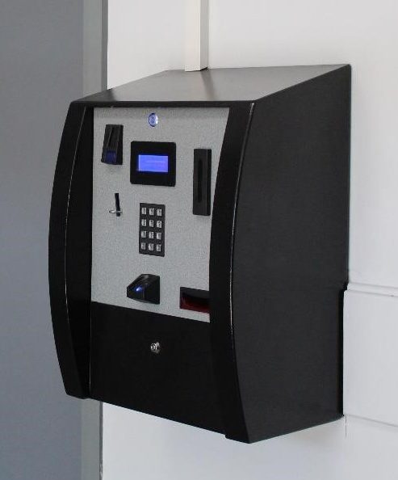

You may be able to get help from [local] Council with Free School Meals and Uniform costs. Use this link to check and apply: [Insert Link]

Map of School
[Edit According to your school setting]
[Inset Map]
I hope this booklet is helpful to you and your child.
If you have any other questions before your child starts with us at [School Name] please contact me [Ambassador for Welcome and Belonging/ Key Adult] at:
Telephone:
Email:
I look forward to seeing you and your child once they start at [School Name]

Thank you.

