Activity  New Arrival Checklist for Buddy  Name of child:…………………………………………………………………………………………………………………………….  Class:…………………………………………………………………………………………………………………………………………. | Date | Completed by
I have given them a tour of the school.
I have shown them where the toilet is.
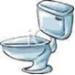
I have shown them the cloakroom and explained where they hang their coals, bags and lunchboxes.
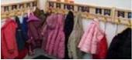
I have showed them the healthy tuck shop.

I have told them the times for playtime and lunchtime.
I have told them the three school rules.
Ready, respectful and safe.
I have showed them around the classroom.
Reading area
Working walls
Pens/pencils
Books
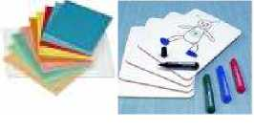
I have explained the classroom rules.
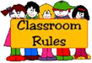
I have introduced them to the class.
I have made sure they have a book for every class.
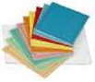
I have helped them pick their school dinner.
I have explained the rewards assembly.
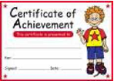
I have told them where to put their reading book in a morning.
I have told them the homework dates.
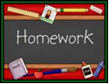
I have showed them where to put their PE Kit.
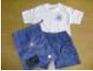
I have told my class teacher to given them a reading book.
