

CBTU
Community Engagement
Toolkit

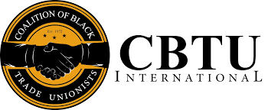

Terrence Melvin, President
May 2025

The Coalition of Black Trade Unionist objectives are reflected in its activities and projects:

- Improve economic development and employment opportunities for black workers.
- Work within the framework of the trade union movement to provide a voice and vehicle for greater black and minority participation.
- Increase union involvement in voter registration, voter education and voter turnout projects.
- Organize unorganized workers.
- Actively support civil rights and civic groups working to improve living and working conditions in the black community.
- Increase effective political alliances between labor, churches and the general community.

Community Outreach Committee Members:
Christine Maclin (Canada); Charles Jenkins (TWU, NYC); Nina Manning (DC 37, NYC); Brandon Cahee (NEA, DC); Brienden Mitchell (AFT, DC); Pierrette “Petee” Talley (AFSCME, Ohio); Natasha Pickens (St. Louis); Noel Crosby (SC); Eric Richardson (Ga); Michael Joseph (MI); Sonya Stalnaker (IUPUT, Fl); Oluwadamini “Damini” Melvin (CWA, Va); Britton (IUPUT, Fl);
Committee Chair: Anthony Harmon, (CBTU Executive Vice President)
CBTU Mission Statement
The Coalition of Black Trade Unionists consists of members from seventy-seven international and national unions with forty-two chapters across the country. CBTU seeks to fulfill the dream of those Black trade unionists, both living and deceased, who throughout this century have courageously and unremittingly struggled to build a national movement that would bring all our strengths and varied talents to bear in the unending effort to achieve economic, political and social justice for every American.

Message from Our President
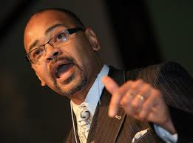
Terrence Melvin
"At the banquet table of nature, there are no reserved seats. You get what you can take, and you keep what you can hold. If you can't take anything, you won't get anything, and if you can't hold anything, you won't keep anything. And you can't take anything without organization."

These powerful words, spoken by the great labor leader A. Philip Randolph, have never rung truer than they do today. We see challenges on every front, and we must fight to hold on to what we’ve achieved—or risk losing it all. Randolph reminds us that without organization, progress is impossible.

Brothers and Sisters, it is time—past time—for us to Strategize, Organize, and Mobilize. That call to action is what led to the creation of this Community Organizing Toolkit. We hope it will serve as a valuable resource in your planning and strategy efforts. More than that, we hope it becomes a living document—something you return to again and again as we work to protect democracy and amplify the voices of our communities.

At CBTU, we take pride in being the bridge that connects labor with communities of color. This toolkit is a step toward sharpening that connection and ensuring we’re always prepared—because as the saying goes, “If we stay ready, we don’t have to get ready.”

We encourage you to make use of the tools provided here as you gear up for your next civic engagement initiative. If you have questions or need support, please reach out to your regional representative. Their contact information can be found in the Resources section of this toolkit.

Finally, I want to extend my heartfelt thanks to the committee responsible for assembling this toolkit. I encourage all of our chapters to adopt it as a guide—and help keep it alive by using it, shaping it, and sharing it.

In Solidarity,
Terry
Terrence Melvin
President

Why a Toolkit?
(Purpose)
The 2024 election taught us many important lessons. One key takeaway was the clear need for us—as both a labor movement and a community of color—to deepen our engagement with the communities we serve. Dr. Martin Luther King Jr. said it best:
“We must be concerned as long as the Negro in Mississippi can’t vote and the Negro in New York feels there is nothing to vote for.” At the Coalition of Black Trade Unionists (CBTU), our mission has always been to serve as a bridge between labor and community—working toward a more fair and just society where we can all live, work, and thrive.

The purpose of this Community Engagement Toolkit is to equip CBTU chapters across the country with practical tools and strategies for effective community outreach. While some chapters are already doing incredible work in this area, others may find this to be helpful refresher as they continue to strengthen community ties. For our new chapter leaders, we hope this toolkit serves as a valuable starting point in building both labor and community capacity. Whether you're organizing your first civic engagement event or expanding an existing initiative, this toolkit is here to support your work every step of the way.



Make sure you use the correct tool to get the job done.

If the only tool you know is the hammer you see everything as a nail

What’s inside?
Table of Contents
Section 1: Community Mapping
Understanding Power
Where is the Power
Who has the Power

Section 2: Setting Goals
S.M.A.R.T.

Section 3: Plan your work
Getting started


Section 4: Budget/Proposal
Narrative
By the numbers

Section 5: The Lift
Community Engagement
Getting people involved
The ASK
Project Management
Managing Conflict

Section 6: Effective Media Tactics
How to engage
Sample Press Release
Messaging
Using the right tool
Public Service Announcements

Section 7: References

Section 8: Telling your story
Section 9: Reporting Out

Section 1: Community Mapping
What is Mapping? Who has the Power? Where is the Power?
Community mapping helps identify sources of power and influence within a community. Every community has assets—ranging from community centers, houses of worship, and government offices to local businesses and grassroots organizations. These spaces are often filled with talented individuals who bring a wide range of skills and resources to the table.
Mapping these assets can be an invaluable step in planning your program of work. It allows you to better understand the community's strengths, build strategic partnerships, and engage more effectively with the people you aim to serve.

Identifying Power?

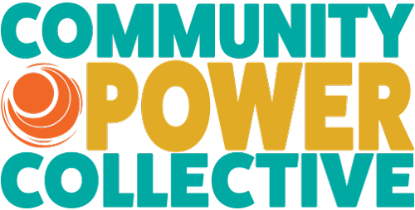

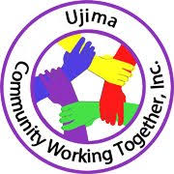

Where Do We Find Power?
Power exists in many forms and places within our communities. Identifying and leveraging these sources is key to successful community organizing. Power can be found in:

1. Individuals
People are the heart of every movement. Look for:
- Volunteers
- Bloggers and social media influencers
- Caring community members
- Advocates and activists
- Organizers
- Skilled and talented individuals with creativity and passion

2. Community Groups
These groups often hold strong networks and influence:
- Social clubs and networks
- Fraternities and sororities
- Faith-based organizations (churches, mosques, temples)
- Sports teams
- Charitable and nonprofit organizations
- Neighborhood block associations
- Cultural and ethnic organizations
- Local residents and community leaders

3. Institutions
Institutions can provide stability, resources, and access:
- Colleges and universities
- Public and private schools
- Religious institutions
- Businesses (local and corporate)
- Homeless and transitional housing shelters
- Parks and recreational centers
- Libraries and cultural centers
- Nursing homes and senior centers
- Local restaurants and small businesses
- Community shopping areas and markets

By recognizing the power within these individuals, groups, and institutions, we can build stronger, more connected, and more impactful organizing efforts.


Section 1: Community Mapping
Something to think about

Section 1: Community Mapping
Who are the people in your neighborhood?
What churches/Faith Based Organizations surround me (clergy have influence)?

What are the schools/colleges in my community (What do they do?)?

What neighborhood businesses are around me (Sometimes businesses are looking to invest)?

Are there any Frat or Soro houses in my community (Are their goals aligned?)?

Are there any civic groups near me (Many hands make light work, think NAACP, APRI, etc>)?

Do we have connections with other unions and CLC/ALFs (Seek to branch out of comfort)?

Section 2: Setting Goals
“Plan Your Work & Work Your Plan”
Goal setting is essential to the success of any movement. When launching a program of work, it’s imperative to establish clear, concise goals that provide direction and purpose.
For the purposes of this toolkit, we encourage the adoption of S.M.A.R.T. Goals. These help all team members understand the plan, the mission, and how success will be measured. SMART goals are a cornerstone of effective planning and implementation.

What Are SMART Goals?
S – Specific
Be as clear and detailed as possible. Ask yourself:
- Who is involved?
- What needs to be accomplished?
- Where will this take place?
- When will it happen?
- Why is this goal important?

M – Measurable
Define how progress and success will be tracked. Ask:
- How will I know when the task is complete?
- What indicators will show progress?

A – Attainable
Make sure the goal is realistic. Ask:
- Is this goal achievable with the resources and time available?
- Can this be done?

R – Relevant
Ensure the goal aligns with your values and priorities. Ask:
- Does this goal reflect the mission of the organization?
- Is it timely and meaningful in the current context?
T – Timely
Set a deadline. Ask:
- When will the goal be accomplished?
- Are there milestones to check progress along the way?

Using SMART goals helps ensure clarity, accountability, and progress. Keep these principles in mind as you develop your action plans—and remember: Plan your work, and work your plan.
Section 2: Goal Setting
Cheat Sheet
S – Specific: Who? What? When? Where? Why?

M – Measurable: How do I know when I am done?

A – Attainable: Is this realistic and reasonable

R – Relevant: Does this goal align with organization values and current situation?

T – Time: What’s the start and END date – Begin with the end in mind

Section 3: Plan your Work & Work your Plan
Getting Started
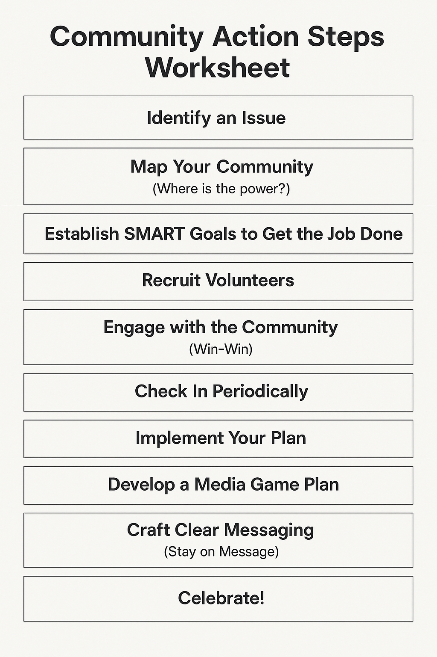

📝 Community Action Steps Worksheet

- Identify an Issue
What community concern or problem do you want to address?

- Map Your Community (Where is the power?) Who are the key players, allies, and stakeholders?

- Establish SMART Goals to Get the Job Done
Define Specific, Measurable, Achievable, Relevant, and Time-bound goals.

- Recruit Volunteers
Who can help you? What roles are needed?

- Engage with the Community (Win-Win)
How will you build trust and ensure mutual benefits?

- Check In Periodically
How will you track progress and stay on course?

- Implement Your Plan
What steps will you take to turn goals into action?

- Develop a Media Game Plan
How will you share your message and reach your audience?

- Craft Clear Messaging (Stay on Message)
What’s your core message? How will you repeat it clearly?

- Celebrate!
How will you recognize wins and show appreciation?

Section 4: Proposals/Budgets
(Scope of the Project)

What are you planning to do? (details)
Will this project be Voter Registration, Civic Engagement, Educational, LGBTQ focus, Worker/Union focused, faith based

This Photo by Unknown Author is licensed under CC BY-SA
Identify measurable targets.

Determine how the project will be measured… through greater participation, awareness, or voter registration numbers
Establish a Clear time line
Projects must have a start and end date
(Ex: Working over the summer we will, by August we will register 500 new voters)

This Photo by Unknown Author is licensed under CC BY-SA-NC
Explain how the money will be spent

Think of all the costs that may be associated with your project, personnel/administrative/tangibles/food/printing/etc.

Section 4: Budget Narrative - Costs to consider
When planning a program or event, budgeting accurately is crucial to success. Below are key cost categories to consider:

Administrative Costs (OTPS – Other Than Personnel Services)
- Are there any fees associated with project development, such as hiring a grant writer?
- Most grants allow up to 15–20% of the total budget to be allocated for administrative costs. Be sure to review specific grant guidelines.

Personnel Costs (P.S. – Personal Services)
- Will you be paying individuals for their work?
- Consider the type of compensation: stipend, hourly wage, commission, or other.
- Personnel costs can represent a significant portion of your overall budget, so plan carefully.

Postage (OTPS)
- Will materials be sent via mail? If so:
  - How often?
  - What’s the current rate for stamps and envelopes?
  - Are your mailing addresses up to date?
- Returned mail due to incorrect addresses can be frustrating and costly—double-check your mailing list.

Printing (OTPS)
- Printing is usually a fixed cost, but it's important to anticipate needs early:
  - Will you need palm cards, event flyers, or other promotional materials?
  - Are you printing T-shirts or branded items? If so, calculate the cost per item and total quantity needed.

Food & Beverage (OTPS)
- Whether it’s a kickoff, mid-point check-in, or wrap-up celebration, budgeting for refreshments is a thoughtful gesture.
- Celebrating achievements and showing appreciation goes a long way in boosting morale and participation.

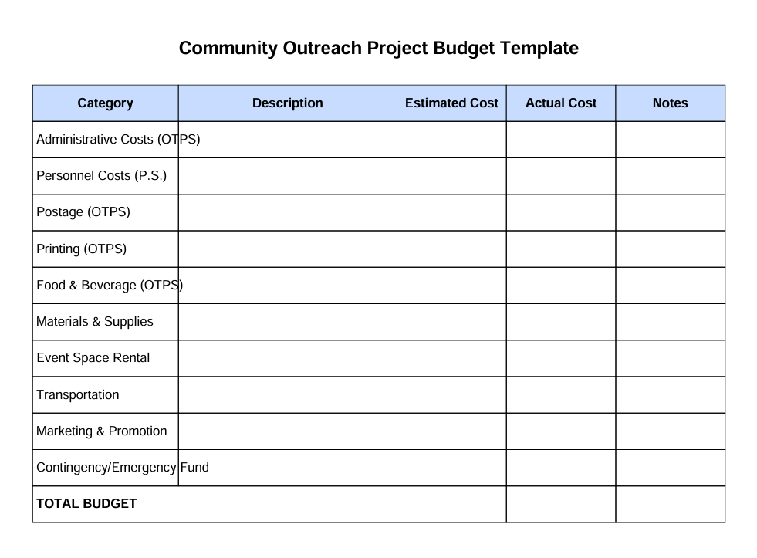
Parent Leadership Academy
SAMPLE PURPOSE ONLY
A
Proposal
designed to educate and empower parents
Parent Power was formed in May 2011 to educate and empower parents and caregivers of children in public schools, enabling them to more effectively advocate for their children and their schools at every level of government. This proposal seeks support for an effort to build parent leadership capacity and parent voice in our city.
Our mission is to ensure that every child receives equal access to a well-rounded quality education.

Parent Academy
In an effort to increase parent involvement and engagement in the educational arena, Parent Power in collaboration with the United Federation of Teachers will sponsor a "Parent Leadership Academy". A five-week leadership-training program designed for parents, helping them to become leaders, advocates and community activists.
Rationale
Parent leadership and parent engagement is crucial in education, but often parents feel that they have no voice in the educational system. Parents are given the "run around" when trying to get information or asking for assistance in navigating "the system". Parents have expressed a desire to know more, understand better, and to become more involved in education, especially considering all the recent school closures, co-locations and school governance issues.
Parents want to know more, but where do they go get the necessary training? The Parent Leadership Academy model will assist parents in that regard. The Parent Academy will seek to educate parents to become leaders, advocates, lobbyists, and activists through a five-week intensive training program beginning May 2012. Parent Power will collaborate with the United Federation of Teachers to help in the Parent Leadership Academy project. 50 parents will be selected throughout the city to participate in the project; each borough parent liaison will be asked to identify ten (10) parents to participate. The liaisons have developed relationships with parents who have demonstrated leadership ability and a desire to become activists. Parents who participate in the project will receive a 50.00 per week stipend to assist with childcare costs (which would be paid at the end of the five-week training), and two-way metro card each week to remove any barriers to participation. Breakfast, lunch, and meeting facilities will be provided as an in-kind expense from the United Federation of Teachers. Each week there will be a different focus of parent engagement with experts in the appropriate field presenting to the parents. The experts will be paid a stipend of 200.00 as a consultant.
There will be two coordinators to service the project whose responsibility will include but not be limited to:
Maintaining weekly attendance logs
Assisting work session instructors with paperwork
Performing administrative tasks
Developing evaluations of the instructors
Confirm instructors each week
Maintain weekly contact with participants to ensure attendance
Distribute weekly metro cards to participants who attend
Process checks requests for participant childcare expenses
Develop end project evaluation
Meet with Director of Parent and Community Outreach weekly

Time Line
The Parent Academy will begin the first week of May 5, 2012, and be hosted by the United Federation of Teachers. All work sessions will be held at the UFT and conclude after five weeks of training June 2, 2012.

The Curriculum
Week One "Parent as Leader"
Work session will focus on leadership skills necessary to become an active participant in educational discussion, meetings, and actions.
Public Speaking, Parliamentary Procedure, Communication Skills, Public Speaking

Week Two "Parent as Advocate"
Work session will focus on becoming active in school governance
School Leadership Training, School Governance Structure, resources available to parents

Week Three " Parent as Lobbyists"
The work session will focus on city and state government understanding City, State and Federal Government structure, school-based budgeting, special education, and title one

Week Four "Parents as Activists"
Work session will encourage parents to get involved in school governance, how to get involved, how to run for office, look at past successful parent projects i.e.: CC9, help to make parents aware of other organizations to partner with CEJ, AQE, NYCC, ARISE

Week Five "Parent as Graduate"
Work session will highlight achievements, explore future possibilities for further training, and serve as graduation day for participants; include a guest speaker, certificate of completion, luncheon

Parent Selection
50 parents will be selected to participate in the project. Each Borough Parent Liaison will be asked to identify 10 parents from each borough who have demonstrated leadership ability and a desire to become more active in public education. Parents will be expected to attend all five sessions and will be compensated with a stipend of 50.00 per week to help with childcare costs to be paid at the conclusion of the five-week session. Each parent will be provided with a two-way metro card each week.


Parent Academy
Budget
Parent stipends 250.00 for the month X 50 parents 12,500.00
Instructor stipends 200.00 X 10 instructors 2,000.00
Materials
Parent Academy Tote bags 100 X 6.00 600.00
Three ring binders 100 X 6.00 600.00
Certificate Plaques 50 X 10.00 500.00
Metro cards 50 X 5.00 = 250.00 weekly X 5 weeks 1,250.00
misc. expenses 500.00
Coordination and management
2 people at a stipend of 3,00.00 6,000.00
=======
$23,950.00

SAMPLE PURPOSE ONLY

TO:
FROM:
DATE: August 14, 2019
SUBJECT: Proposal: Voter Registration/GOTV Project & CENSUS
=================================================================
Narrative
At a time in America when so many eyes are on the political process, voter registration and education is crucial. The time to act is now.

During this election cycle, the New York Branch of the NAACP, will conduct voter registration drives throughout the Harlem Community and extend throughout the city.

Because of our closely shared interests with the labor movement, our intent is to partner with labor to help those in our communities register to vote, become educated on the issues and ultimately participate in the process. The New York Branch NAACP is that bridge that serves to bring labor and community together, strengthening the relationship between communities of color and labor.

We will partner with the Metro New York Chapter of the A. Philip Randolph Institute and assist in registering hundreds of voters, before the next city election cycle ends, we realize that the City Council will have several seats that are term limited and there will be a lot of vacancies on to be filled on the council. It is important to us and labor that we have candidates that understand the struggle for civil, human and labor rights. But to do so we rely on you for assistance, our brothers and sisters in the labor movement, who understand all too well the importance of the vote and how necessary it is to get involved in the political process. By playing an active role now, it will help to strengthen ties between the labor and the community in the future.

We will begin by focusing our attention on registering voters at street festivals, schools, community housing developments, and college campuses. Our first street event will be “A Great Day in Harlem: Family Unity Day, August 18, 2019 at 135th Street, where thousands of community residents attend, followed by street festivals and events during

the summer months. Coupled with the GOTV activities, we also plan to assist in the CENSUS 2020 project, by helping to inform the Harlem Community of the changes with the CENSUS i.e.: technology but also having our office open to serve as a resource for the community for those who still suffer because of the digital divide. Our goal would be to have our office open in the evenings throughout the week so that individuals would have an opportunity to come and use our computers to log on and be counted. We anticipate partnering with local elected as well to help get the word out about the availability and opportunity to get counted.

Please take a moment to review the attached budget narrative. To be successful in this endeavor, it requires contributions from organizations that share our vision. We anticipate our funding needed is $20,000.00, however any part of that would help us tremendously.

In Solidarity,

Treasurer
NAACP

Voter Registration/GOTV Project/CENSUS

BUDGET NARRATIVE

T-shirt printing (to use when working in the community and to advertise that we are registering voters)
200 @ 10.00/shirt = 2,000.00

Office supplies (clip boards, pens, paper, index cards, etc.)

1,500.00 = 1,500.00

Technology (laptops to purchase to assist in CENSUS)

8 laptops (chromebooks)
@ 600.00 4,800.00

Stipends (for workers who work the community, to include meal allowances)

25 workers @ 50.00/day x 7 days

= 8,750.00

Printing costs (Advertising, signage, etc. not to exceed)

2,000.00 = 2,000.00

Food/Beverages = 1,000.00

----------------
Total requested 20,000.00

*In-kind: office space, phones

Section 5: The Lift - Getting People Involved
ASK

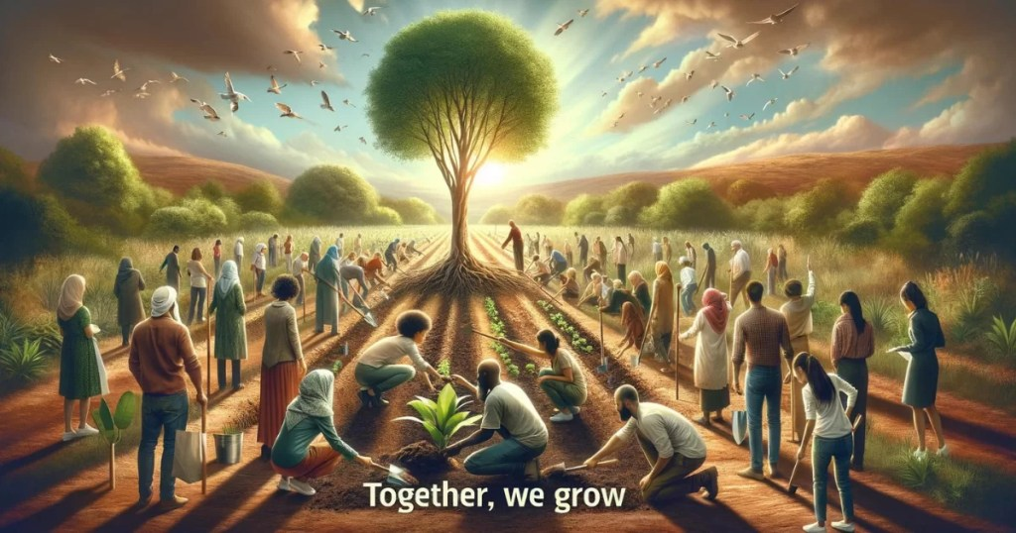
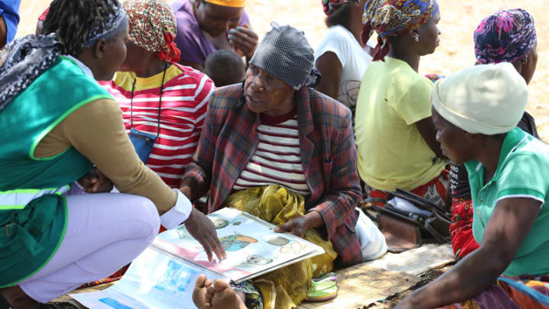
- Create a warm welcoming environment.
- Everybody is Somebody.
- Volunteers are hard to come and more difficult to keep.
- Cultivate opportunities to learn.
- Share from experience.
- Meet them where they are.
- “Be curious more than judgemental”.
Tips for getting people involved
Section 5: The Lift – Getting People Involved
Leadership is Action not Being.
The leader who rests on his laurels soon loses them.
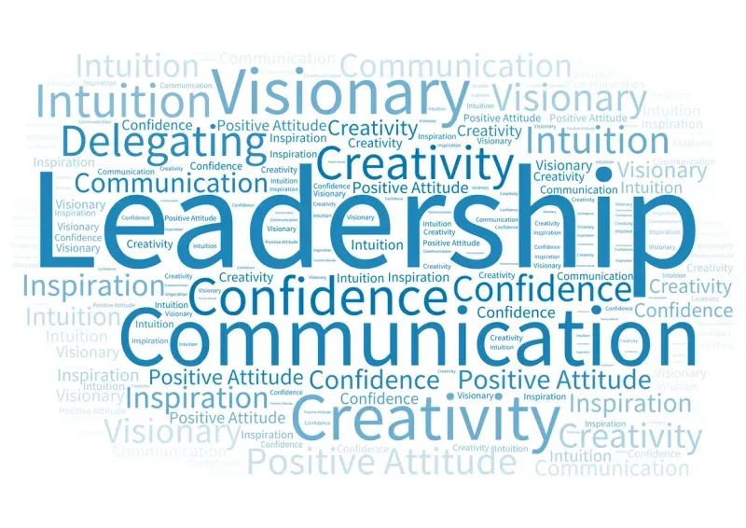

Leadership above all is People
Knowing them
Understanding them
Helping them attain their wants and needs

Section 5: The Lift - Getting People Involved

Six Basic Steps to Effective Community Engagement
Use these steps as a guide when building relationships and mobilizing support in your community:

  - Introduction – Who are you, and why are you here?
Establish trust and credibility right away.
We’re often met with skepticism—whether because of past tactics, a lack of visibility, or community fatigue. That’s okay. Start with honesty and humility. Understand how your group or association is currently perceived, and reflect on your strengths, weaknesses, and opportunities for connection. Remember: just as the community isn’t monolithic, your reputation isn’t either.

2. Ask Questions – Get them talking.
Engage quickly by asking thoughtful, open-ended questions.
- What do you want to know?
- How do they see the issues?
- What matters most to them?
Everyone appreciates being heard—especially when their voices are valued and respected.

3. Listen – Actively and intentionally.
Listen not just with your ears, but with your eyes and body language too.
- Identify the issues they care about.
- Observe how they feel and where their interests lie.
- Take note of verbal and non-verbal cues.
Authentic listening builds relationships.


Six Basic Steps to Effective Community Engagement (continued)

4. Discuss / Make Your Points – Connect with their concerns.
Now is the time to share your purpose.
- Frame your message around what they’ve told you.
- Build common ground and align your mission with their values.
- If disagreements arise, acknowledge them respectfully—focus on the issue, not the person.


5. Commitment – Ask for something concrete.
This is known as the “crunch.”
- Will they sign a petition?
- Attend a meeting?
- Donate or contribute?
- Help mobilize others?
A clear ask moves the conversation into action.

6. Close – Clarify the next steps.
End with intention.
- Exchange contact information.
- Leave behind materials or information.
- Be clear about what comes next—and who is responsible.
- Express gratitude and acknowledge their time, insight, and commitment.
Every interaction should leave the door open for continued engagement and deeper collaboration.

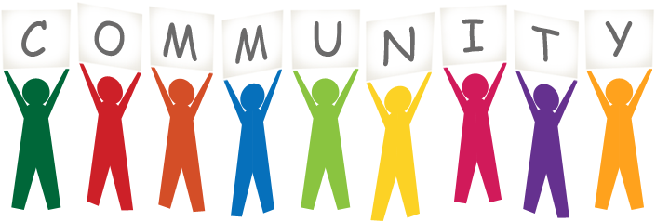

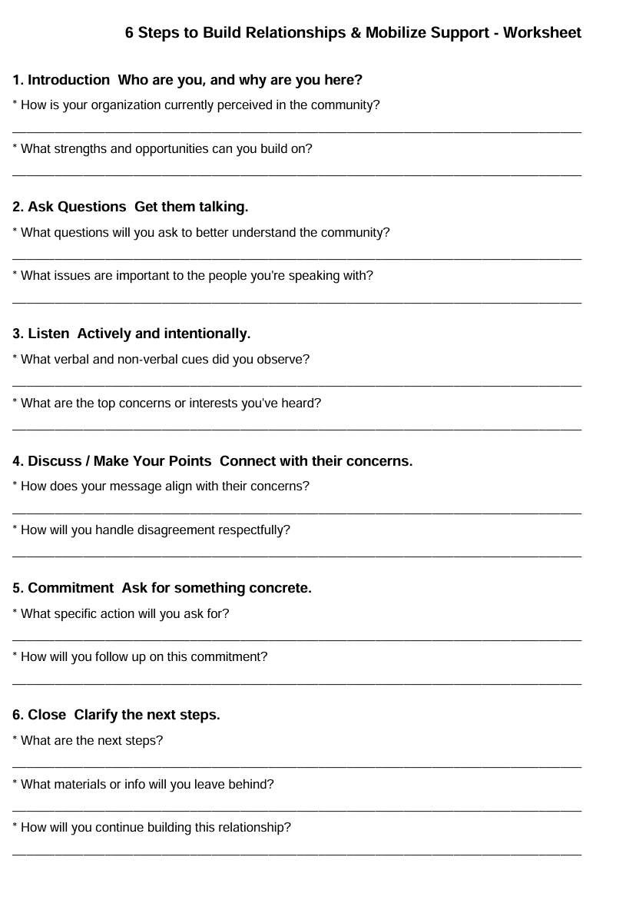
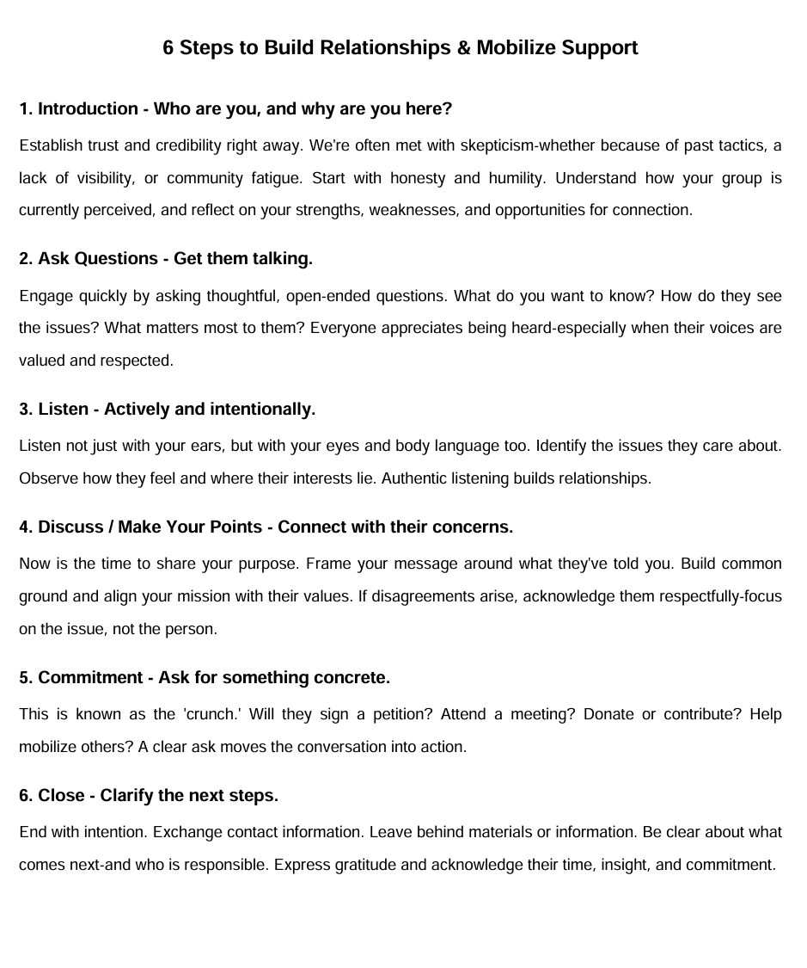

Section 5: The Lift - Getting People Involved

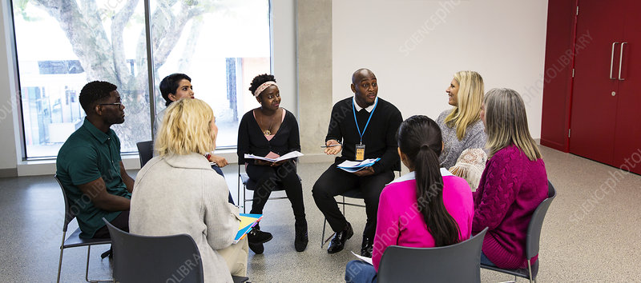

- Ask them one on one
- Don’t always go for pro people first
- Make clear what you want people to do
- Encourage people to ask questions
- Give the big picture, and how each task fits in with the rest – how others work is dependent on them.
- Start small and build, make tasks manageable
- Keep people accountable – check in at each meeting on progress of work
- Explain how their work will make people’s lives better


Section 5: The Lift - Getting People Involved
“There’s No Magic Wand”

Getting people involved is hard work—but it's worth it.
Just like engaging members in the labor movement, getting people involved in their communities takes time, patience, and persistence. But the rewards are just as powerful.
When people feel seen, heard, and empowered, real change becomes possible. The work may be challenging, but the impact is lasting.

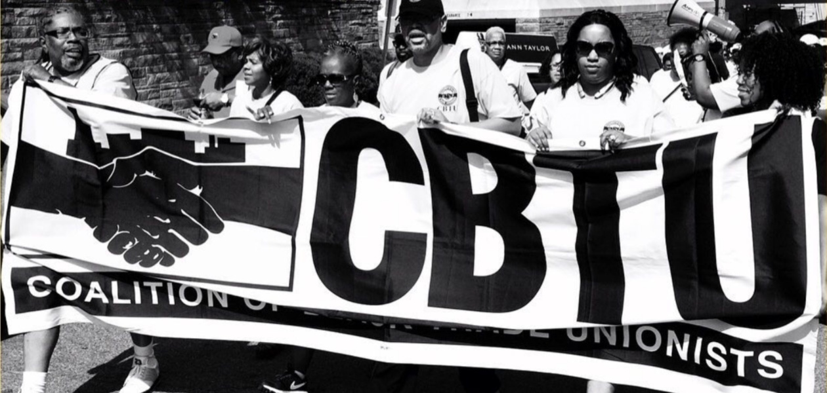

Section 5: The Lift - Getting People Involved
“Nothing Can Withstand the Force of An Idea Whose Time Has Come” – Victor Hugo

ANGER– righteous anger – people need to feel that the boss is taking advantage of them.
HOPE – people need to feel that things can get better.
URGENCY – people need to see that time to move is NOW, later or tomorrow will be too late
YOU can make a difference!
From the United Farm Workers – AHUY
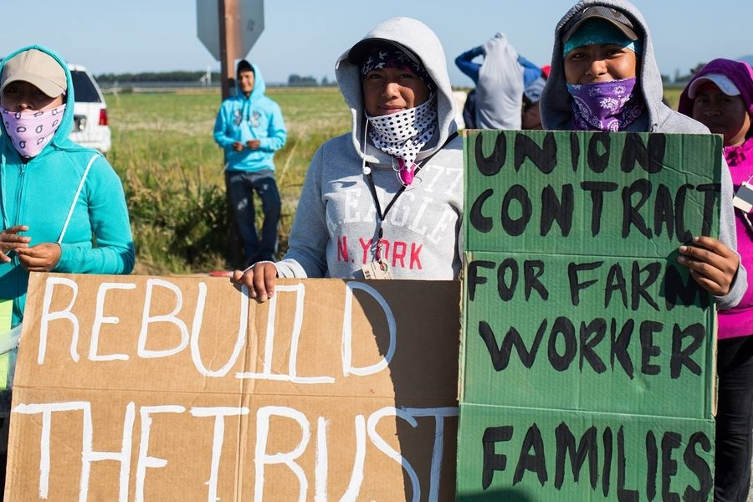
“The skill to develop and deliver a rap will serve you well in any organizing work that you do – whether it is a one-on-one, a house visit, a tabling effort or a petition drive. It is not hard but requires that you take some time to be clear about the goals of the effort and the subsequent conversations.”

“Organizing for Power, Organizing for Change”
Section 5: The Lift – Dealing with conflict directed at you!

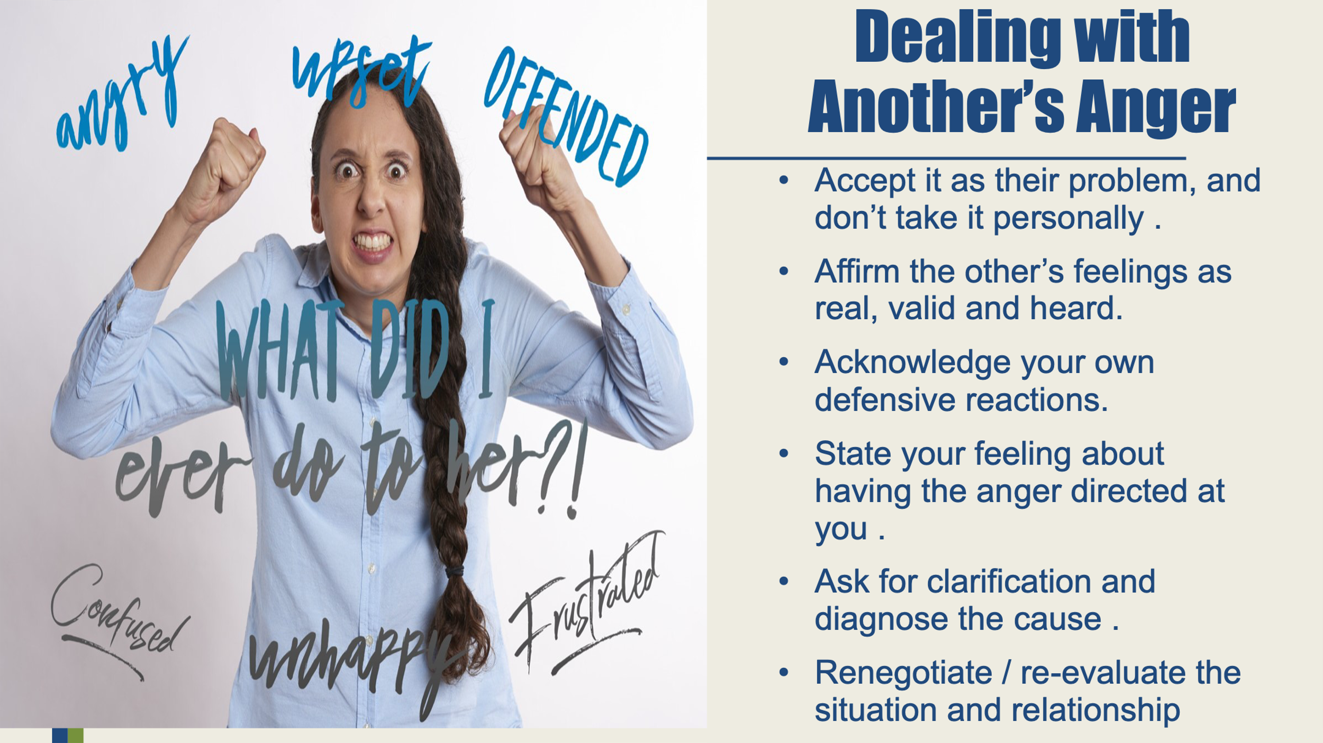

Disclaimer: You are not expected to resolve all Conflicts, and it is ok to walk away for your own well-being.

Section 5: The Lift - Power Triangle
Below is a resource from http://www.fu-berlin.de/
Power Triangle Model
Research by Bogott and Woischwill (2017) suggests that power is effectively built when all three factors are used together within a coherent framework known as the Power Triangle Model. The Power Triangle (Figure 1) illustrates the foundations of power structures. Additionally, this model enables various actors in different contexts to evaluate their power and gain a deeper understanding of their sphere of influence.

**The Power Triangle Model in Detail**
When evaluating the three factors—knowledge, network, and resources, it is crucial to recognize that all three must be developed simultaneously to expand one's sphere of influence. This means that simply focusing on building a stable network is insufficient for improving power dynamics if the other two elements—resources and knowledge—are neglected. Consequently, a reliable assessment is necessary to avoid imbalances and promote harmonious integration of these factors. Such assessments should be based on proven scientific methods, such as surveys, that reflect both the self-image and the external perceptions of the actor.

A key aspect highlighted in this seminar is communication. Effective communication is essential for building and promoting networks. It serves as a channel through which an actor can convey concrete knowledge—whether through giving speeches, publishing articles, or discussing specific topics. Moreover, communication is vital for demonstrating resources. For an individual to gain influence, others must recognize the resources they possess. Therefore, it is important to choose the right communication methods to effectively convey this information.
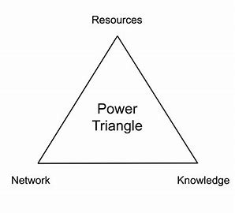
Section 5: The Lift - Managing Projects
Here is a suggested look at managing the work of people known as MOCHA


MOCHA is a project management framework that defines the roles and responsibilities within a project. It breaks down the people involved into five categories, which spell out the MOCHA acronym: manager, owner, consultant, helper, and approver. This can be a useful resource when thinking of planning a community engagement event that can help to also create efficiency in planning an event from beginning to end.

§ This link details what the steps of MOCHA are. - https://www.teamwork.com/blog/mocha-project-management/

Section 6: Effective Media Tactics
Getting the Word Out: Crafting Effective Messaging

Creating a strong, effective message takes research, collaboration, and a clear understanding of your issue and your audience.
Don’t go it alone—many hands make light work.
Here are a few key steps to guide your message development:

1. Know Your Audience
Whether you're speaking to church groups, union leaders, or community members, take time to understand who they are:
- What do they value?
- How do they get their information?
- What tone or language will resonate with them?

2. Understand the Purpose
Define your goal from the start:
- Are you raising awareness, educating, or calling people to action?
- What do you want the audience to think, feel, or do?

3. Brainstorm with Others
Gather input from your team before finalizing the message.
- Collaborate on key points, tone, and delivery.
- Different perspectives help ensure clarity and impact.

4. Structure the Message
Build your message like a sandwich:
- Top layer: Grab attention with a relatable hook or question.
- Middle: Deliver the core message with facts, emotion, and relevance.
- Bottom layer: End with a clear call to action or summary.
And above all: stay on message—clarity is key.

5. Write It Out
Whether it's a speech, a flyer, or a social media post—write it down.
- Refine your message for tone, accuracy, and impact.
- A well-crafted message is a powerful tool. Remember: the pen is mightier than the sword.



Give it a try!
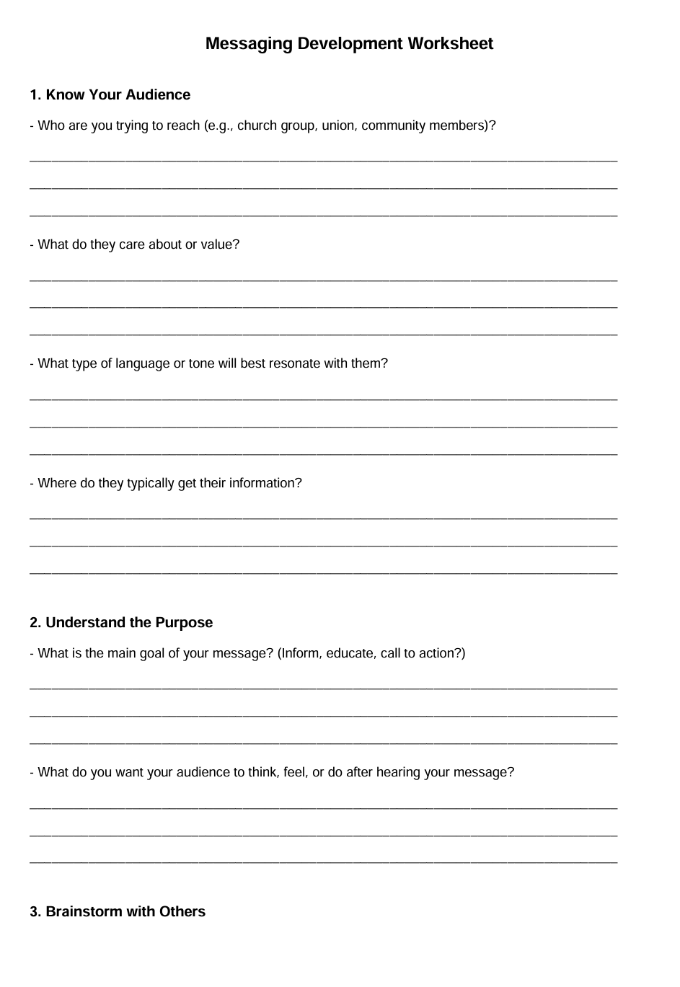
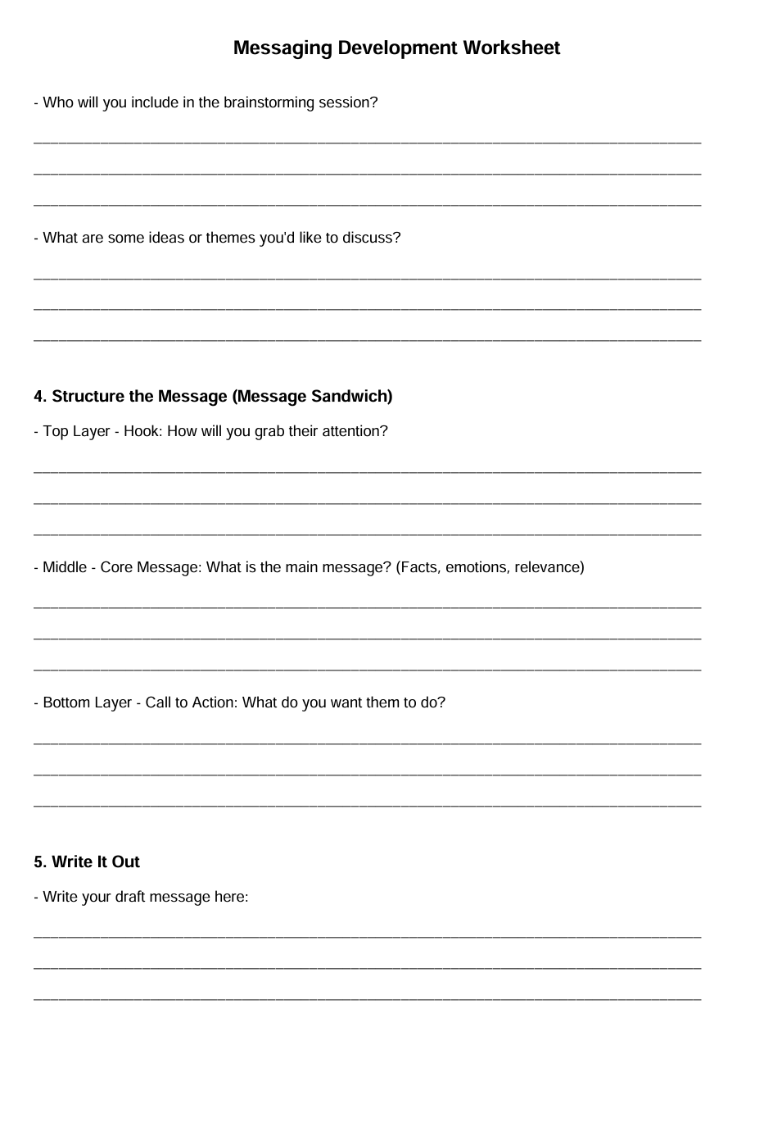
Section 6: Effective Media Tactics
Messaging Tips

Messaging Tips for Maximum Impact
Crafting a powerful message isn’t just about what you say—it’s also how you say it and who you’re saying it to. Use the tips below to sharpen your strategy and stay on point.

K.I.S.S. – Keep It Short & Sweet
Simple, clear messages are easier to remember—and repeat. Don’t overcomplicate your point.

Make a Connection
Your audience should feel something.
Whether it’s humor, emotion, or shared values, build a bridge between your message and their lives.

Let Them Know What’s In It for Them
Answer the question:
"Why should I care?"
People are more likely to engage when they understand how the issue impacts them directly.

Facts, Facts, Facts
Ground your message in truth. Use data, real stories, and clear evidence to support your position.
Speak truth to power—and stay on message.

Know Your Audience
What works for one group might not work for another.
Be ready to adjust your tone or delivery to connect with different audiences.

What’s the Best Strategy?
Not every media strategy will work in every situation. Consider:
- Traditional media (TV, radio, newspapers)
- Social media (Instagram, X/Twitter, TikTok, Facebook)
- Grassroots outreach (flyers, canvassing, word-of-mouth)
Choose the most effective tactic for your message and your audience.

Not Every Comment Deserves a Response
Sometimes, silence is strategy.
Stay focused. Don’t let detractors pull you off message or waste your energy.

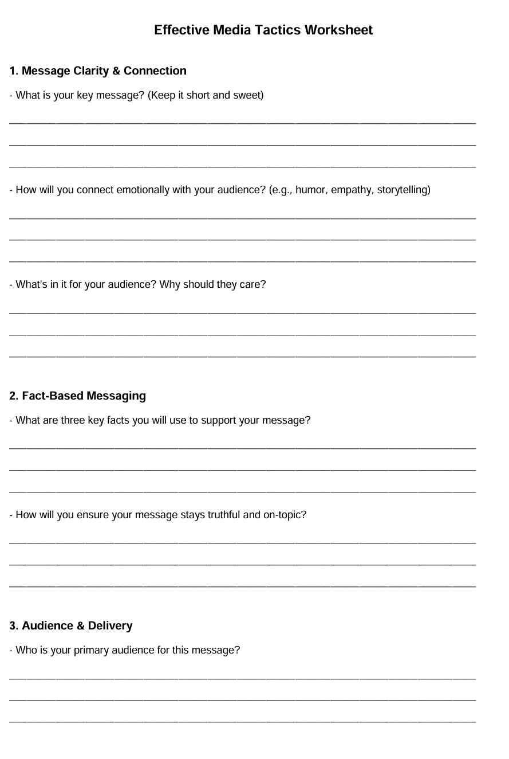
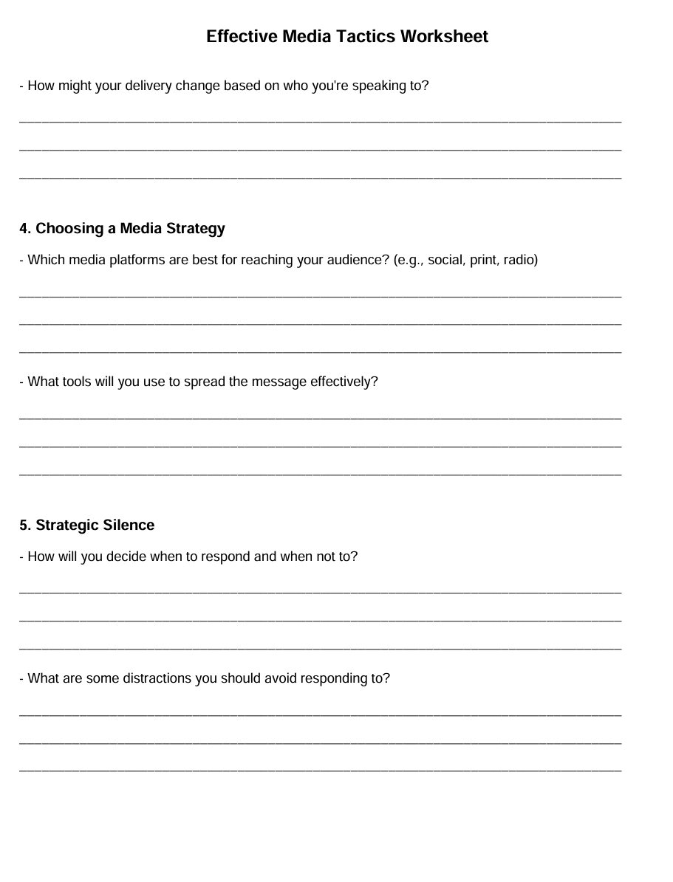

Section 6: Effective Media Tactics
Getting the Word Out
Press Release

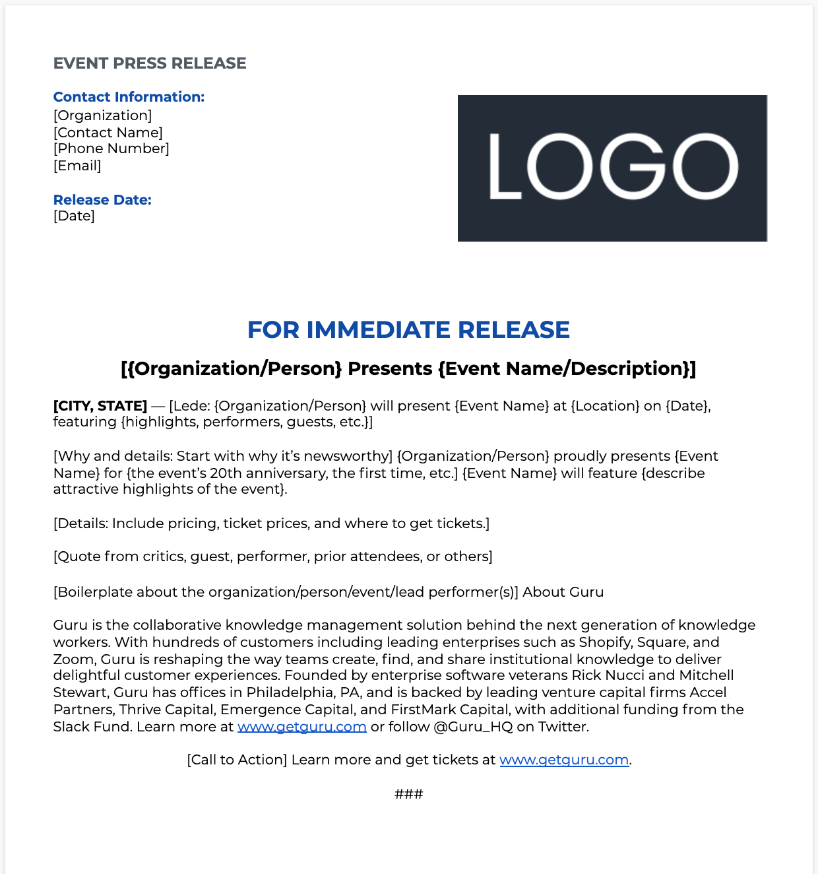

Section 6: Effective Media Tactics
7 steps to a press release?

- Craft a Compelling Headline. ...
- Write an Engaging Lead Paragraph. ...
- Expand on Key Details in the Body. ...
- Include a Strong Quote. ...
- Provide Additional Resources and Context. ...
- Add Contact Information. ...
- Include a Boilerplate.

Cheat Sheet

What is a pre-event press release?
There are generally two types of event press releases: Pre-Event Press Releases: Issued before the event to build anticipation and encourage attendance. Post-Event Press Releases: Released after the event to summarize outcomes and share highlights with those who could not attend.

Steps to writing an effective press release:

- Step #1: Do Something Newsworthy.

- Step #2: Develop Your Hook.

- Step #3: Write Your Press Release Headline.

- Step #4: Write Your Press Release Lead.

- Step #5: Write Your Body Copy.

- Step #6: Add Final Touches.

- Step #7: Distribute Your Press Release.

-30- or ###
How far in advance of an event should a press release go out?
This requires striking a balance in sending the press release with enough time for readers to act but not too much time that they forget about it, or too little time, they can't attend. You should send a press release about two weeks prior to the event.

What are the golden rules of press release?
Remember the five Ws – who, what, where, why and when. These are the details that will put your story into context. And you want them to follow your opening paragraph as soon as possible.

15 Words to catch attention: Free, Sex, Now, Easy, Best, New, Save, Safety, Proven, Love, Discover, Guarantee, Health, Results and You!

Three core components of a press release are….

the headline, which captures the essence of the news; the lead paragraph, which summarizes the most critical aspects of the announcement; and the body, where you include detailed information and quotes to support the lead.

Section 6: Effective Media Tactics
Examples of Effective Press Releases

- Press release for a product launch.
- Press release for the launch of a service.
- Press release to promote an event.
- Press release to announce a new partnership.
- Press release to announce a fundraiser.
- Press release to promote a new study.
- Press release to announce an award.

How will you get the word out?
Use Multiple Outlets for Maximum Reach
Getting your message into the world requires a diverse and intentional approach. People absorb information differently—make sure you meet them where they are.

📰 Traditional Media
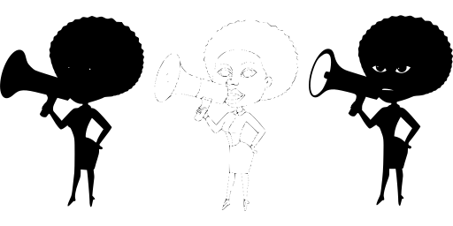
Some members of our community still prefer hard copies and printed materials.
Be sure to consider the who, what, and where:
- Where will flyers be distributed?
→ Churches, union halls, libraries, local businesses, events
- Will anything be mailed?
→ Make sure your mailing list is accurate and up-to-date.

🗣️ Word of Mouth
Never underestimate the power of the spoken word.
- One conversation can lead to a dozen more.
- Equip your volunteers with talking points to help them spread the word.

🌐 Social Media
Choose the platforms that work best for your audience. Don’t try to be everywhere—just be effective where you are:
- Facebook – great for events, photos, and updates
- Instagram – visuals, short videos, and stories
- Websites – home base for all info
- TikTok – short, creative video storytelling
- Bluesky – growing audience of activists and organizers
- Podcasts – in-depth discussions and storytelling

📻 Radio PSAs (Public Service Announcements)
Radio can still be a powerful tool—especially in communities where access to tech is limited.

🗞️ Press Release
When using a press release, keep it short, relevant, and newsworthy.
Stick to the who, what, when, where, and why. And always include contact info for follow-up.

Word of Caution: NOT EVERY COMMENT DESERVES A RESPONSE
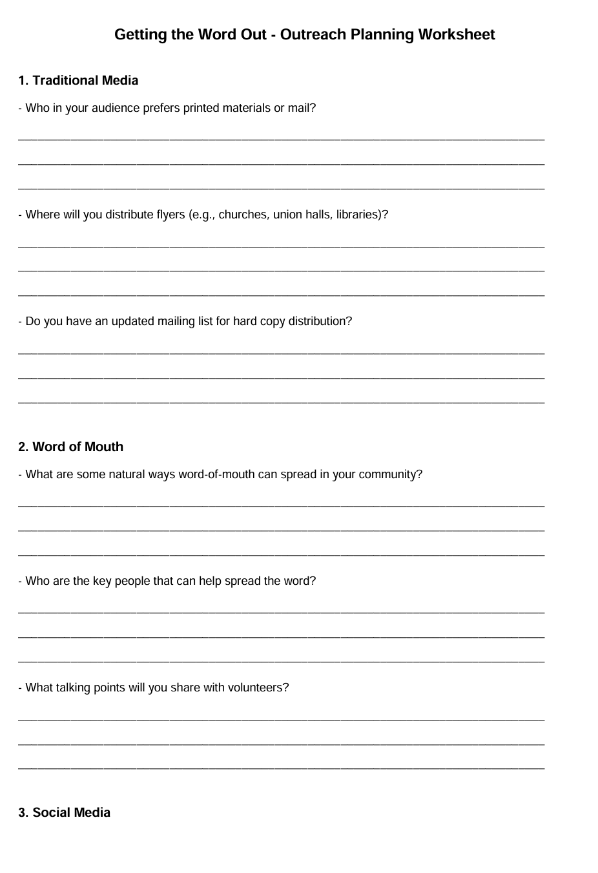
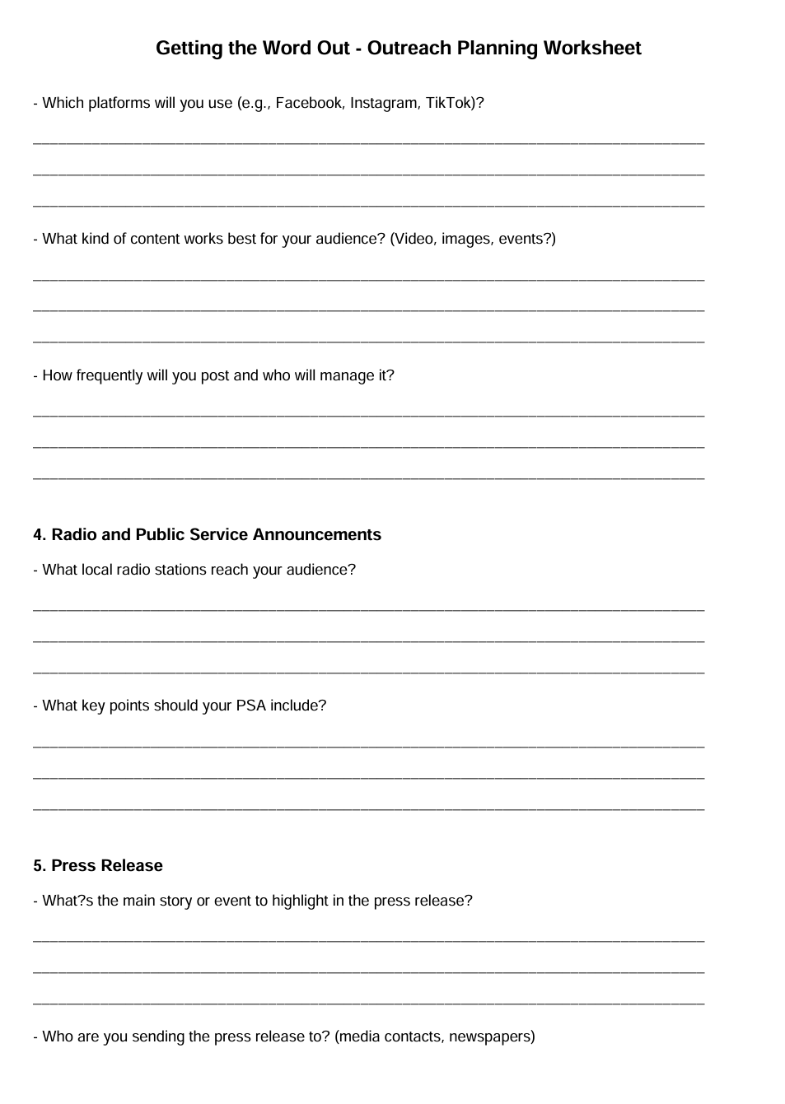


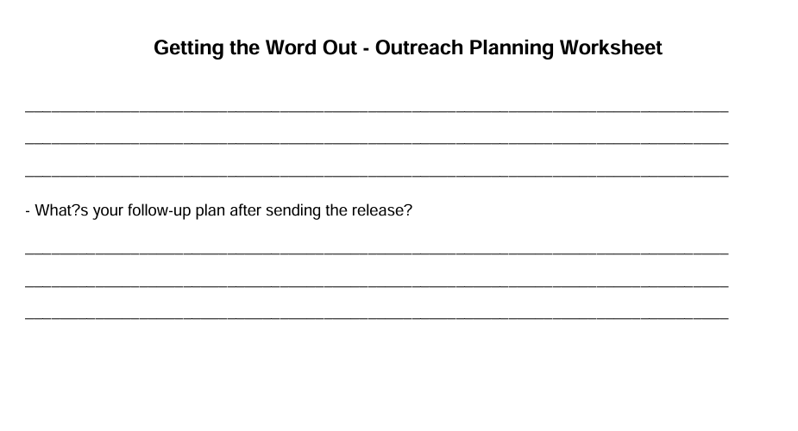

Section 6: Effective Media tactics
Public Service Announcements (PSAs)

📌 What Is a PSA?
A Public Service Announcement (PSA) is a short, impactful message created to inform, raise awareness, and inspire change. PSAs are commonly broadcast on radio, television, and increasingly through digital platforms—often free of charge.

🎯 Purpose of a PSA

PSAs are designed to:
- Raise Awareness
Educate the public on important issues (e.g., health, safety, civic duties).
- Change Behavior
Encourage action—like getting vaccinated, voting, or volunteering.
- Promote Programs
Spotlight programs and services offered by nonprofits, unions, and community groups—such as voter registration drives or food distribution efforts.

🧩 Key Elements of a PSA

Effective PSAs have the following features:
- Short and to the Point
Generally 15–60 seconds long.
- Purpose-Driven
Clear goal: change behavior, increase knowledge, or promote action.
- Emotional Impact
Use compelling language, music, or storytelling to connect with the audience.
- Clear Call to Action
What do you want people to do? (Call, sign up, show up, donate…)
- Tagline or Identifier
End with your organization’s name, slogan, or contact info.

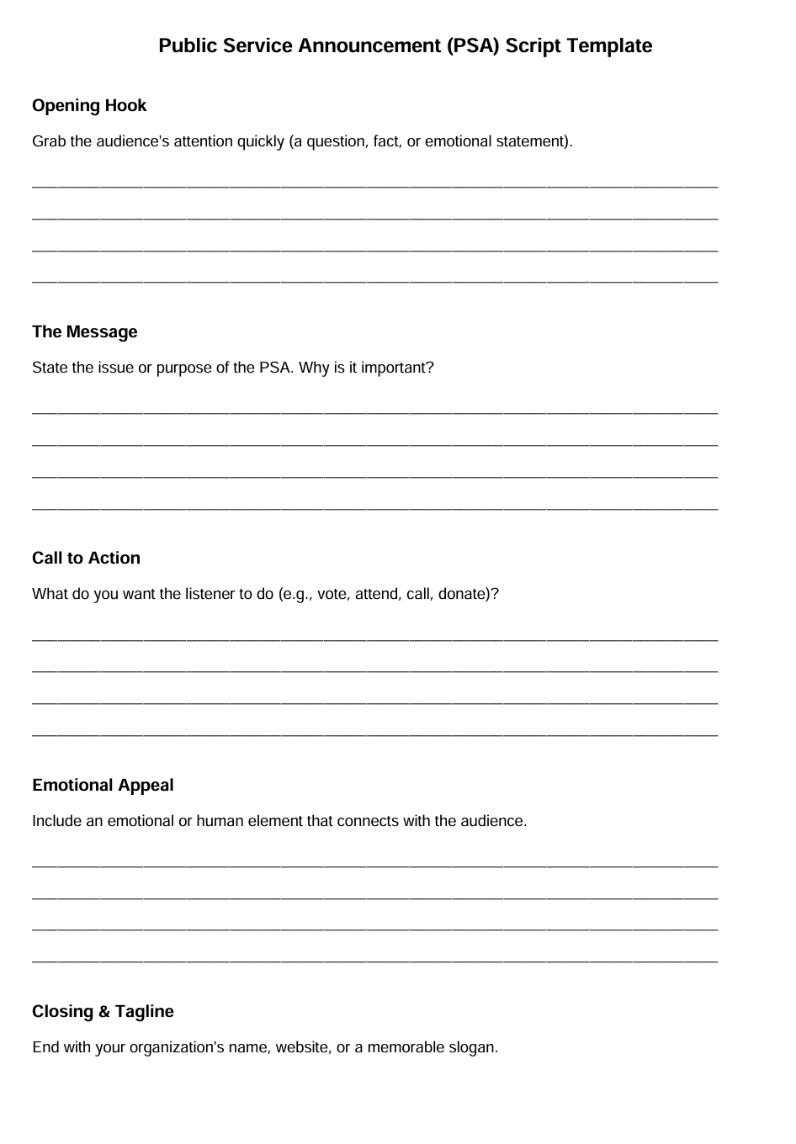
Section 7: References and Resources
Where to go to get help
Regional Directors:
Region 1: Sharon Lovelady-Hall – region1@cbtu.org – (518) 257-1469
Region 2: Jamaall Craig – jamaallcraig@gmail.com – (412) 789-3970
Region 3: Mike D. Payne – cbturegioniii@gmail.com –
Region 4: Randall Payne – mrrlpayne1984@gmail.com – (615) 238-5375
Region 5: Pierrette “Petee” Talley – ptalley@cbtu.org – (614) 490-3009
Region 6: Marcus Shepherd – Mshepherd37@gmail.com – (414) 430-2587
Region 7: Dana Harris – dlh0202@yahoo.com – (810) 335-1565
Region 8: Jean Hervey – region8@cbtu.org (jhervey2850@yahoo.com) – (469) 335-0063
Region 9:
Region 10: Maurice Washington – mw1966@att.net – (310) 864-0855

CBTU Executive Vice President: Anthony Harmon, aharmon1968@gmail.com

Websites:
NEA- 95 ways of engagement

Section 8: Evaluate Your Project
Plus/Delta

What could we change?
What went well with the project?

Section 9: Reporting Out …
Sharing your story

Title of your Project: ______________________________________________________________

What Happened: __________________________________________________________________
(Tell your story)

When did It Happen: _______________________________________________________________
(Timely)

Who were the major players/partners? ______________________________________________
(List them Here)

Major Takeaways: _________________________________________________________________
(Through this experience we learned)

Send us your plan …. We might be able to help

Develop a proposal?

What is the issue you would like to work on?
Voting, Education, Health (specific)

What are your goals?
SMART

Who are your partners?
Community Mapping

How do you intend to get the project done?
Recruit volunteers

How do you anticipate engaging with the community
WIM-WIN (messaging)

Do you have a budget (narrative and financial ask)
Costs to consider

How do you plan to implement your plan?
Step by step implementation plan
(start date – end date, goals identified, messaging, follow up, measureadble}

What’s the media game plan?
Messaging, press releases, social media, mail, etc.

Send your proposals to:

Terry Melvin
Tlmelvin@gmail.com

