CEIU Ontario Region SW District Representative Report 2025 - Gall
Greetings friends. I submit this report to the 2025 CEIU Ontario Presidents’ Conference to inform of the activities of your CEIU Ontario Region SW District Representative.
My activity:
I have attended the CEIU Ontario Regional Council meetings and engaged in debate and discussion on behalf of members is the SW district.
I have served on two CEIU Ontario Regional Council sub-committees and attended meetings for the Structure and Orientation Committee as well as the Finance Committee.
I have attended CEIU National Executive meetings as an observer to learn and understand the work of our union and how that bigger picture reflects to our members in Ontario region and the Ontario SW district.
I attended the annual CEIU Ontario Standing Committee Training to learn about the concerns of our standing committee members in the region and the district.
I have continued to provide support to CEIU SW District Locals by responding to concerns escalated to the region and by attending General Membership Meetings. For this period, I have attended meetings for Guelph, Chatham and St Catharines
Assisting locals with writing Level 1 grievances and Duty to Accommodate requests Assisting locals with Level 1 grievance presentation.
I represent our members and raise concerns of the district at the Regional Union Management Consultation Committee (RUMCC) as a member of the RUMCC.
I have been active in the opposition to Bill 5 which threatens Indigenous rights, environmental protections, and democratic processes across Ontario. To this, I have:
- Endorsed the PSAC and CEIU statements in opposition to Bill 5 and we posted the CEIU Ontario Statement on Bill 5 to our CEIU Regional website on June 4, 2025
- I was invited to speak at a local rally against Bill 5 in Dresden where the park was filled with local community members. We served hotdogs and water to those gathered
- I also attended and participated in the Human Chain rally
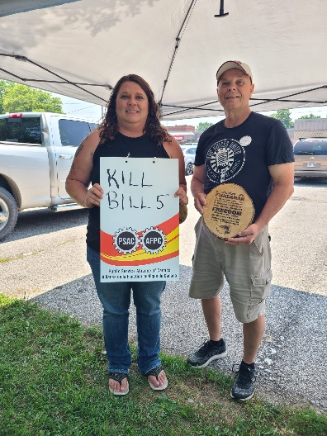
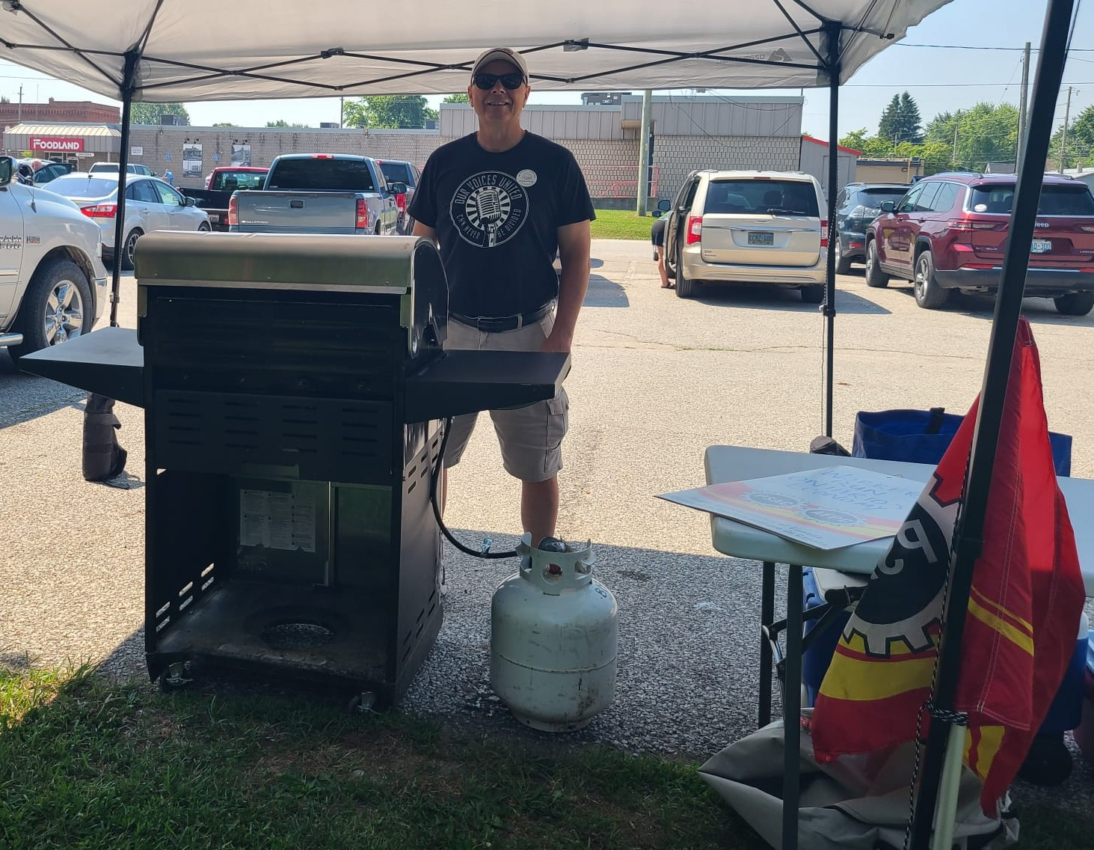

Labour/Community involvement and Political and Social activism captured in media:
https://www.cbc.ca/news/canada/windsor/dresden-landfill-protest-bill-5-1.7576876?cmp=rss
“Lyle Gall, a representative of the Public Service Alliance of Canada, said all workers in Canada should stand in opposition to Bill 5, which has sparked a fierce opposition and anger among First Nations.
"We stand in solidarity with Indigenous leaders who oppose this attack on their national sovereignty and treaty rights," he said.
"We will not stand for this direct attack on First Nations, we will not stand for this direct attack on workers, we will not stand for this direct attack on the land. We called for an immediate repeal of Bill 5," Lyle added.”
https://petrolialambtonindependent.ca/2025/08/11/if-it-can-happen-here-it-can-happen-in-anyones-backyard/
“It is an attack on the lands and the waters, and we stand in solidarity with this community and all communities who are opposing Bill 5. We stand in solidarity with the First Nations in their opposition to Bill 5 and its attack on their sovereignty and treaty rights,” said Lyle Gall, the Southwest District representative of the Canada Employment and Immigration Union.”
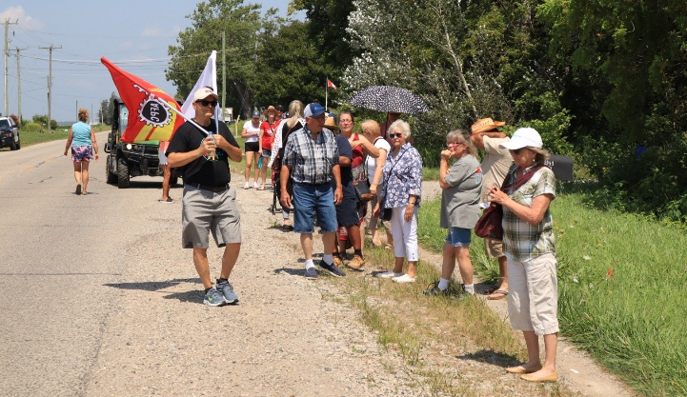
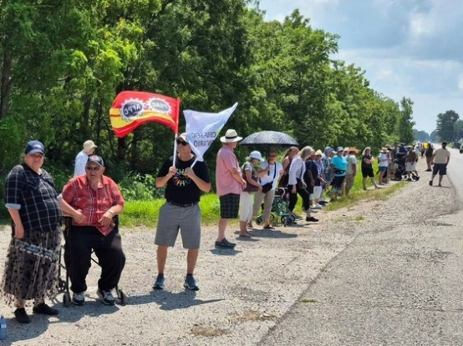
Celebrating Labour at Windsor-Essex Labour Day Parade 2025
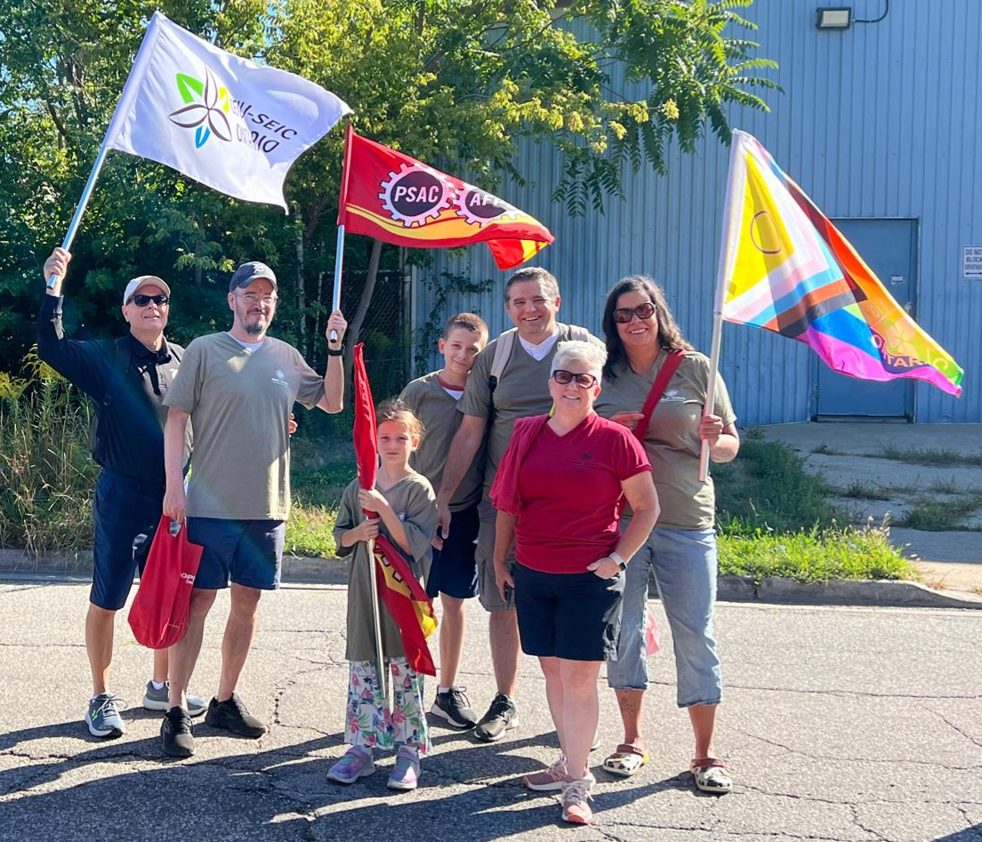
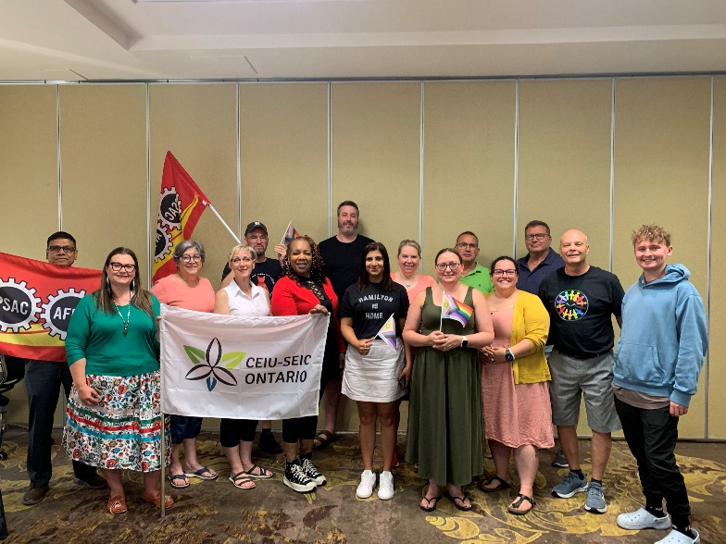
Representing our members at conferences and conventions: Hosted the 2025 CEIU Ontario Southwest District Conference

Next Steps:
With the possibility of cuts to our membership, I will stand to support our members in the face of this. I look forward to working with locals to engage our membership, strengthen our locals through mobilization and bringing locals into compliance with full local executive committees.
Collective bargaining with be forefront for our membership and we will need to be educated and united in our support of our collective bargaining team. I will be visible and vocal in the collective bargaining process.
I will work to raise our members’ awareness of bargaining, the concerns of our Ontario Region Standing Committees and will continue to be an ally with equity deserving groups.
It is super important for CEIU to have your up-to-date contact information. Please make sure that your email address is up to date with CEIU and PSAC so you receive all the updates.

