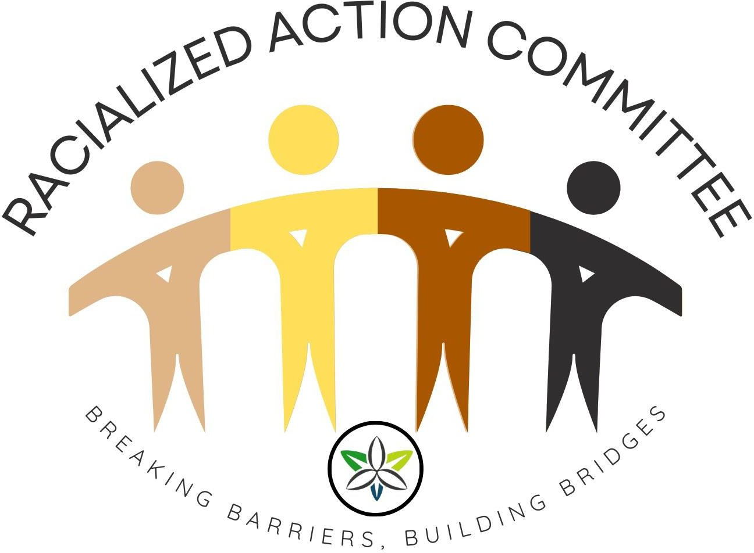

Racialized Action Committee (R.A.C.) Report 2025

R.A.C. 2025 Year in Review
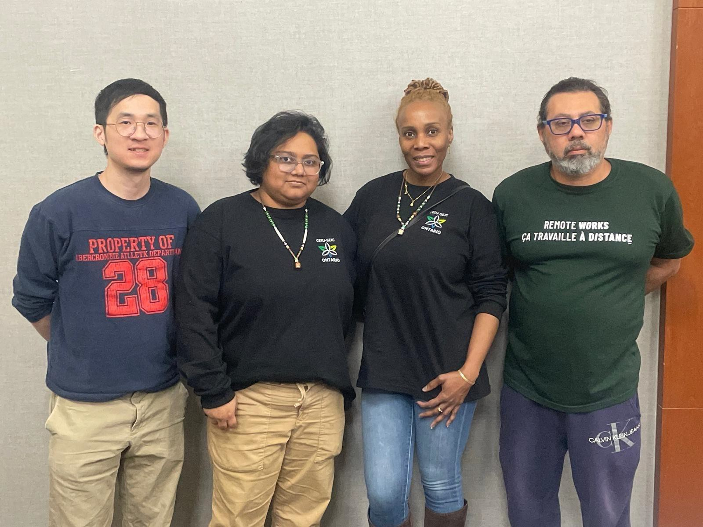
The Racialized Action Committee (R.A.C.) began 2025 with steady pace. This year, the Racialized Action Committee proudly brought together members from IRCC, IRB, and ESDC—reflecting the rich diversity of experiences, cultures, and perspectives within CEIU.
We participated in the Ontario region committee training weekend in February and started planning for the year. Few months later, R.A.C. bid farewell to three members : Jagdeep, Susannah and MarkPaul. The following months were spent regrouping our committee, allowing us to meet virtually in March. In May, we held a virtual meeting, successfully completing our mandate and planning our activities for the year.
During the planning process, the Racialized Action Committee faced several challenges:
- Member Turnover: The departure of three members.
- Coordination: Scheduling meetings that accommodated everyone’s availability, especially with virtual and in-person formats.

LETTER TO MYSELF by Vincent Ho

Being a part of the Racialized Action Committee has been an honour and a privilege.
My goal in joining this committee will always be to further the goal of empowering racialized members to realize that they can utilize their experiences for helping develop the unions overall collective strength.
One of our committee highlights has been helping attend and coordinate the CEIU Ontario Human Rights and Race Relations Conference in August 2025.
Our overall goal is to show the members that being racialized carries its own positive and negatives in the workplace and beyond. We urge all new committee members joining us that we welcome all voices that can help put marginalized voices at the forefront.
We recognize that the fight will always continue and we urge everyone to join our committee to bring an open mind and determination in addressing the social inequities born from race, identity and social structures. I speak from a local who is very large and culturally diverse. My experiences in the union also reflect this cultural diversity. We see leaders of all backgrounds

making a difference in the union and beyond and we only hope that you can activate that within yourself for the greater good.
I hope that by whomever reads this, they can make positive change in themselves especially for those marginalized. Our typical days may seem unfulfilling or mundane with work, emails and sleep schedules, but I see each of us (and you!) are putting in the work. Keep up the hard work, observe the gains and you'll reap the rewards.
In solidarity, Vincent Ho

Dear Future Members by Iffat Haque
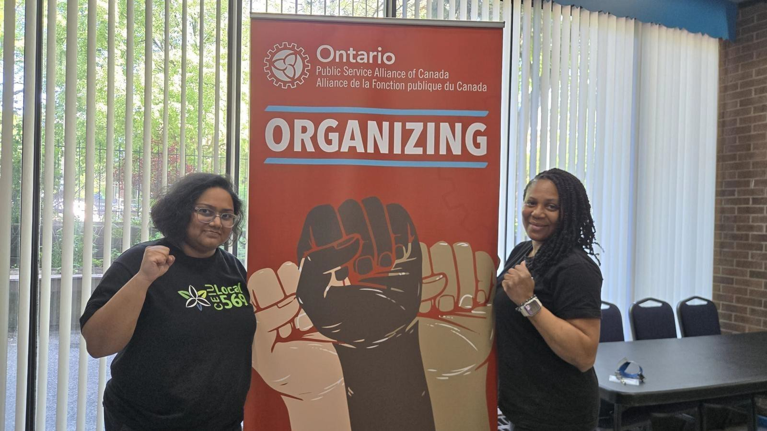
Dear Future Members,
When I first joined the Racialized Action Committee (RAC), I didn’t fully understand the depth of what I was stepping into. I quickly learned that RAC is more than a name on a list or a title on a résumé—it is a commitment, a responsibility, and a calling. We are part of a history that has been built by those who refused to be silent in the face of inequity, and it is our role to carry that torch forward.
Being part of RAC means showing up—not just to meetings, but to moments where courage and compassion are needed most. It means advocating for equity, amplifying marginalized

voices, and ensuring that racialized workers are seen, heard, and respected. It also means listening deeply, learning continuously, and holding space for difficult but necessary conversations.
Our history is rich with determination. RAC has organized events, supported campaigns, and built connections across communities and equity-seeking groups. We have celebrated culture, and worked to make the labour movement more inclusive. But our work is far from done. We still need bold action, creative ideas, and unwavering solidarity to breaking barriers and building bridges.
To future members: know that this work will challenge you, inspire you, and shape you. It will teach you that progress is built not only through big wins, but through consistent, everyday acts of advocacy and support. RAC thrives when its members bring their skills, their lived experiences, and their willingness to work collectively toward a shared vision of justice.
To my future self: remember why you joined. Remember the moments that sparked your fire and the faces that reminded you why this work matters. Carry the drive, nurture the hope, and never forget that change is made by those who show up and do the work—together.

In solidarity,
Iffat Haque

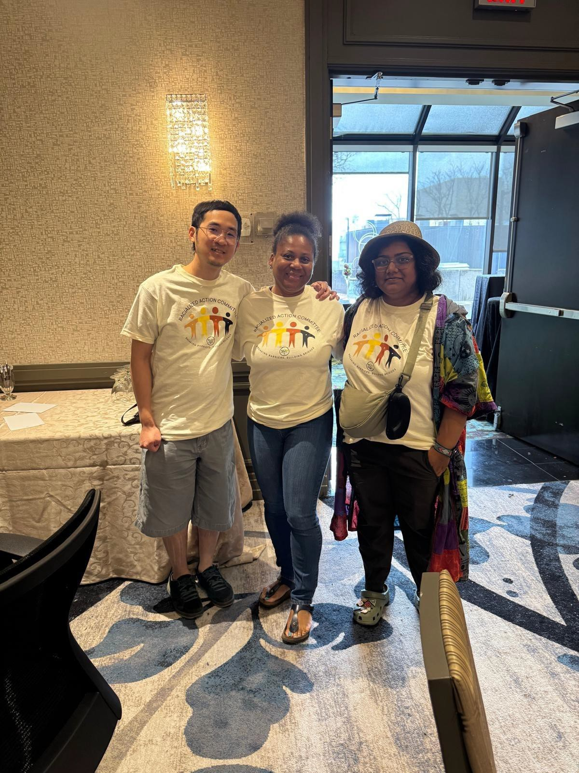
To Our Future Selves and Future R. A.C. Members by Lorenza St Martin
To Our Future Selves and Future R.A.C. Members,
We write this letter with hope, pride, and a deep sense of purpose. To our future selves: May you look back and see how far we’ve come. May you remember those meetings, the courageous conversations, the moments of doubt—and the unwavering belief that racial equity is not just a goal, but a responsibility. You stood up when it was easier to stay quiet. You built bridges where there were walls. You dared to imagine a union where every member feels seen, valued, and empowered. To those thinking of joining the Racialized Action Committee: Welcome. You are needed. Whether you bring lived experience, fresh ideas, or simply a desire to learn—there is space for you here. This committee is more than a group; it’s a movement.
We are dreamers and doers, strategists and storytellers, advocates and allies. We challenge systems, celebrate cultures, and create tools that help CEIU grow into the inclusive organization it must be. We have a Vision for 2026 and plans. But the real work—the heart work—happens in community. And that’s where you come in. If you’re ready to make change, not just talk about it… if you believe that racial justice is union justice… then this is your invitation. Let’s build the future together.
In solidarity, Lorenza St Martin Chair
The Racialized Action Committee- CEIU

“We lead with lived experience. We fight with collective power.”

