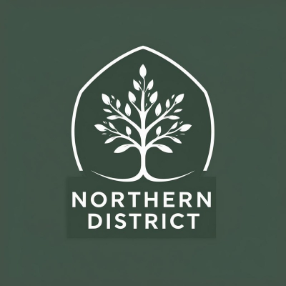

Northern District Report

Lisa Flaherty

Northern District Representative Report

This past year has been a busy one, not only in the Northern District but across the province. Our members have been called back into the office when the employer simply wasn’t ready, and that has caused a lot of stress. To support our members through this, I set up a few online Zoom meetings. They were set up like open forums where I went through a list of what members’ rights were, gave space for questions, and tried to provide clear answers. Out of those conversations, I also started working on a document outlining common limitations and restrictions for Duty to Accommodate requests. Some of you may already know about this, since I’ve shared it when questions came up in Ontario Chat or when members reached out to me directly. The idea behind it is simple: this whole work from home Duty to Accommodate process is new, and doctors often weren’t sure what to write on the forms and a lot of them were giving our members medical diagnosis allowing the employer to play doctor. So, I began compiling a list of limitations and restrictions for the different medical issues people were experiencing. The document is now about five pages long and gives members language they can bring to their doctors to help frame limitations and restrictions in a way the employer will recognize, without disclosing a medical diagnosis. That last part has been particularly important, because the employer has been far too eager to play doctor. We saw a pattern where if a form mentioned anything about anxiety, management would immediately refuse to accommodate. Having this resource has helped members push back and get the right wording in place to protect themselves.
I also had the pleasure of visiting some of the locals in the North. I was able to travel up to Kirkland Lake and share a pizza lunch with the members there and I also attended the Timmins AGM, which gave me the chance to hear directly what’s on people’s minds. I have to say the Timmins AGM was fantastic!! The AGM was well attended with around 42 members, which is pretty impressive considering our reports show that they have just over 200 members. In the coming months, I’m planning to continue this work by visiting Kenora, Thunder Bay, and Barrie.
In October 2024, we held a combined conference with the Northern and Toronto Districts. I think it was a real success. We had some big names join us, including my brother, who is a human rights lawyer and spoke about how he’s been able to prove discrimination in court. We also heard from Nicholas Marcus Thompson, who was the Secretariat for the Black Class Action Lawsuit. Our National President, Rubina Boucher, joined us, as well as James Infantino from PSAC, who explained how our pensions work. NUR Sean McNeil gave a session on writing resolutions. On top of all that, we had Caribbean dancers come in, which added some energy, got people moving, and made the conference fun. We’re planning to hold another joint conference with Toronto this year. While we were hoping to bring everyone to the North this time, it looks like we’ll need to push that plan to next year. For now, we’re looking for ideas to make this upcoming conference just as enjoyable and useful as the last one.
Another part of my role as a District Representative is sitting at the Regional Union-Management Consultation Committee (RUMCC) with Mary Ann Triggs and other Director Generals. This is where we raise issues directly with senior management. Duty to Accommodate has been one of the biggest issues at that table, and health and safety has also been a huge concern. In the North, health and safety since the return to office has been rough. The employer wasn’t prepared, and in some cases, decisions by certain directors have made things worse. To be honest, the transition has been anything but smooth. That’s why I think it’s important that all districts work together on health and safety. These problems aren’t unique to the North, and we need to take a united approach.
I want to stress that members need to bring their concerns to their District Representatives. If we don’t know what’s happening, we can’t bring it up at RUMCC. These meetings matter because what goes into the official minutes can be seen by the public and even the media. Having real issues recorded there means the employer can’t just brush them aside. That’s why it’s important that we continue to raise valid points that reflect the actual challenges our members are facing.
Looking ahead, my focus will be on keeping Northern members’ voices heard at every level. I’ll continue to push for better health and safety standards and keep building on the work I’ve done with DTAs, both by supporting members directly and by making resources available. I also look forward to bringing our next joint conference to the North, so members from Toronto can see all the North has to offer. Most of all, I’ll keep making sure that the North is visible, supported, and included in the bigger picture as we move forward.

