IRB / IRCC STANDING COMMITTEE 2024-2025
Our newly formed committee, the IRB/IRCC standing committee, in its inaugural year.
On January 31, 2025, we had our first meeting, where we selected our chair and roles for all are committee members; created a mandate and a logo for the committee.
On March 25 & 26 the IRB/IRCC standing committee collaborated with CAPE in Ottawa regarding the government’s Work Force Adjustment. It was a successful event, where future collaboration is in the works.
Back on May 12th. we hosted a virtual town hall for all IRB/ IRCC locals to introduce ourselves to all IRB and IRCC members.
After this President’s Conference, we are very excited to be hosting a bowling meet and greet for IRB and IRCC employees. We will be hosting events in various cities, starting October 18, we will simultaneously be hosting 2 events – one in Scarborough & the other in Mississauga; October 25 – London; and October 26 – Guelph. Don’t forget to signup and please show up and join us in this fun outing.

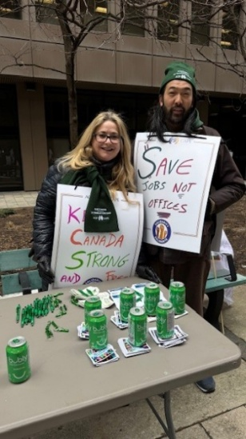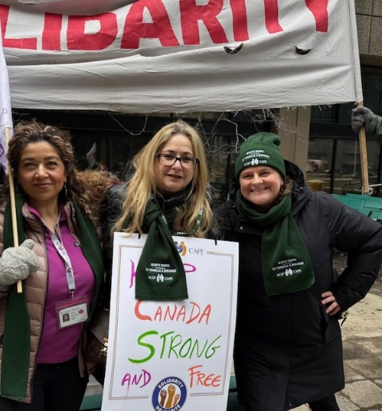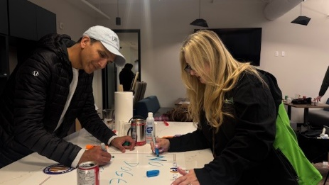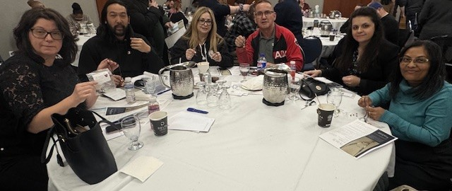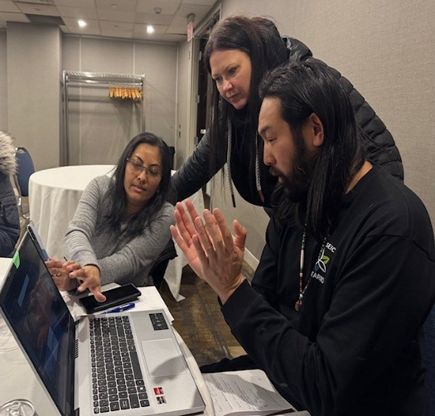
DIANA PEREIRA – CHAIR
My name is Diana, and I have been part of the IRB for about 5yrs now. I’m a (RO) Registered Officer at 25 St. Clair Ave. in Toronto. I’m Vice President 645 (IRB) Immigration Refugee Board and IRB Departmental Rep Alternate on the (ORC) Ontario Regional Committee as well as the Alternate NVP representing the IRB. I sit on the PSAC Women’s Committee as Treasurer. I am also part of the Central Region OCOW Committee in Toronto. I am currently Chair of our new IRB/IRCC Standing Committee and I believe that the only way to get things done is to get involved. A unity union is a strong union.
Were Stronger Together! Diana
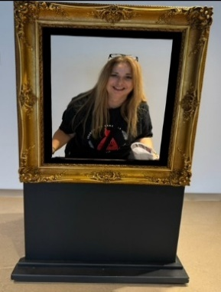

RADMILA KONDIC-ALTERNATE
Greetings everyone,
My name is Radmila Kondic, and I have been a Case Processing Agent/Officer for approximately 10 years at IRCC. My previous experience in the union includes being a secretary for the local 614 as well as currently an alternate for the IRB/IRCC Standing Committee. I know that there may be times when we all need a helping hand, be it with our career development or just a resource of further information regarding employee right and benefits. I would like to make sure that are union dues are utilized well and that we have a voice for our members when we need it the most.
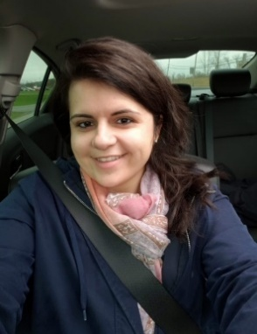
RONAKBEN MEHTA- SECRETARY
My name is Ronakben Mehta. I joined the federal government in 2021 during the pandemic, a time that highlighted the importance of unity and resilience. I serve as Secretary for the IRB/IRCC Standing Committee and as one of the Vice-Presidents of Local 613. I am committed to ensuring every member’s voice is heard and valued. I am honored to contribute to the IRB/IRCC Standing Committee, where I strive to bring a fresh perspective, foster collaboration, and help drive meaningful, positive change for our members.
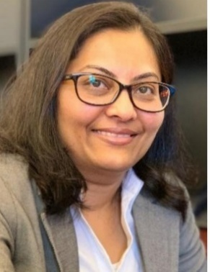

Robert Pyne - TREASURER
I bring over 30 years of union experience and currently serve as Vice President of IRCC Local 592, a role I’ve held since 2024. Prior to this, I served as a steward for two years and have been a member of the CIEU Ontario Region Standing Committee since January 2025. With 10 years of experience at IRCC in the Citizenship and Immigration line of business, I am committed to representing and supporting our membership. Previously, I held the position of Financial Secretary Treasurer for C.A.W./Unifor Local 1524 from 1998 to 2014. I believe in strong, transparent representation, and recognize that the membership is the highest authority.
RT PYNE
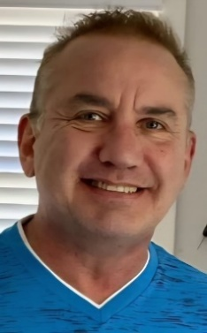

ERIC TRAN- INFO OFFICER
Eric Tran is a Case Management Officer with the Immigration and Refugee Board (IRB) in Toronto, and a member of the Local 645 executive team. He is proud to have been selected to represent the newly established IRB/IRCC Standing Committee. As a new member of this committee, he is eager to contribute to its foundational work, help shape its direction, and ensure it reflects the diverse needs of its members.


CELESTINA-KING
My name is Celestina-martins King. I am honoured to be part of the newly formed IRB IRCC committee where we advocate for the rights and well-being of our members. I also serve as a treasurer for local 613. With over 30 years of dedicated service at IRCC I bring extensive experiencing both immigration and Citizenship programs Throughout my career, I’ve been committed to supporting newcomers and ensuring the integrity and efficiency of Canada’s immigration system. I look forward to contributing to this important and evolving chapter in our work.
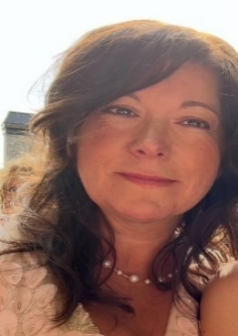

DOREEN DIXON-ORC ADVISOR IRB REP
I have been a member of CEIU for the last 30 years. I have served as local VP Point of Service, president and member of Ontario Council as the IRB Representative and advisor to the IRCC\ IRB Standing Committee and look forward to continuing working.
Regards,
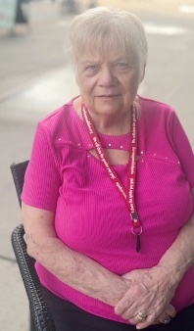

DHAVAL SHAH – ORC ADVISOR IRCC REP
My name is Dhaval Shah. I am an active member in good standing with CEIU.
I serve as a Case Processing Officer at IRCC and currently hold several leadership roles within our union. I am the Local President of Local 614, a CEIU Ontario Regional Council Member representing IRCC, and the Alternate National Vice-President for IRCC at CEIU. I also serve as an advisor to the IRCC/IRB Standing Committee. I look forward to continuing this important work. Together, we can build a stronger, more connected, and responsive union.
Thank you,
Dhaval
