CEIU Ontario Regional Council Women’s Representative Presidents Conference Report 2025
Presented at the 2025 CEIU Ontario Presidents’ Conference
Submitted by:
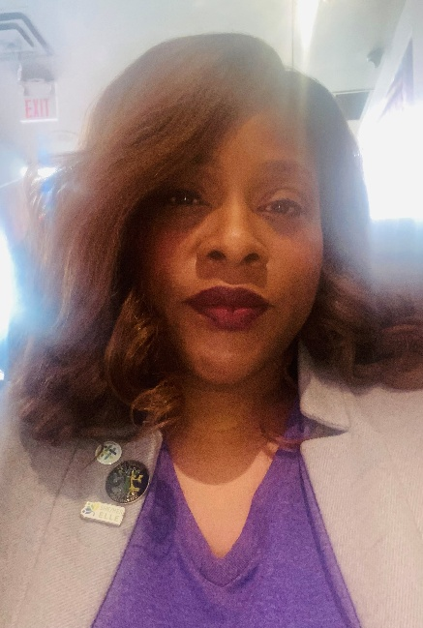
Karen Spencer-Cousins
Ontario Regional Council Women’s Representative
Chair, CEIU Ontario Regional Women’s Committee
CEIU National Women’s Committee
This year has been a journey of growth, connection, and bold action for women across our region. Serving as the Ontario Regional Council Women’s Representative, Chair of the Ontario Regional Women’s Committee, and a member of the CEIU National Women’s Committee has been both an honor and a responsibility I hold with pride.
Through these roles, I have had the privilege of being a voice for women at every level—bringing forward concerns from locals, shaping initiatives on Ontario Regional Council, and helping set priorities nationally. These experiences have reinforced the value of leadership that listens and the importance of building bridges between our members on the front lines and the decision-making tables where real change happens.
Highlights of 2025
The Ontario Regional Women’s Conference – Sisters in Strength
One of my most significant achievements this year was leading our Ontario Regional Women’s Committee in planning and delivering our highly anticipated Ontario Regional Women’s Conference, in London Ontario- Sisters in Strength. This event brought women together from across Ontario to share stories, gain knowledge, and strengthen our collective power.
Following this, I also supported the CEIU National Women’s Committee in planning our National Women’s Conference in Montreal. Both experiences underscored the importance of translating ideas into resolutions and actions that make a tangible difference for members.
Connecting with Women Building Committees
I especially enjoyed meeting with energized women who have started—or who aspire to start—their own Women’s Committees in their locals and regions. Their enthusiasm and commitment reaffirm the potential for a network of connected locals across Ontario. I aspire to build these connections so that we can communicate, mobilize, and act in unison for worthy causes at any given moment—creating collective power that is immediate, coordinated, and impactful.
Ontario Regional Council and Equity Work
At the Ontario Regional Council level, I have worked at the RUMCC table and beyond to ensure that women’s voices are present in every discussion—whether about equity, workplace health and safety, or human rights. I have collaborated closely with our Human Rights and Race Relations representatives, Indigenous representatives, and other equity leaders to push for meaningful inclusion at every level of CEIU.
Health, Equity, and Justice
I have made a point of raising awareness of issues too often overlooked, including fertility, perimenopause, menopause, and other women’s health concerns, recognizing their impact on the well-being and dignity of members. We have spoken out for racialized women, Indigenous women, 2SLGBTQIA+ women, and women with disabilities—ensuring that those at the intersections of oppression are not forgotten.
I support initiatives such as the Black Class Action, because true equity requires acknowledging systemic barriers and actively working to dismantle them. My commitment has been to amplify voices that are often unheard—including frontline workers and marginalized women who also deserve safety, fairness, and respect.
National Initiatives
At the national level, I am proud to be involved in the upcoming rollout of domestic violence training, which will soon be available to members. This initiative goes beyond awareness; it is about saving lives and creating a culture of safety, understanding, and empowerment. My goal is to bring this training to Ontario, alongside complementary initiatives focused on self-defence, safety, mental wellness, and communication.
Looking Ahead to 2026
I aspire to make the year ahead one of action and transformation. My priorities include:
- Uniting women across Ontario to speak with one strong voice
- Increasing representation in every local
- Creating platforms for women’s wellness, leadership, and development
- Strengthening connections between locals to enable real-time solidarity
- Ensuring that every member—regardless of role or location—feels seen, valued, and supported
As Audre Lorde said:
“I am not free while any woman is unfree, even when her shackles are very different from my own.”
We have a lot of work ahead of us: It's time for us all to start lifting as we lead, connect grassroots members to resources, and build bridges that transform solidarity from words into action.
To every delegate, ally, and leader here today: thank you for standing with the Women of CEIU. Thank you for recognizing that equity is not optional—it is essential. Together, we will keep rising. Together, we will make CEIU a stronger, safer, and more inclusive union—for all.

In Sisterhood and Solidarity,
Karen Spencer-Cousins
Chair, CEIU Ontario Regional Women’s Committee
Ontario Regional Council Women’s Representative
CEIU National Women’s Committee

