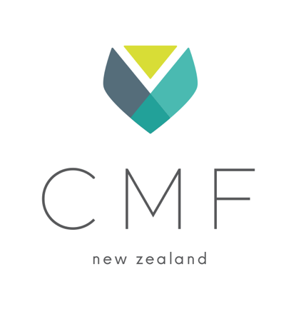

Agenda for the Annual General Meeting of  
The Christian Medical Fellowship of New Zealand Incorporated

**Wednesday 20th August 2025 at 7.30pm-9.30pm**

**Meeting Chair: Tim Jelleyman**

1. Welcome (announce recording of meeting)
2. Opening prayer
3. Apologies
4. Meeting arrangements
   1. Establish voting strength
   2. Establish timing of session
5. Confirmation of previous minutes – 21 Aug 2024

**Motion:** *Accept Minutes of 2024 AGM as a true and correct record.*

1. Looking Back - Tim Jelleyman

Acknowledgement of all volunteers and contributors to the annual report

**Receive:** *CMFnz 2024-2025 Annual Report*

1. **Constitutional Amendments**

Confirm proposed amendments to the constitution:

**Table of proposed constitutional amendments**

**Motion:** That the members approve the proposed technical AGM amendments to the constitution, as advised by Parry Field Lawyers.

**A proposal to invite Christian Dentists to join CMFnz as Full Members and Dental students as student members.**

**Members Consultation Report**

**Draft constitution 1 (with technical AGM amendments only)**

**Draft constitution 2 (with technical AGM amendments and the addition of Dentists and Dental students)**

**Motion:** That the members approve the draft constitution 2 with the technical AGM amendments, as advised by Parry Field Lawyers, and the addition of dentists as full members and dental students as student members.

1. Financial Position presented by Treasurer Phil White

**Receive:** *Performance report 2024-2025 and Budget 2025-2026 (Phil White)*

**Motion:** *That the performance report 2024-25 and budget 2025-2026* *be accepted.*

**Motion:** *CMFnz Board proposes no auditor* *be appointed for the 2025-2026 year.*

Questions

1. Election of the new Board – up to 10 positions including two student representatives
   1. Nominations received
   2. Voting
2. Looking Ahead presented by National Director Jen Collings
3. Thank-you’s
4. Closing Prayer, farewell, and conclusion of the meeting