In the 1800s, people managed sewage outflows by dumping in the nearest creek to be carried away from their populations. People were getting cholera and didn’t connect that it was because sewage was in drinking water.
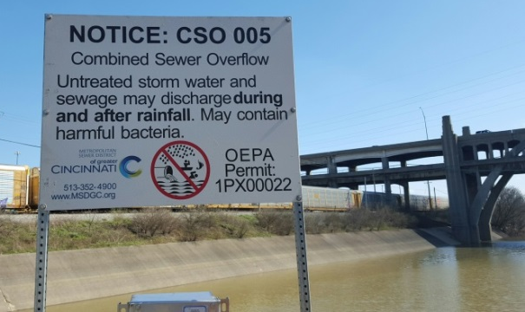
Our sewer system in Hamilton County is combined – meaning that both sewage and storm water goes into the same pipes. Cities build streets to drain into sewers, and industrial polluters are sometimes allowed to use the sewers for their liquid waste.
As urban and suburban sprawl occurred in Hamilton County, the Metropolitan Sewer District of Greater Cincinnati (MSD) added on to the sewer system without increasing capacity. When the sewers are overwhelmed with storm water, just like in the 1800s, it is still designed to overflow into our waterways from Sanitary and Combined Sewer Overflows (SSOs & CSOs). Each year 11.5 billion gallons of untreated sewage and storm water spews into our waterways and neighborhoods. It also backs up into residents’ basements, causing property damage and harming public health.
In effort to clean up our nation’s waterways, the Clean Water Act (CWA) was passed in 1972, making our SSOs and CSOs illegal. Hamilton County has 70 SSOs and 200 CSOs, among the top five in the country for urban CSOs. The United States Environmental Protection Agency (USEPA) negotiated with the MSD for compliance with the CWA to fix our sewers but MSD wasn’t complying.
In 2002, Sierra Club filed in federal court “intent to sue” the MSD within 60 days if they would not comply with the CWA to fix the sewers. To avoid a court battle with the Sierra Club, MSD entered into a Consent Decree with their regulators - USEPA, Ohio EPA and the Ohio River Valley Water Sanitation Commission.
The Consent Decree has two basic requirements: fix the sanitary and combined sewer overflows and help people who have sewer backups.
The Consent Decree governs the Sewer Backup Response Program. See our fact sheet “Sewer Backup Response Program” for more on what that program is legally mandated to do to help victims of sewer backups.
Most Consent Decrees have the requirements for sewer fixes in them, but ours is set up for the work to be done in “Phases” that the plaintiffs and defendants must agree will solve the sewer overflows and backups.
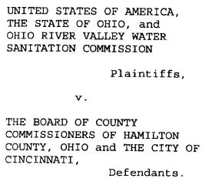
The USEPA and MSD fought over Phase 1 for three years, but work to fix our sewers finally began in 2009 with what MSD now calls “Project Groundwork.”
The County and City, as the owner and operator of MSD, respectively, submitted separate plans to the USEPA for Phase 2. The USEPA rejected both plans, calling for the City and County to agree on Phase 2.
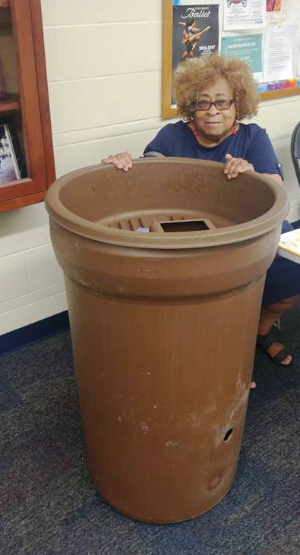
The Court has ordered the County and City into mediation to settle on a joint plan. According to the Consent Decree, work is supposed to commence on Phase 2 in 2020. If the plaintiffs and defendants cannot settle on plans for Phase 2, the Court and the USEPA can exercise their legal authorities for enforcement.
Green infrastructure, like rain barrels and retention ponds, can minimize the amount of storm water that enters our sanitary sewers and has been shown to be effective at eliminating CSOs. Grey infrastructure, like increased pipe capacity and separated storm drains, is the traditional way to upgrade sewers. Both methods can be used to comply with the Consent Decree, but green infrastructure can be more cost-effective for ratepayers.

