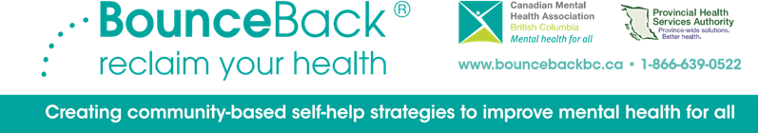
Submitted by Robyn Guidon, Team Lead & Lucy Morton, Administrative Assistant
Bounce Back® is a free, supported, self-directed program that supports individuals in learning tools and strategies to help overcome symptoms of mild to moderate depression or anxiety and improve mental health. By accessing workbooks based on Cognitive Behavioural Therapy principles, and working with trained coaches to further learning, Bounce Back® is proven to be very successful in overcoming unhelpful thinking, symptoms of depression, worry and anxiety, and participant’s report higher quality of life levels. Bounce Back® materials are available online, or by mail – both free of charge.
“I have been to numerous health/mental health programs. This is the most concise and done by one step at a time. I will keep these books for issues I still need to work on. As to the coaching, I haven't got the words to say how thankful I am. Their skills as a coach are beyond anything I've experienced”.
-Vancouver Island Bounce Back Participant
This is the second year of successfully having participants be able to self-refer to Bounce Back® - removing additional barriers to service. Participants can refer themselves through the self-referral portal and just need to be linked to a physician’s office. We also continue to increase who is able to refer to the program.
After successfully rolling out this model to other provinces, Bounce
Back® has gone national! BC is the flagship program and continues to
help with training and program development across the country.
The Cowichan Bounce Back® team manages all the referrals for Vancouver Island and the Islands. Our team has been successfully working remotely for the last fiscal year and remains strong and focused. Our Coaches report great job satisfaction and value the support and tools they’ve been able to provide during an incredibly difficult time (and are busier than ever!).
“Without Bounce Back there is a huge gap for patients needing mental health help. Bounce Back meets a critical part of that gap”
-local referring physician
2021-22 Referrals
Referred Referrals | 1205
Self Referrals | 489
Total Referrals | 1694

BounceBack® is funded by the Ministry of Health and Provincial Health Services Authority.
Coaching and workbooks are available in English, French, Mandarin, Cantonese and Punjabi.

Bounce Back® is available to individuals 15 years and older.

