911 Memorial Bluegrass Concert
Saturday Sept 9th 5pm
Columbus Veterans Park, Ward St. Columbus NC
King James Boys / Golden Valley Crusaders
Mike Upright / Colt Creek Bluegrass
SPECIAL PATRIOTIC SERVICE 6:30pm
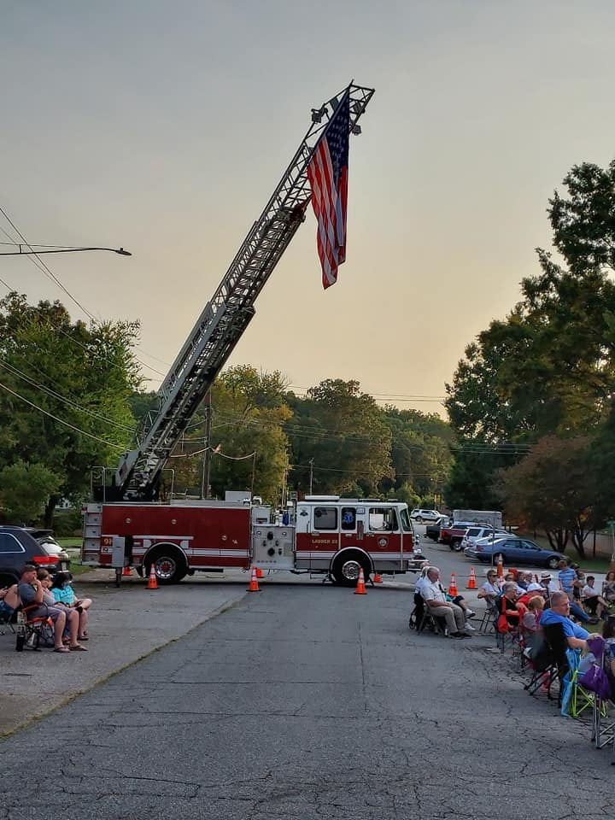
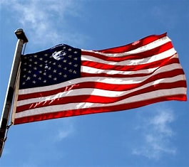
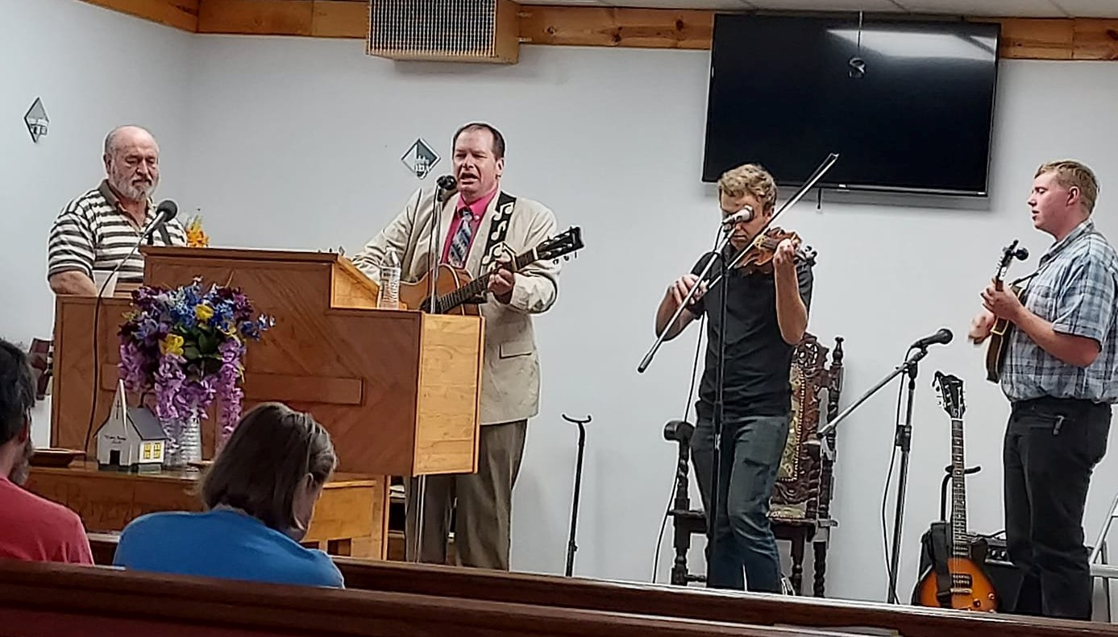
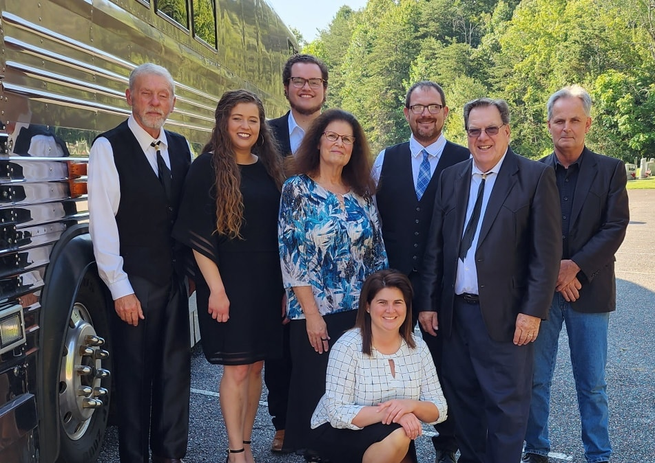
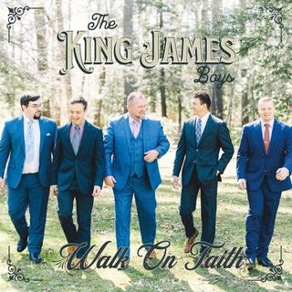
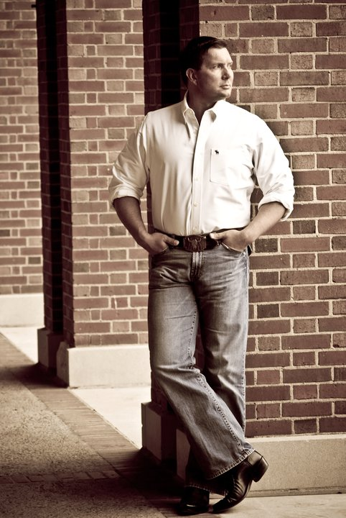
FOOD SALES - DONATIONS ACCEPTED
ALL PROCEEDS BENEFIT
COLUMBUS FIRE DEPT BENEVOLENT FUND
IN CASE OF RAIN, IT WILL BE HELD INSIDE FIRE DEPT.
CALL 828-817-3722 FOR INFO
SPONSORED BY:
SEW CLASSY, DON MINTZ BUILDERS
WATSONS FURNITURE, POLK SHERIFF’S OFFICE,
TRYON IGA, TRYON AUTO CARE,
& MCFARLAND FUNERAL HOME

