Ability/Disability Picture Books
Here are some of the picture books dealing with ability/disability that are in ETFO’s Social Justice Begins With Me kit.
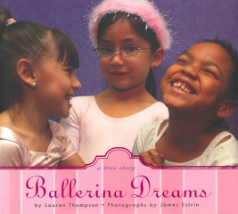 | Book Title: Ballerina Dreams  Author: Lauren Thompson  ISBN-13: 978-0312370299  Suggested Grade: JK/SK |  | 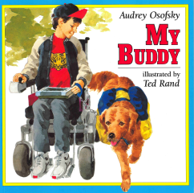 | Book Title: My Buddy  Author: Audrey Osofsky  ISBN-13: 978-0805017472  Suggested Grade: JK/SK
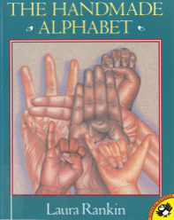 | Book Title: The Handmade Alphabet  Author: Laura Rankin  ISBN-13: 978-0590462396  Suggested Grade: JK/SK |  | 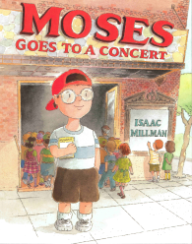 | Book Title: Moses Goes To A Concert  Author: Isaac Millman  ISBN-13: 978-0374453664  Suggested Grade: One
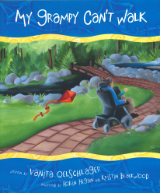 | Book Title: My Grampy Can’t Walk  Author: Vanita Oelschlager  ISBN-13: 978-1596240155  Suggested Grade: One |  | 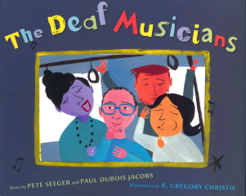 | Book Title: The Deaf Musicians  Author: Peter Seeger and Paul Dubois Jacobs  ISBN-13: 978-0399243165  Suggested Grade: One
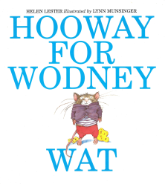 | Book Title: Hooway For Wodney Wat  Author: Helen Lester  ISBN-13: 978-0395923924  Suggested Grade: Two |  | 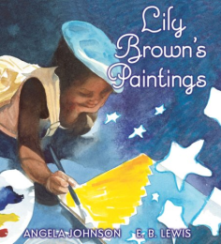 | Book Title: Lily Brown’s Paintings  Author: Angela Johnson  ISBN-13: 978-0439782258  Suggested Grade: Three
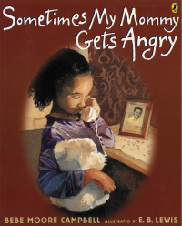 | Book Title: Sometimes My Mommy Gets Angry  Author: Bebe Moore Campbell  ISBN-13: 978-0142403594  Suggested Grade: Three |  | 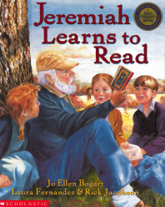 | Book Title: Jeremiah Learns to Read  Author: Jo Ellen Bogart  ISBN-13: 978-0531301906  Suggested Grade: Four

Ability/Disability Picture Books
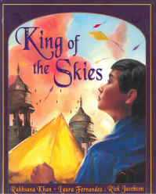 | Book Title: King of the Skies  Author: Rukhsana Khan  ISBN-13: 978-0439987257  Suggested Grade: Five |  | 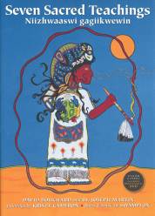 | Book Title: Seven Sacred Teachings: Niizhwaaswi gagiikwewin  Author: David Bouchard and Dr. Joseph Martin  ISBN-13: 978-0978432720  Suggested Grade: Five
 | Book Title: Sadako  Author: Eleanor Coerr  ISBN-13: 978-0698115880  Suggested Grade: Five |  | 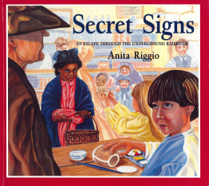 | Book Title: Secret Signs: An Escape Through The Underground Railroad  Author: Anita Riggio  ISBN-13: 978-1590780725  Suggested Grade: Five
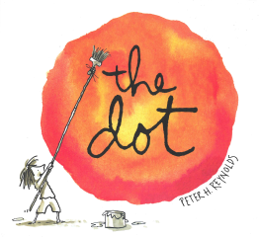 | Book Title: the dot  Author: Peter H.Reynolds  ISBN-13: 978-0763619619  Suggested Grade: Five |  | 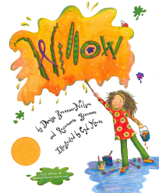 | Book Title: Willow  Author: Denise Brennan-Nelson and Rosemarie Brennan  ISBN-13: 978-1585363421  Suggested Grade: Five
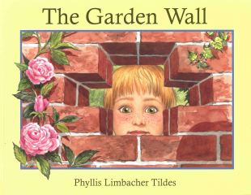 | Book Title: The Garden Wall  Author: Phyllis Limbacher Tildes  ISBN-13: 978-1570914683  Suggested Grade: Six |  | 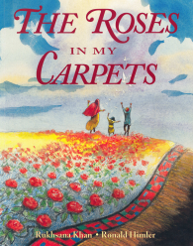 | Book Title: The Roses In My Carpets  Author: Rukhsana Khan  ISBN-13: 978-1550050691  Suggested Grade: Six
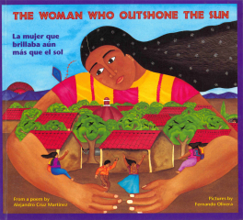 | Book Title: The Woman Who Outshone the Sun/La mujer que brillaba aún más que el sol  Author: Rosalma Zubizarreta, Harriet Rohmer, David Schecter  ISBN-13: 978-0892391264  Suggested Grade: Six |  | 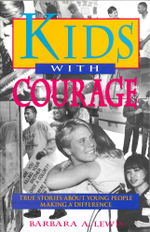 | Book Title: Kids With Courage: True Stories About Young People Making A Difference  Author: Barbara Lewis  ISBN-13: 978-0915793396  Suggested Grade: Six

Ability/Disability Picture Books
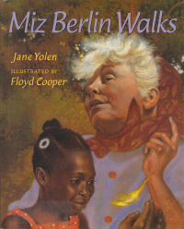 | Book Title: Miz Berlin Walks  Author: Jane Yolen  ISBN-13: 978-0329219871 Suggested Grade: Seven |  |  | Book Title: Teammates  Author: Peter Golenbock  ISBN-13: 978-0152006037  Suggested Grade: Seven
 | Book Title: Every Human Has Rights: A Photographic Declaration For Kids  Author: National Geographic Society  ISBN-13: 978-1426305108  Suggested Grade: Eight |  | 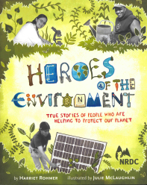 | Book Title: Heroes of the Environment: True Stories of People Who Are Helping to Protect Our Planet  Author: Harriet Rohmer  ISBN-13: 978-0811867795  Suggested Grade: Eight
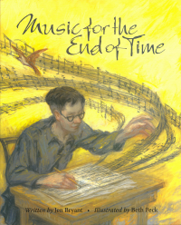 | Book Title: Music for the End of Time  Author: Jen Bryant  ISBN-13: 978-0802852298  Suggested Grade: Eight |  | 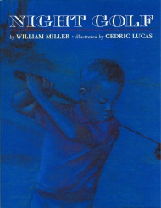 | Book Title: Night Golf  Author: William Miller  ISBN-13: 978-1880000793  Suggested Grade: Eight
Book Title: Terry Fox: His Story
Author: Leslie Scrivener
ISBN-13: 978-0771080197
Suggested Grade: Eight

