Human Rights Picture Books
Here are some of the picture books dealing with human rights that are in ETFO’s Social Justice Begins With Me kit.
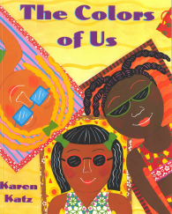 | Book Title: The Colors of Us  Author: Karen Katz  ISBN-13: 978-0805058642  Suggested Grade: JK/SK |  | 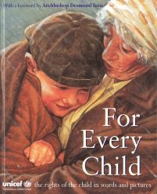 | Book Title: For Every Child:  the rights of the child in words  and pictures  Author: UNICEF  ISBN-13: 978-0091768157  Suggested Grade: JK/SK
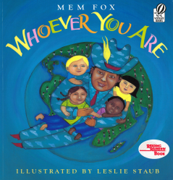 | Book Title: Whoever You Are  Author: Mem Fox  ISBN-13: 978-0152007874  Suggested Grade: JK/SK |  | 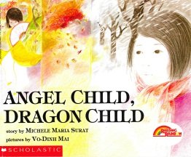 | Book Title: Angel Child, Dragon Child  Author: Michele Maria Surat  ISBN-13: 978-0590422710  Suggested Grade: One
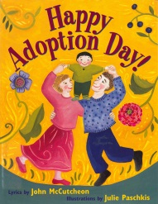 | Book Title: Happy Adoption Day!  Author: John McCutcheon  ISBN-13: 978-0316554558  Suggested Grade: One |  | 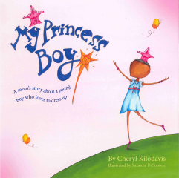 | Book Title: My Princess Boy  Author: Cheryl Kilodavis  ISBN-13: 978-1442429888  Suggested Grade: One
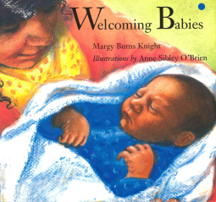 | Book Title: Welcoming Babies  Author: Margy Burns Knight  ISBN-13: 978-0884481232  Suggested Grade: One |  | 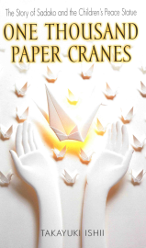 | Book Title: One Thousand Paper Cranes: The Story of Sadako and the Children’s Peace Statue  Author: Ishii Takayuki  ISBN-13: 978-0440228431  Suggested Grade: Two
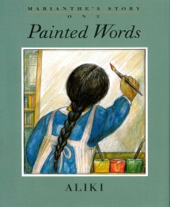 | Book Title: Painted Words/Spoken Memories  Author: Aliki (Brandenberg)  ISBN-13: 978-0688156619  Suggested Grade: Two |  | 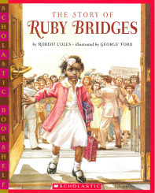 | Book Title: The Story of Ruby Bridges  Author: Robert Coles  ISBN-13: 978-0439472265  Suggested Grade: Two

Human Rights Picture Books
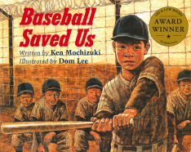 | Book Title: Baseball Saved Us  Author: Ken Mochizuki  ISBN-13: 978-1880000199  Suggested Grade: Three |  | 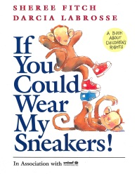 | Book Title: If You Could Wear My Sneakers!  Author: Sheree Fitch  ISBN-13: 978-0385255974  Suggested Grade: Three
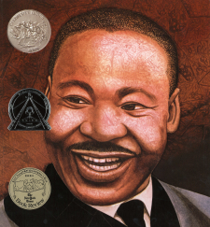 | Book Title: Martin’s Big Words  Author: Doreen Rappaport  ISBN-13: 978-1423106357  Suggested Grade: Three |  | 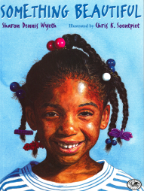 | Book Title: Something Beautiful  Author: Sharon Dennis Wyeth  ISBN-13: 978-0385322393  Suggested Grade: Three
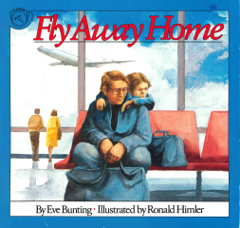 | Book Title: Fly Away Home  Author: Eve Bunting  ISBN-13: 978-0395559628  Suggested Grade: Four |  | 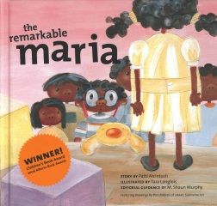 | Book Title: the remarkable maria  Author: Patti McIntosh  ISBN-13: 978-0973933208  Suggested Grade: Four
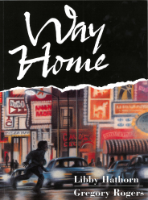 | Book Title: Way Home  Author: Libby Hathorn  ISBN-13: 978-1842702321  Suggested Grade: Four |  | 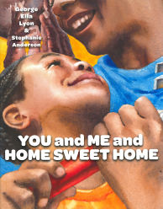 | Book Title: You and Me and Home Sweet Home  Author: George Ella Lyon  ISBN-13: 978-0689875892  Suggested Grade: Four
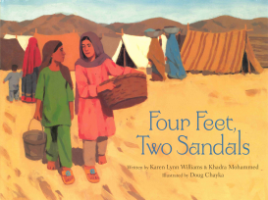 | Book Title: Four Feet, Two Sandals  Author: Karen Lynn Williams and Khadra Mohammed  ISBN-13: 978-0802852960  Suggested Grade: Five |  | 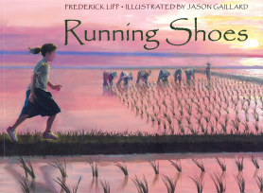 | Book Title: Running Shoes  Author: Frederick Lipp  ISBN-13: 978-1580891752  Suggested Grade: Five

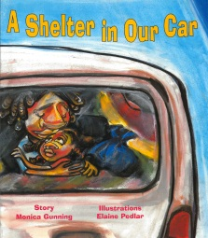 | Book Title: A Shelter in Our Car  Author: Monica Gunning  ISBN-13: 978-0892391899  Suggested Grade: Five |  | 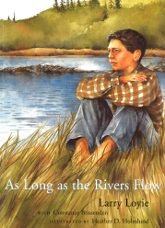 | Book Title: As Long as the Rivers Flow  Author: Larry Loyie with Constance Brissenden  ISBN-13: 978-0888994738  Suggested Grade: Six
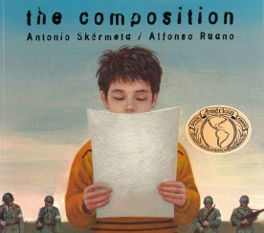 | Book Title: the composition  Author: Antonio Skármeta  ISBN-13: 978-0888993908  Suggested Grade: Six |  | 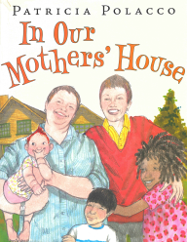 | Book Title: In Our Mothers’ House  Author: Patricia Polacco  ISBN-13: 978-0399250767  Suggested Grade: Six
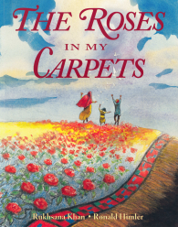 | Book Title: The Roses In My Carpets  Author: Rukhsana Khan  ISBN-13: 978-1550050691  Suggested Grade: Six |  | 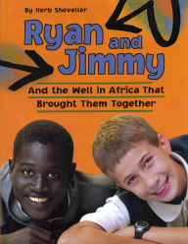 | Book Title: Ryan and Jimmy: And the Well in Africa That Brought Them Together  Author: Herb Shoveller  ISBN-13: 978-1553379676  Suggested Grade: Six
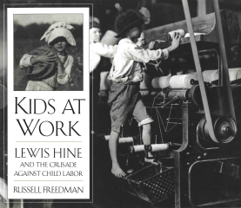 | Book Title: Kids At Work: Lewis Hine And The Crusade Against Child Labor  Author: Russell Freedman  ISBN-13: 978-0395587034  Suggested Grade: Seven |  | 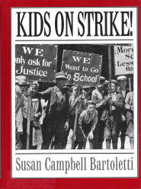 | Book Title: Kids On Strike!  Author: Susan Campbell Bartoletti  ISBN-13: 978-0395888926  Suggested Grade: Seven
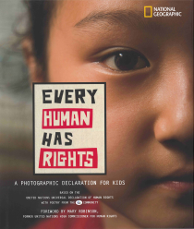 | Book Title: Every Human Has Rights: A Photographic Declaration For Kids  Author: National Geographic Society  ISBN-13: 978-1426305108  Suggested Grade: Eight |  | 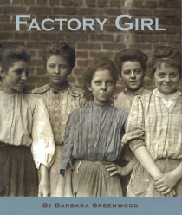 | Book Title: Factory Girl  Author: Barbara Greenwood  ISBN-13: 978-1553376484  Suggested Grade: Eight
Human Rights Picture Books

Human Rights Picture Books
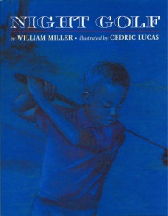 | Book Title: Night Golf  Author: William Miller  ISBN-13: 978-1880000793  Suggested Grade: Eight

