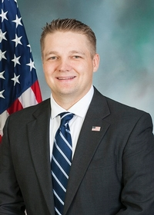
Pennsylvania State Representative
Aaron Bernstine (R)

District 8 News Center
(Formerly District 10)

Ballotpedia

The Representative is not on the State Government Committee.

The Representative made the following negative official actions:
- Signed the letter to object to the Electoral College votes
- Joined Texas Amicus Brief

The Representative has the following negative public positions:

The Representative claimed that former President was not responsible for January 6th Facebook, Facebook

12/31/2020: There are literally HUNDREDS of letters asking for asking for investigation into election fraud. I have signed on to several. Facebook

One thing is certain about the integrity of the process in Pennsylvania for the most recent election; there are too many questions and not enough answers. Therefore, I have joined many members of the General Assembly in urging the United States Congress to declare the selection of presidential electors in this Commonwealth to be in dispute. Facebook

Bernstine cited restoring election integrity as a top priority, recently winning a lawsuit that asked the court to strike down Act 77 and rule no-excuse mail-in voting unconstitutional. New Castle News (The PA Supreme Court overturned the Act 77 decision)

The Representative has made the following positive public positions:

A few minutes ago, Joe Biden was sworn in as President. I did not vote for him and I campaigned hard for President Trump. That being said, I wish him well in taking on the most difficult job in the world.
I will do everything in my power to work with the President and his administration to help our area. That has been, and always be, my only priority. Facebook

Notes:

The Representative is not a co-sponsor of HB 1369 (Open Primaries). No public statements on this legislation have been found.

No public statements were found from the Representative on Ranked Choice Voting.

The Representative faced calls to resign after video surfaced showing him telling his 5-year-old son how to smoke a cigar as well as engaging another child in an adult social media game. New Castle News

