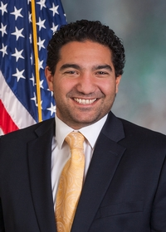
Pennsylva nia State Representative
Joshua D. Kail (R)

District 15 News Center

Ballotpedia Campaign Website

The Representative is not on the State Government Committee.

The Representative made the following negative official actions:
- Joined the Texas Amicus Brief

The Representative has the following negative public positions:

The Representative has provided support for the position that our election system is not trustworthy. https://www.repkail.com/News/19976/Latest-News/Kail-Applauds-Passage-of-Election-Reform-Bill-

The Representative has made the following positive public positions:
- Voted for Act 77

1/6/2021
There is no place for violence. I fully agree with our leadership’s statement. Let’s pray for our country. https://www.facebook.com/RepKail/posts/pfbid0mCVduzwfrwSs28REtb5aCwruZEV2k4Cwa84S9sB7qggfiKNfvrkVawmi1nCcXBWQl

Notes:

The Representative is not a co-sponsor of HB 1369 (Open Primaries). No public statements on this legislation have been found.

No public statements were found from the Representative on Ranked Choice Voting.

In the primary, the Representative ran unopposed. There were no listed candidates on the Democratic side, either. https://www.timesonline.com/story/news/2022/05/17/beaver-county-2022-republican-democratic-primary-election-results-today/65355350007/

The Representative supports voter ID.

