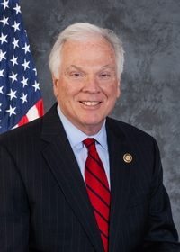
Pennsylvania State Representative
Timothy R. Bonner (R)

District 17 (Formerly District 8) News Center

Ballotpedia

The Representative is not on the State Government Committee.

The Representative made the following negative official actions:
- Joined the Texas Amicus Brief

The Representative is one of the lawmakers who brought the suit to overturn Act 77 (mail in voting). https://www.spotlightpa.org/news/2022/08/pa-mail-voting-law-uphelp-state-supreme-court/

The Representative has the following negative public positions:

He has also challenged the constitutionality of Act 77, which allows “no excuse” mail-in and absentee voting in Pennsylvania. Residents should vote at the polls unless they are physically unable to cast a ballot in person, he said. https://www.alliednews.com/news/bonner-seeks-another-house-term/article_5a38f2ae-a07e-11ec-b392-87ed19a94900.html

The Representative has made the following positive public positions:

“Tragically, this lawful process of delegate certification was interrupted by a riotous mob intent on disrupting the rule of law as they committed numerous criminal acts as part of their unlawful and violent protest of the election process. In a nation whose foundation is built upon the rule of law, this action is unacceptable and cannot go unpunished. News Center

However, despite speculation to the contrary, the General Assembly does not have the legal authority to set aside the election results nor substitute its preferred list of Electoral College delegates for those delegates which have already been submitted by the two presidential candidates…If the alleged irregularities are not accurate or are proven to be correct but insufficient to overturn the results of this election at the end of the audit and/or the court review, we must then recognize and encourage our next president of the United States as he will have been chosen in accord with law. May God Bless America and our next president of the United States. Newsletter

Notes:

The Representative is not a co-sponsor of HB 1369 (Open Primaries). No public statements on this legislation have been found.

No public statements were found from the Representative on Ranked Choice Voting.

The candidate is running unopposed.

