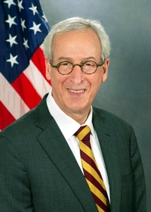
Pennsylvania State Representative
Dan Frankel (D)

District 23 News Center

Ballotpedia

The Representative is not on the State Government Committee.

The Representative made the following negative official actions:
- None

The Representative has the following negative public positions:
- The Representative does not have any negative public positions.

The Representative has made the following positive public positions:
- Voted for Act 77

Drop Boxes are only a problem if you think obstructing voters will improve your chances. https://www.facebook.com/RepDanFrankel/posts/pfbid0fiN6wA7yquhH2fDmjW5fWy1wVqQ4JVmDSxu5QQAebtDRxQASH81WShLHebmuLRfRl

✅Same-Day Registration (HB 1053)
✅ Early in-person voting (HB 2217)
✅ Automatic voter registration (HB 205)
✅ Pre-canvassing (HB 2090)
Pennsylvania, it's not the Democrats that are stalling your voting rights; it's the GOP. https://www.facebook.com/RepDanFrankel/posts/pfbid0TRmY8kUYEN7LZCvoxgfGbANbzGqZFboUhdFNdqkLD7uvo4fDk71vDiiMH5Kj1MtEl

Notes:

The Representative is not a co-sponsor of HB 1369 (Open Primaries). No public statements on this legislation have been found.

No public statements were found from the Representative on Ranked Choice Voting.

The Representative has sponsored legislation in the past that would add Pennsylvania to national popular vote interstate compact. https://www.pahouse.com/Frankel/InTheNews/NewsRelease/?id=80145

When talking of the voting bills he supports, the Representative far too often includes an unnecessary criticism of the Republicans. Attacking the other party makes it harder to convince them to vote for these proposals.

