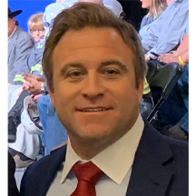
Candidate for
Pennsylvania State Representative
Ted Tomson (Theodor A. Tomson, II) (R)

District 33 Campaign Website

Ballotpedia

The Representative has the following negative public positions:

I support the maintaining of the integrity of the election process and that we need to discuss appropriate and fair ways that we can uphold a standard where everyone feels confident in its results. Losing faith in our election process is one of the biggest detriments democracy could suffer. As your state representative I will work for reasonable policies that deliver results in a timely matter.

The Candidate made the following positive public positions:
- None

Notes:

The candidate has made no public statements on open primaries have been found.

No public statements were found from the candidate on Ranked Choice Voting.

