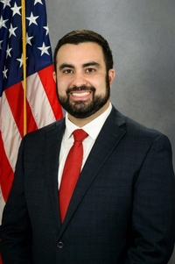
Pennsylvania State Representative
Nick Pisciottano (D)

District 38 News Center

Ballotpedia

The Representative is not on the State Government Committee.

The Representative made the following negative official actions:
- None

The Representative has the following negative public positions:
- The Representative does not have any negative public positions.

The Representative has made the following positive public positions:

4/28/2021
“Pennsylvanians deserve a fair and open redistricting process free from political processes designed to punish or discriminate against a particular legislator or political party, and ensure accountability,” said Pisciottano. “I support Fair Districts PA’s efforts to see this legislation move forward and signed into law. Residents are tired of extreme partisan actions as it relates to their legislators and this measure is certainly a step in the right direction.” https://www.pahouse.com/pisciottano/InTheNews/NewsRelease/?id=119508

1/20/2021
Congratulations to President Biden, a native son of Pennsylvania, on his inauguration today. He takes office during one of the most challenging times in the history of our nation. https://www.facebook.com/RepPisciottano/posts/pfbid02DBFtKwjKk8wVmPZYH4ALWwuc4XEYUChQfBvok4Z45G8EkcMt1YqaLcFr3aaVPkWml

Notes:

The Representative is not a co-sponsor of HB 1369 (Open Primaries). No public statements on this legislation have been found.

No public statements were found from the Representative on Ranked Choice Voting.

After January of 2021, the lack of public positions from the Representative on issues of democracy has been striking. Although the Representative condemned the attack on January 6th, the condemnations were on social media without a follow-up press release.

