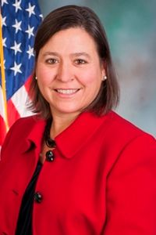
Pennsylvania State Representative Valerie Gaydos (R)

District 44 News Center

Ballotpedia

The Representative is not on the State Government Committee.

The Representative made the following negative official actions:
- Joined the Texas Amicus Brief
- Joined Congressmen Kelly’s Electors Lawsuit.

The Representative has made the following negative public positions:

Gaydos and Puskaric, both of whom voted for Act 77 in 2019, told PublicSource in late November that they now favor abolishing no-excuse mail-in balloting…She said having mail-in voting and more steps in the process makes the system more prone to errors. She also said she has voted by absentee ballot in the past while traveling for business. https://www.publicsource.org/trump-politicized-mail-in-voting-in-2020-pa-republicans-supported-it-originally/

The Representative has made the following positive public positions:
“It is truly a dark day in American history when dissent turns to destruction. I condemn the criminal acts that took place yesterday. What should have been about meaningful debate, peaceful protest and the Rule of Law turned into chaos, coups and death. I pray for a restoration of peace.
“We are supposed to be civil human beings who look after each other. The actions that took place at the Capitol are unacceptable. Being destructive is not going to do anything except make the divide greater.
“As citizens, we must remain undeterred in our efforts to settle our disagreements the American way — through civil public debates and other legal processes and procedures that are afforded to us stated in the Constitution. However, violence, threats, property damage and bodily harm are unacceptable. Those responsible must be identified and prosecuted to the fullest extent the law allows.
“Election reform is needed to address the many issues that have arisen. People deserve a system that is accountable and transparent. I will always work within my constitutional authority to do this. I will not condone the immoral and disrespectful behaviors taken against our democracy yesterday.” https://www.repgaydos.com/News/18868/Press-Releases/Gaydos-Says-Chaos,-Violence-and-Bloodshed-Must-Stop-NOW
Notes:
The Representative is not a co-sponsor of HB 1369 (Open Primaries). No public statements on this legislation have been found.

No public statements were found from the Representative on Ranked Choice Voting.

