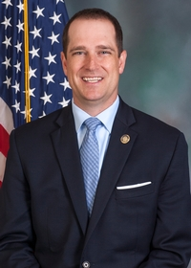
Pennsylvania State Representative
Ryan Warner (R)

District 52 News Center

Ballotpedia

The Representative is not on the State Government Committee.

The Representative made the following negative official actions:
- Joined the Texas Amicus Brief
- Joined House Resolution 1094

The Representative has the following negative public positions:

There’s an open investigation here in Fayette County regarding people who received mail-in ballots already marked for Joe Biden. There were military ballots from Luzerne County found in the trash. Thousands of people received duplicate mail-in ballots while others got them despite never having applied for them. These are very real concerns that must be addressed. https://www.repwarner.com/News/18612/Latest-News/Warner-Supports-Resolution-Calling-for-Election-Audit

The Representative has made the following positive public positions:
• Voted for Act 77

Working to ensure the state’s elections run smoothly, legislation authored by Rep. Ryan Warner (R-Fayette/Westmoreland) to ensure voting precincts across the Commonwealth have enough ballots to accommodate in-person voters has been signed into law. https://www.repwarner.com/News/31110/Latest-News/Warner-Bill-to-Prevent-Election-Day-Ballot-Shortages-Now-Law-

Notes:

The Representative is not a co-sponsor of HB 1369 (Open Primaries). No public statements on this legislation have been found.

No public statements were found from the Representative on Ranked Choice Voting.

At the time of researching this scorecard, the representative’s social media had issues that prevented viewing. Only his personal facebook page was viewable.

