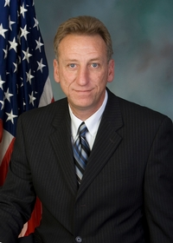
Pennsylvania State Representative
George Dunbar (R)

District 56 News Center

Ballotpedia

The Representative is not on the State Government Committee.

The Representative made the following negative official actions:
- Signed Letter to Object to the Electoral College Votes

The Representative has the following negative public positions:

The Representative supported HB 1300, which was drafted in large part due to the former President’s lose in the 2020 election. He voiced his support on Facebook.

Dunbar defended his original support for Act 77 but said the law he supported was far different from how Gov. Tom Wolf and his administration interpreted the legislation. Dunbar said he now wants to amend the election reform to include more stringent voter identification requirements, signature verification on mail ballots and the elimination of drop boxes. https://triblive.com/local/westmoreland/dunbar-faces-primary-challenge-for-state-house-seat-in-westmoreland/

The Representative has made the following positive public positions:
- Voted for Act 77

“I think there were issues, but I don’t think either side can say the election was stolen. The governor’s administration did some things that were outright illegal, but it didn’t change the results,” https://triblive.com/local/westmoreland/dunbar-faces-primary-challenge-for-state-house-seat-in-westmoreland/

Notes:

The Representative is not a co-sponsor of HB 1369 (Open Primaries). No public statements on this legislation have been found.

No public statements were found from the Representative on Ranked Choice Voting.

The Candidate is running unopposed.

