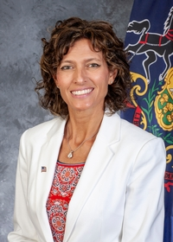
Pennsylvania State Representative
Leslie Rossi (R)

District 59 News Center

Ballotpedia

The Representative is not on the State Government Committee.

The Representative made the following negative official actions:

Although not in office yet, the Representative supported the attempts to overturn the election, including the letters to object to the Electoral College Votes. Facebook

Supported Congressman Mike Kelly’s lawsuit. Facebook

The Representative has the following negative public positions:

1/21/2021: We must demand Election Integrity and the full repeal of Act 77 as we continue to stand strong for the Trump policies to MAGA. Facebook

Prior to taking office, the Representative shared elections lies on Facebook.

12/16/2020: Biden did not win this election! Facebook

12/11/2020: Biden & His running mate did NOTHING to earn all the things they are being handed right now. They can have their COVER (did they even campaign) but they can not take our votes nor will we stand by and just accept the dumps that occurred in the middle of the night along with all the other bullshit the left expects us to believe that isn’t statistically even possible. We will not take it and our STATES are the hero’s of this nation! Facebook

“I feel, and will always feel, that he won and by a lot in our state. When we went to bed, he was winning by such a wide margin that I didn’t have a slightest concern, and then I woke up in the morning like everyone else to see that had flipped in every swing state after they stopped counting,” https://triblive.com/local/westmoreland/trump-house-creator-leslie-baum-rossi-seeks-nod-to-run-for-open-state-house-seat/

The Representative has made the following positive public positions:
- None

Notes:
The Representative is not a co-sponsor of HB 1369 (Open Primaries). No public statements on this legislation have been found.

No public statements were found from the Representative on Ranked Choice Voting.

The Representative created Trump House. https://globalnews.ca/news/6301879/pennsylvania-trump-house-owner/

