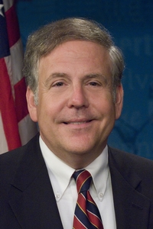
Pennsylvania State Representative
Robert Freeman (D)

District 136 News Center

Ballotpedia

The Representative is not on the State Government Committee.

The Representative is on the House Local Government Committee.

The Representative made the following negative official actions:
- Voted against Act 77 (mail in ballots)

The Representative has the following negative public positions:
- None

The Representative has made the following positive public positions:

Elections You Can Trust- “Pennsylvanians can only have faith in their government if they have faith in the system that elects our federal, state and local leaders. To help restore that faith, the new state budget ELIMINATES any use of third-party funding for the administration of elections. Instead, the budget provides $45 million for election integrity and administration.” Facebook

Notes:

The Representative is not a co-sponsor of HB 1369 (Open Primaries).

The Representative is a co-sponsor of HB-2042 (Ranked Choice Voting).

Voted No for SB 106 – Establishes a Constitutional Amendment that States there is No Right to Taxpayer Funded Abortion and Amends Voter ID Laws. Just Facts

Freeman seeks to prevent majority from avoiding debate on important topics PA House

