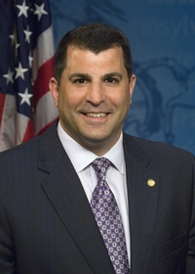
Pennsylvania State Representative
Mark Rozzi (I)

District 126 News Center

Ballotpedia

The Representative is the Speaker of the House.

The Representative made the following negative official actions:
- Voted against Act 77 establishing mail-in voting

The Representative has the following negative public positions:

- None

The Representative has made the following positive public positions:

Upon becoming Speaker of the House, the Representative stated that he would no longer caucus with the Democratic Party & declared himself an independent. Spotlight PA

The Representative has supported legislation in the past for Ranked Choice Voting. PA HB 2042

The Representative was a co-sponsor of the bill to create Open Primaries in the last session. HB 1369

Now, more than ever, we must ensure that we uphold the freedoms guaranteed in our state and nation’s constitution. In these unprecedented times, the voters must have the final say, not the candidates or their lawyers. “Virtue, liberty and independence” is our state motto and we must uphold the highest moral standard to ensure liberty and independence persist for all. News Center

Notes:

Beyond honored to be chosen by my colleagues to serve as the next Speaker of the Pennsylvania House of Representatives -- I pledge to work for ALL people, not just a political party. Facebook

