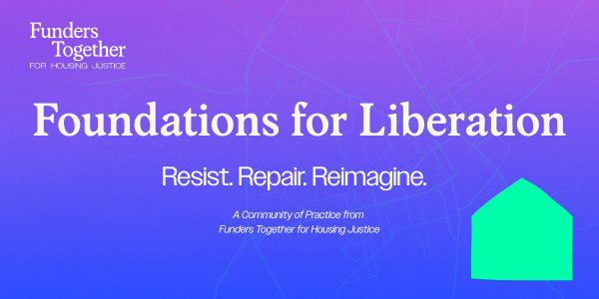

Application Questions
Use this document to draft your responses to the Foundations for Liberation (FfL) application form, but submit your answers via the online form itself: https://forms.office.com/r/7CYUHypGYV

*indicates required field

- Key contact person:
  - Name*
  - Pronouns*
  - Email address*
  - Cell phone (for optional Signal group)
  - Job title*
  - Where are you located?*
  - What is your race/ethnicity?
  - What is your gender?
  - Please list any other identities you’d like to share with us
- Do you have an additional representative?
  - Yes
  - No
If “yes”…
- Additional representative information:
  - Name*
  - Pronouns*
  - Email address*
  - Cell phone (for optional Signal group)
  - Job title*
  - Where are you located?*
  - What is your race/ethnicity?
  - What is your gender?
  - Please list any other identities you’d like to share with us
If “no” to additional representative question…
- Funders Together believes that your learning and accountability will be enhanced through peer support, i.e., a buddy system. If you are the only representative from your own organization, do you have a colleague in mind at another grantmaking/philanthropic organization who also intends to apply?
  - Yes
    - If “yes”… Name, organization, and email of potential buddy:
  - No, but I’d like to be paired with someone in the cohort
  - Other:

Organizational Information
- Applicant organization*
- Headquarters city, state*
- What type of grantmaking institution is this?* (e.g., family foundation, intermediary, funder collaborative, healthcare conversion, corporate foundation, PSO/PIO, United Way, etc..) [open field]
- Is your organization a member of Funders Together?*
  - Yes
  - No, and I’m not interested in membership at this time
  - No, but I’m interested in learning more about membership
  - Unsure
- Has your organization participated in either of the previous Communities of Practice hosted by Funders Together, then known as Foundations for Racial Equity?*
  - Yes
  - No
  - Unsure
- What is your grantmaking budget on housing justice/homelessness?* (These categories help us determine your registration fee, but Funders Together recognizes that your portfolios may not break down so easily; please use your best judgment and know that we can negotiate as needed.)
  - Less than $1 million
  - More than $1million
  - NA: we don’t do grantmaking
- What appeals to you about Foundations for Liberation? What stood out from the announcement?*
- What does your organization stand to gain from participation?*
- What is your organization (and/or you personally) positioned to contribute to our collective learning?*
- At the conclusion of the Community of Practice, what do you imagine would have made it worthwhile?*
- Funders Together seeks sponsorships to support in-person convenings, guest speaker honoraria, and to offer discounts to less-resourced participants. Is your foundation open to a conversation about additional financial support?*
  - Yes
  - No
  - Other
- The community of practice will include three in-person convenings. Are you open to a conversation about hosting an in-person gathering in your city?*
  - Yes
  - No
  - Other
- Please add any additional comments or questions in the space below.
- By submitting this application, you certify that your senior leadership has endorsed your participation, is prepared for the accompanying expenses, and embraces the prospect of making internal and/or external changes toward liberation. You commit to the expectations of participation, including prioritizing attendance at every meeting (barring emergencies), being emotionally present, completing “homework” between sessions, reflecting on your personal responsibilities for racial justice and liberation according to your identities and lived experiences, and contributing to and abiding by the behavioral norms agreed upon by the group.*
  - I agree

