PROOFED!
Subject: Democrat Playbook: Pack the Supreme Court, Shred the 2A!
Deployment: 11-12-2025 at 11:00am

Video Link: https://x.com/RealAaronDorr/status/1988605731931922749?s=20
Aaron’ X Link: https://x.com/RealAaronDorr
Renewal Link: https://action.iowagunowners.org/2026renewal_em

Dear First,
Anyone with a pulse can feel our country whipsawing back and forth these days, as our country tries to heal from four years of horrific abuse at the hands of Joe Biden’s auto-pen.
The crime plaguing our cities.
The foreigners that are changing entire states.
The fiscal policies that harmed so many people.
And, of course, we’re working to roll back the damage Biden did to our gun rights in the form of Executive Orders, court actions, congressional actions and more.
The Democrats are seething now, as you and I were seething under Biden. But it’s critical to understand that this whipsaw effect is going to get much worse in the years ahead.
That’s why I am writing you today, to make absolutely certain gun owners know what will happen the next time the Democrats take power -- which could happen in just three years.
It’ll be everything you can think of: gun control, foreign nationals flooding our country, an explosion of violent crime, tax hikes, debauchery in our schools, it’s a long list.
But worst of all may be the Democrat’s plan to override the American people and pack the United States Supreme Court with 4 additional justices, giving them majority control of the court!
Don’t take my word for it, listen to James Carville, a long-time Democratic strategist openly bragging about it below.

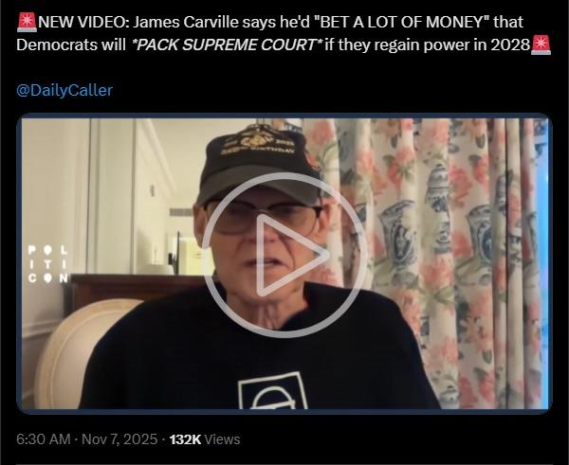

(Feel free to follow me on X, too, after you watch this clip.)
And Carville is far from the only person calling for this. House Minority Leader Hakeem Jefferies wants to pass this. AOC wants to pass this. The entire Obama Machine is pushing for this.
Heck, the bills have ALREADY been filed in Congress!
All it takes is a simple majority vote in Congress plus the President’s signature and the court will go from 9 to 13!
This Democrat-run Supreme Court will approve a national ban on AR-15s, magazines that hold over 10-rounds, a national gun registry, national ‘Red Flag’ law, and much more.
If there is anything you need to buy to prepare yourself, your children, maybe your grandchildren...buy it now while you can.
Prices are at rock bottom right now on rifles, ammo, mags, etc.
Stock up!
In the meantime, Iowa Gun Owners is working to secure as much Second Amendment freedom as possible in Des Moines.
We need to throw up a fence around our state, and I hope that you’ll continue to help us do that. If you haven’t renewed your membership for 2026, now is the time. Stand with us.

For Iowa,

Aaron Dorr
Chairman
Iowa Gun Owners

