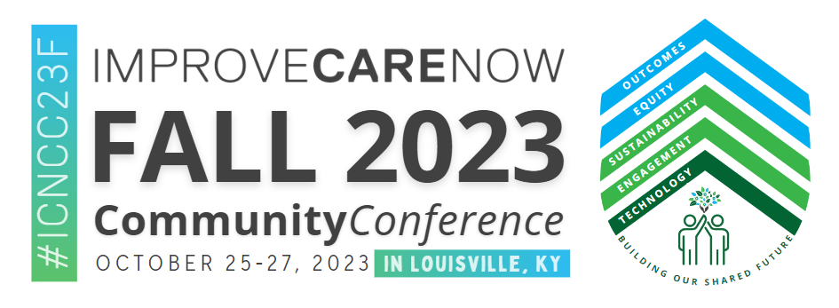
To: <Supervisor / Division Leader name >
From: <your name>
Date: <insert date>
I am most interested in attending the pediatric IBD focused ImproveCareNow Fall Community Conference. The conference will be held October 25-27 in Louisville, KY.
The learning event fosters an environment enhancing professional and personal growth while providing a forum to share updates in research related to improving outcomes in the pediatric inflammatory bowel disease field.
During this conference, I will:
- Learn best practices that enhance patient experience, quality care, cost reduction, and promote outcomes for our patients and their families and care providers.
- Collaborate with others in the pediatric Inflammatory Bowel Disease field and accordingly grow my professional network.
- Enhance my quality improvement skills enabling me to test and implement the changes I discover
- Create a professional development plan through networking and participation in educational sessions.

The variety of educational topics would allow me to attend several sessions directly applicable to my work on <unit goals/best practices you are working on>. The sessions are led by respected leaders in pediatric gastroenterology and will enhance my knowledge of research, evidence-based practice, and hot topics in pediatric inflammatory bowel disease. Furthermore, the sessions will enable me to see evidence-based initiatives at other hospitals and to speak directly with physicians, nurses and other health care providers involved in their implementation. Additionally, I will have the opportunity to learn from my peers in a role specific breakout exclusively for <role at care center>
This education will provide me with continuing nursing / medical education contact hours that I can apply towards renewing my license and my <insert other advanced certifications requiring contact hours for renewal>.
[For Physicians only] In addition, conference participation will enable me to apply for approximately 10 American Board of Pediatrics Lifelong Learning and Self-Assessment (Part 2) Maintenance of Certification points.
I am seeking <hospital’s name> sponsorship for the registration fee, travel, onsite lodging and meal expenses during the conference. The detailed cost breakdown, including travel and other expenses are listed below.
Airfare: <add flight expenses>
Ground Transportation: <add estimate>
Hotel: <add total hotel estimate (ImproveCareNow rate of $208+ tax per night)>
Meals: <add meal estimate or per diem rate during travel [meals during the conference are included]>
ImproveCareNow Registration Fee: $825
Total conference cost: <Insert sum of amounts noted above>
The opportunity for me to develop better contacts with fellow clinicians, learn emerging trends, and gain knowledge in specific areas of <medical areas of interest> makes my attendance at the ImproveCareNow Community Conference a wise professional investment, which could result in streamlined practices, insights, and an enhanced network of peers to call upon when faced with an unusual or difficult case.
I will submit a post-conference report that includes a summary, major takeaway concepts, techniques or tips, and action items for each of the sessions that I attend during the conference. In addition, I will be happy to circulate the conference proceedings and provide brief presentations to others within the <care center>.
I look forward to your reply. For more information about the Fall ImproveCareNow Community Conference, you can click here. For more information about ImproveCareNow please visit www.improvecarenow.org.
Sincerely,
<insert your name>

