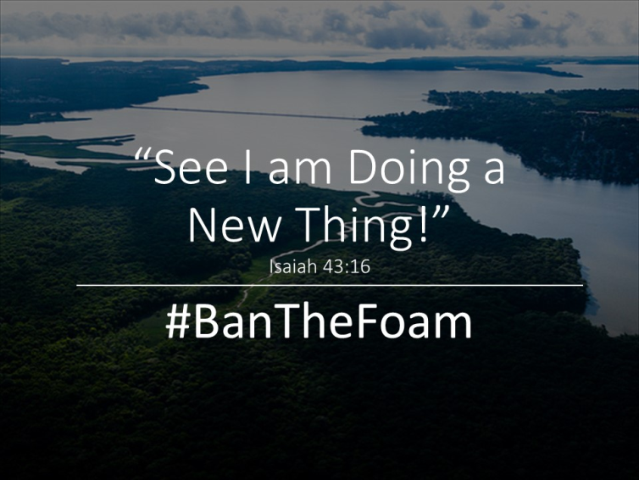

Dear Members of the Maryland House and Senate,

Congregations throughout our region have already stopped using Styrofoam cups and plates at our places of worship because it is the right thing to do.

We understand you are considering a bill that would ban the sale and production of polystyrene food containers in Maryland. We thought you might be interested to know that our institutions have already stopped using such products at our events where food is served in an effort to reduce our footprint on the Earth.

As people of faith, we are called to continually renew ourselves, improve our behaviors, and be open to new ways of doing things that are more mindful of future generations. When Styrofoam food containers are discarded, they do not always make it into a garbage can. Such strewn trash becomes an eyesore in our woods, fields, streams and streets. This non-biodegradable material persists indefinitely in the environment and accumulates over time. Styrofoam never breaks down, but breaks up into increasingly small particles that fish and wildlife mistake for food. This bioaccumulation of toxicity is a risk to the food chain.
That is why we have already taken the necessary steps to stop using such products at our churches, synagogues, and temples. We feel it is our moral duty to protect the Earth and restore clean water for tomorrow’s children.
Sincerely, the members of

