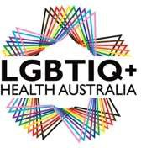
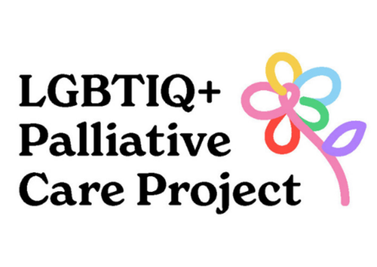
Request for Tender
National Palliative Care Project
LGBTIQ+ Health Australia

Project title | National Palliative Care Project
Summary | Inviting responses to this request for tender (RFT) from educational design consultants/services and/or  creative design agencies for the provision of videography (storytelling/ social documentary), animation or audio stories.
Response due | 16/05/22
Contact Person | Please note that all communication about this RFT, and the response should be submitted to:  Hannah Morgan  Palliative Care Coordinator  E: hannah.morgan@lgbtiqhealth.org.au  M: 0433 690 612

About LGBTIQ+ Health Australia

LGBTIQ+ Health Australia (LHA) is the national peak health organisation in Australia for organisations and individuals that provide health-related programs, services and research focused on lesbian, gay, bisexual, transgender, intersex and queer (LGBTIQ+) people and other sexuality, gender, and bodily diverse people and communities. LHA’s mission is to provide a national focus to improve health outcomes for LGBTIQ+ people through policy, advocacy, representation, research evidence and capacity building.

Project Overview

The Department of Health has funded LHA to deliver a three-year project that aims to build the capacity of the palliative care sector to provide inclusive services to LGBTIQ+ people accessing palliative and end-of-life care. This will be achieved through research, training (eLearning for health professionals) and development of Community of Practice groups.

Aim

LHA are developing eLearning for health care professionals with the primary audience being nurses and general practitioners. A co-design team consisting of LGBTIQ+ health care professionals and LGBTIQ+ community members with lived experience has been established to assist in the design of the e-modules.

Objectives of the project

Work in collaboration with LHA’s project team as well as the palliative care co-design team to develop eLearning for health care professionals. The eLearning modules may include topics such as:

LGBTIQ+ communities | LGBTIQ+ experiences in health care settings | Barriers and facilitating factors of LGBTIQ+ communities in palliative and end-of-life care
Chosen family, carers and community supports | Inclusive language in palliative/ end-of-life health care settings | Advanced care planning and legal issues
Grief and bereavement | Spiritual/ religious and non-religious supports at end-of -life | Resources and referral pathways

And/or

Develop audio-visual content for the eLearning modules. This may include videography (storytelling/ social documentary), animation or audio stories.

Key deliverables

Educational design

- Develop and design a suite of eLearning modules on LGBTIQ+ palliative and end-of-life care.
- Work with subject matter experts (project and co-design team) to write and develop content for each module.
- Ensure that disability accessibility needs are incorporated in the design of the platform and eLearning content.
- Work in collaboration with creative design consultants – either internal or external to your organisation.
- Scope/ advise on suitable Learning Management System (LMS).
- Support beta testing before eLearning go live date.
- Advise / support the dissemination of eLearning modules to target audience.

Work in consultation with the external evaluation team to measure impact of eLearning.
Creative design

- Work with subject matter experts (project and co-design team) to design and develop engaging content for each eLearning module.
- Understanding of co-design principles, especially working with diverse communities.
- Create content that incudes principles of accessible design.
- Content may include short videos of personal stories and animations that explain concepts or facilitate storytelling.

Proposal
We invite you to propose the educational design and/or creative design strategy for this project as a part of your response. Ideally, we are seeking a tender that can undertake all the listed activities within the scope however, we will consider tenders for specific activities.

Selection criteria

Responses will be assessed on the following criteria:

Educational design
Essential

- The proposed educational design approach most suitable for this project in line with the key deliverables.
- Understanding of co-design principles and experience developing education in collaboration with co-design teams.
- Experience in creating eLearning that is accessible for people with disabilities.
- At least two years' experience developing / designing education in health care contexts.
- Previous experience understanding and capacity to design eLearning which is underpinned by adult learning principles.
Desirable

- Experience working on palliative care projects or with LGBTIQ+ communities/ organizations.
- Experience in disseminating eLearning to an audience of health care professionals.

Creative design

Essential
- The proposed creative design approach most suitable for this project in line with the key deliverables.
- Capacity to undertake high quality creative animations, videos and other listed resources within the timeframe and resources available.
- Understanding of co-design principles and experience designing with co-design teams.
- Experience designing content that incorporates accessible design principles.

Desirable

- Demonstrated experience working on similar projects that have been evaluated, especially within a health context is desirable.
- Experience working with LGBTIQ+ communities/ organisations or health related projects.

Funding and milestones
Deliverable | Timeframes
Develop detailed activity work plan with LHA | End May
Meet with co-design team on a monthly basis to develop content and design of eLearning modules.  This includes working with creative consultants who will be developing audio-visual content. | June-August
Support small pilot of eLearning modules across two different health care settings e.g. GP clinic and Community Palliative Care team. | September
Work in partnership with external evaluation team to assist in providing data around learning outcomes/impact. | May-October
Desirable: Facilitate eLearning to be accredited for health care professionals | May-October
Launch eLearning to health care audience. | November

The allocated budget for the provision of all activities is $140,000 (excluding GST).

Submission process

Submissions are accepted via email. Applicants are invited to submit a response to the RFT addressing the selection criteria above. Additionally, outline the methodology that will be used to complete the project. Submissions will be shortlisted by 16th May 2022 and may be invited to present their proposal to the project team prior deciding the successful tender.

