WATFORD CONSTITUENCY PROFILE
to support PPC selection 2022/23
Dated: 14th October 2022

The Hertfordshire constituency of Watford comprises the entire Borough of Watford and part or all of five wards of the neighbouring Three Rivers District Council. Watford is designated by the national party as a ‘moving forward’ seat and it borders St Albans constituency where of course there has been recent strong success for the Lib Dems.

Watford is urban in nature with a mix of housing/buildings ranging from late 1600s (mainly in the Town Centre), through to 1880s terraces, to 1920, 30/40s council estates and “metro land” developments, to more modern developments including an increasing number of high and medium rise flats. There is significant office and light industrial development in Watford. The Three Rivers District parts include less densely populated villages such as Abbotts Langley, Leavesden and Carpenders Park which are predominantly residential.

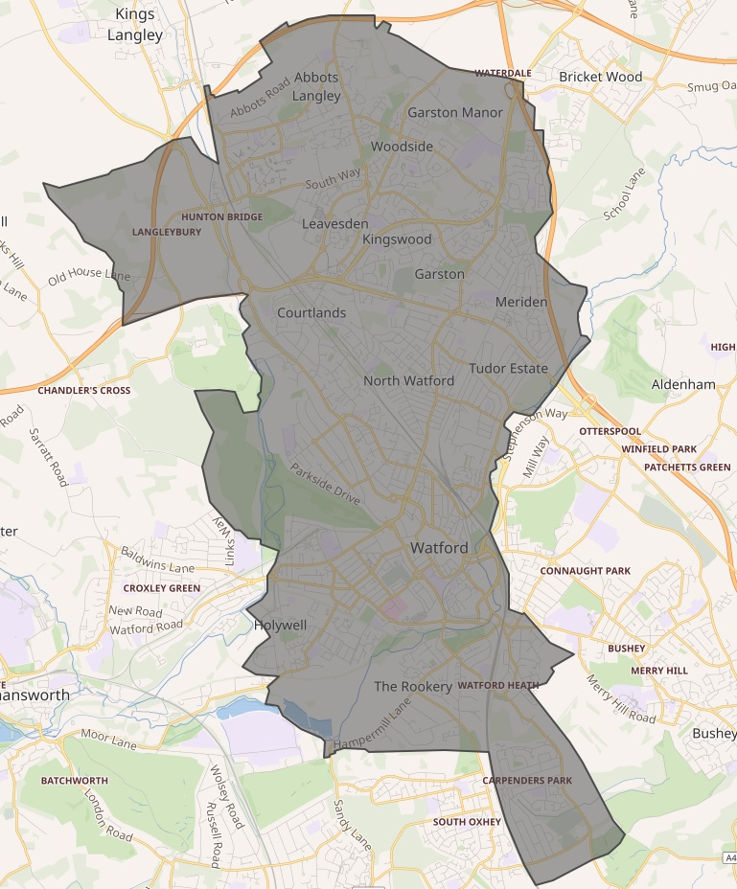
Watford is the home of several major employers including the European headquarters of TJ Maxx Europe (TK Maxx brand in the UK) and has excellent transport connections with a mainline station (Watford Junction), 5 other rail stations, a London Underground station, and close proximity to the M1 and M25 motorways. Within the Constituency is the largest UK film studio, Warner Bros, Leavesden which also hosts the award winning Harry Potter Tour.

Both Watford and Three Rivers Council leaders have a close working relationship with the major employers and the Watford Chamber of Commerce.

The Watford constituency population is 96,800 (2017 figure) and the electorate numbers ca. 83,000. The number of doors/flats is approximately 53,000.

Local Electoral Success

There has been a steady growth in support for the Liberal Democrats over many years, with significant gains in both Watford Borough and Three Rivers District councils since the mid 90's. Borough/District elections are held in three out of four years, the fourth year being the Hertfordshire County Council election year.

Within Watford Borough Council the Liberal Democrats have held the Elected Mayor position since its inception in 2002, with (Baroness) Dorothy Thornhill and subsequently Peter Taylor since 2018. Peter Taylor was re-elected for a further 4 years in May 2022 with a record 55% of first preference votes. The result was:

Lib Dem 12,895 (54.8%)
Labour 6,234 (26.5%)
Conservative 4,404 (18.7%)

Watford Borough has 36 councillors in 12 wards and the Liberal Democrats have held the majority of these seats since 2003. The current Council is 27 Liberal Democrat and 9 Labour members, following a significant LibDem gain in a Labour ward in May 2022. The elected Mayor is the 37th member for voting purposes. There are also 4 Liberal Democrat Hertfordshire County councillors in Watford Borough out of a Watford total of 6, the other two being Labour.

In 2022 the total Councillor Votes in Watford Borough were

Lib Dem 12,163 (51.3%)
Labour 6,624 (27.9%)
Conservative 4,642 (19.6%)
Others 282(1.2%)

In the Three Rivers wards (total votes all five wards – but see above re: splits)
Lib Dem 4,299 (48.1%)
Labour 1,576 (17.7%)
Conservative 2,445 (27.4%)
Greens 549 (6.1%)
Other 66 (0.7%)

Since 2002 every Watford Borough ward at some stage has elected Liberal Democrat councillors. The Conservatives, having made some recovery by 2015 (1 in 2014 and 4 gains in 2015), lost all 5 seats in an all-up election in 2016, following ward boundary changes. The Conservatives currently have no councillors in Watford and little prospect of gaining any.

The Green Party used to have a significant presence on Watford Borough Council (3 seats and a County Councillor) but by 2017 all these were lost and now often do not field candidates.

Three Rivers Council (39 members) is also Liberal Democrat controlled with 23 Liberal Democrat members. Currently one Three Rivers ward is wholly in the Constituency (Leavesden – 3 Lib Dems); 4 other wards are partly in the constituency, ranging from 50% to 70% by area. Of these the Liberal Democrats hold 9 seats to the Conservatives 3 (Carpenders Park). One County division is whole in the Watford Constituency part of Three Rivers and has a Lib Dem County Councillor; the other division with 50% in the constituency is Conservative held. In addition the Liberal Democrats un Abbots Langley Parish Council which is 75% in the Constituency. Watford Borough is un-parished.

Westminster Picture

Labour won the Constituency from the Conservatives in 1997. The boundaries have been unchanged since then (when there were changes to the north of the seat).

The seat has been considered a bellwether seat. The Constituency has had a Conservative MP since 2010. In 2005 the Liberal Democrats had pushed the Conservatives into third place and were just 1,000 votes behind.

There has been a large degree of split voting between local and national elections. For example in 2010, when the Conservative won, Dorothy Thornhill polled more votes for Mayor on the same day than the winning Conservative for the larger parliamentary constituency.

The 2010 general election was fought (as in 2005) by (Baroness) Sal Brinton, and the result – on a turnout of 68.3% - was:
Conservative 19,291 (34.9%)
Lib Dem 17,866 (32.4%)
Labour 14,750 (26.7%)
BNP 1,217 (2.2%)
UKIP 1,199 (2.2%)
Green 885 (1.6%)

However Liberal Democrats have polled less well in elections since then and the last result in 2019 was as follows (turnout 69.7%):
Conservative 26,421 (45.5%)
Labour 21,988 (37.9%)
Lib Dem 9,323 (16.1%)
SDP 333 (0.6%)

Under the proposed boundary changes due to be considered by Parliament in 2023 the Constituency will change with the removal of all the Three Rivers wards in whole or part to a new Three Rivers Constituency comprising just that Council area plus part of the current Hemel Hempstead seat.

The Watford Constituency will then be reduced in size and electorate to about 70,100, and to just the 12 Borough wards plus the Hertsmere ward of Bushey North (which is next to Oxhey) which in the all out elections in 2019 elected three Liberal Democrats.

As a result Watford could be a key Labour/Lib Dem seat in the future. Labour have recently selected a Watford Borough Councillor as their candidate for the next General Election.

Local Party

Membership of the local party has dropped in the last year to 268, having been steady for 2-3 years at just below 300. The local party is taking steps to reverse this decline and increase both membership engagement and numbers.

Watford Local Party is un-branched and campaign activities are co-ordinated and driven by the Campaigns Committee, a sub-committee of the main Executive. The Executive carries out Party Governance and Oversight tasks. The main fund-raising events are organised by the Campaigns Committee or delegates to key members. The main source of income is through local councillor’s tithes, paying a percentage quota of their allowances to the Local Party which goes to fund election costs and printing costs, e.g. Focus, target letters and newspapers. The local party has received significant donations in the past as well to support campaigning. The local party has strong expertise and is very active in leaflet production, and more recently in social media, and is working to improve the latter.

Funding of a paid Organiser, currently at one day a week, is also provided for. The constituency has no office premises, for reasons of cost.

The local party however has access to in-house printing through its Campaigns Chair for both two and full colour Riso, plus enveloper stuffer and other equipment. Offset litho printing of most leaflets is carried out by a local firm who are highly competitive in pricing, and reliable.

Watford’s People

Watford was historically a market town and a centre for the printing industry. One national newspaper still prints in Watford. Nowadays the town area is a very strong sub-regional retail centre, together with many office based activities, as well being a commuter town for London. Several major companies have chosen to base their headquarters in the area.

The population of the area is very diverse with only 64% being “White British”. There is a substantial presence from all Asian countries and faiths (16.7%) as well as a significant Afro-Caribbean presence (5.4%). Recently there has also been an influx from Eastern European countries. This is not new as Watford has always been an area for immigration, from Irish before WW2, to Polish and Italians (a substantial community of which still remain) after WW2.

There is a cultural heritage within the constituency, with a strong involvement by its citizens in arts and entertainment. The Borough has a major film studio (Warner Bros, Leavesden) on its doorstep. Watford Palace Theatre is a highly regarded regional producing theatre supported by both The Arts Council and the Borough Council. The Council-owned Colosseum music and light entertainment venue is also home to The BBC Concert Orchestra who use the venue for rehearsal and recording purpose as well as live public concerts. There is a wide range of sporting activity in the area, not least with Watford FC being a premiership Football Club (promoted in 2020-21).

The Issues

Watford has exceedingly good road and rail links. It is easy to get to London and the north via the West Coast main line (Watford Junction is a major station). There is also good access into London via Underground and Overground services. The Metropolitan Line tube service terminates a mile from Watford town centre. Plans for an extension using the former Croxley Rail link linking to Watford Junction were vetoed by the London Labour Mayor a few years ago. Other options using the old line are being explored.

The M25 runs close by and there is easy access to the M4, M40, M1, and A1 is relatively quick. As Watford grew largely before the advent of the motor car, congestion and parking is a big issue.

The health of the local economy remains good but it is heavily dependent on the retail presence in the centre of Watford, a major sub-regional shopping centre. The availability of office space for HQ and/or regional office activities remains good. There is an Active Business Improvement District and the Council has funded improvements to local shopping areas outside the Town Centre.

Housing remains relatively expensive, due to high demand and low availability. The majority of houses are owner occupied. Land for building in a densely populated area is scarce and many local developments have to be flats. This presents all kinds of issues, not least providing enough mix of homes for those who cannot afford the going rate and whose presence ensures the economic viability of the area. The Borough Council, in partnership with Kier, is developing on the “Health Campus” site 700 new homes, with 35% being affordable.

Development is a big issue as the central government housing targets have increased to over 800 a year for Watford Borough. This has increasingly meant larger and taller high rise development proposals coming forward close to the Town Centre, with 22, 24, 28 storeys etc., and results in significant political attacks by both Labour and the Conservatives despite the housing numbers being government objectives.

Gren Belt development issues are the main factor in the Three Rivers wards.

Council housing was disposed of almost 20 years ago and the majority in the borough is run by Watford Community Housing Trust but there are several other providers.

Crime levels are relatively low, but close to and within the Town Centre (mostly linked to ease of transport) there remains constant issues with anti-social behaviour and drug use.

Ethnic diversity and awareness in Watford is relatively good with community cohesion within the town being particularly strong. Several faiths have places of worship in the Constituency (for examples there are two Mosques and one Sikh temple) and Watford is the UK HQ to one particular faith, the Seventh Day Adventists.

Watford General Hospital, next to the football club, is a key feature of the Town and successive Mayors and the Council has fought a long battle to retain it in Watford including securing a new access road and now helping with a £400m investment for a re-build of which a planning application has recently been submitted.

