Wells Liberal Democrats
Constituency Profile
Summary
The Wells Constituency was held by Tessa Munt for the Liberal Democrats from 2010 to 2015. Following success in winning 15 of 22 Somerset County Council seats contested in 2022 we are looking for a PPC to win back the seat for the Lib Dems. We have to offer:

- Paid constituency organiser
- Proven campaign capabilities
- Enthusiastic team of campaigners with strong membership base, willing to go the extra mile to win back the seat
- Regular, good income stream

About the Constituency: The Wells Constituency is set in the centre of Somerset, extending from the coast of the Bristol Channel to the Mendip Hills, encompassing much of the Avalon Marshes and Somerset Levels. Latest figures indicate that 103,947 people live in the Constituency, with 82,671 people on the electoral roll. Wells ranks 113th in the list of constituencies by geographical size.
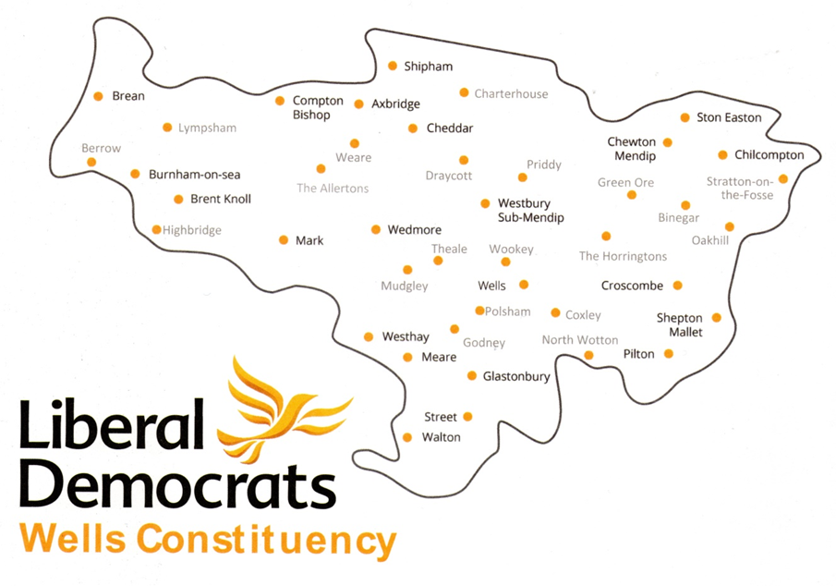
The largest centres of population are Burnham & Highbridge with a combined population of 23,325; Street with nearby Glastonbury had nearly 21,500 residents at the 2021 census. Wells is a Cathedral City, the smallest in England, with 10,536 residents in 2021. Market towns include Axbridge, Cheddar and Shepton Mallet. The many villages range from good sized settlements with local services like Chilcompton, Wedmore and Pilton to tiny hamlets. Population growth in the past 10 years of 6% and 9.4% in Mendip and Sedgemoor Districts respectively, reflects widespread expansion of housing in the towns and larger rural settlements.
The Political Environment: The constituency is entirely within the Somerset County Council boundary, currently split between Mendip and Sedgemoor District Councils. Reform of local government in Somerset will result in April 2023 in replacement of the county and district councils by the unitary Somerset Council. Following elections in May 2022 Somerset Council will be Liberal Democrat led; indeed, Somerset Lib Dem councillors now comprise the largest local authority group in the country.

The table below summarises the state of parties in constituency wards in the District, and Somerset County Councils. District elections returned a Lib Dem led Mendip District Council which laid the foundation for widespread gains at the 2022 County Council election when we won 15 of 22 seats contested.

 | Lib Dem | Con | Green | Ind
2019 Mendip & Sedgemoor District Council Seats | 18 | 17 | 2 | 3
2022 Somerset County Council/Unitary Seats | 15 | 7 | 0 | 0

Implementation of the on-going Boundary Commission Review is expected to see the formation of the Wells and Mendip Hills County Constituency. Under the Commission’s final draft proposal, coastal areas including the towns of Burnham-on-Sea and Highbridge will be split off while four wards currently in Weston-Super-Mare and North Somerset Parliamentary constituencies, all located in the area of the North Somerset Unitary authority, will be added.

Of the six North Somerset Councillors elected in 2019, there are 2 Lib Dems, 2 Greens, 1 Conservative and 1 Independent.

The Wells Parliamentary seat has been held by Conservative James Heappey for the past seven years with 54% of the vote in 2019. Lib Dems have polled between 32 and 38% of the votes in the past three general elections and are the clear challengers to the Conservatives. With support for the Conservatives on the wane nationally, Wells Lib Dems believe that with an enthusiastic candidate we have every chance of securing the 8.11% swing required to win back the seat following our strong showing at the 2022 local elections. It has been well publicised in local media that Heappey refused to support the bid for Levelling Up funds for the constituency submitted jointly in July 2022 by Conservative led Sedgemoor and Lib Dem led Mendip District Councils providing further evidence of his ambivalence towards the community he should be supporting,

The Local Party: Current membership across the constituency stands at 510. A membership drive is underway and will be given added impetus by the selection of a PPC. We are discussing with our neighbouring local parties how we will support their campaigns for North Somerset Unitary elections in May 2023 in the four wards that will be joining Wells constituency after boundary change. The aim will be to enhance local networks in these areas ahead of the general election.

Our PPC will be supported by a paid Constituency organiser, an enthusiastic Executive and team of experienced campaigners who will take forward a winning mentality from the 2022 local elections. Our councillor base provides the local party with a regular income and a spring-board for further fundraising.
For any further information about the constituency, you can contact our Chair Charlie Riches on 07887642579 or by email at richesagherba@gmail.com

