Prepared by: Environmental Services and Regulation, Department of Environment and Science

© State of Queensland, 2022.
The Department of Environment and Science acknowledges Aboriginal peoples and Torres Strait Islander peoples as the Traditional Owners and custodians of the land. We recognise their connection to land, sea and community, and pay our respects to Elders past, present and emerging.
The department is committed to respecting, protecting and promoting human rights, and our obligations under the Human Rights Act 2019.
The Queensland Government supports and encourages the dissemination and exchange of its information. This work is licensed under a Creative Commons Attribution 4.0 International License.
Under this licence you are free, without having to seek our permission, to use this publication in accordance with the licence terms. You must keep intact the copyright notice and attribute the State of Queensland as the source of the publication.
For more information on this licence, visit https://creativecommons.org/licenses/by/4.0/

If you need to access this document in a language other than English, please call the Translating and Interpreting Service (TIS National) on 131 450 and ask them to telephone Library Services on +61 7 3170 5470.

This publication can be made available in an alternative format (e.g. large print or audiotape) on request for people with vision impairment; phone +61 7 3170 5470 or email <library@des.qld.gov.au>.

Month date of publication

Contents
Acknowledgement of Country 4
Summary 5
1.0 Overview 6
1.1 Background 6
What is CSG? 6
What is brine and how much will be produced? 7
Current management of brine 7
Environmental risks 8
Possible long-term brine management options 8
Queensland Government oversight 9
Regulatory framework 9
Rehabilitation Requirements 9
1.2 Brine Management Options 9
Australian Petroleum Production and Exploration Association Report 9
University of Queensland Report 13
1.3 Current Regulatory Framework 14
Environmental Protection Act 1994 14
Resource Activities 14
Prescribed Activities 15
Environmental Authorities for 15
resource activities 15
Environmental Authorities for prescribed activities 16
Waste (Salt) Disposal – Resource Activity vs. Prescribed Activity 17
Planning Act 2016 17
Waste Reduction and Recycling Act 2011 18
CSG Water Management Policy 2012 18
1.4 Rehabilitation Requirements 19
2.0 Key Principles for CSG brine management 20
2.1 Robust regulatory framework 20
2.2 Waste management hierarchy 20
2.3 Research and development investment 21
2.4 Stakeholder Engagement 22
3.0 Actions 22
4.0 Moving forward – monitoring and review of the Action Plan 23
5.0 Glossary 23
6.0 References 24

Acknowledgement of Country
The Department of Environment and Science acknowledges the Country and people of Queensland’s First Nations. We pay our respect to Elders, past, present and emerging.
We recognise and value the ongoing contributions of First Nation people and their culture and the opportunities that exist for shared ways of working to protect Queensland’s environment.
We acknowledge that:
- Land and water are of spiritual, cultural and economic importance to First Nation people.
- All places in Queensland exist on the traditional country of First Nation people.
- First Nation people’s interests, needs and aspirations are integral to the department’s core business.
In recognising and respecting thousands of years of environmental stewardship, Queensland’s First Nation people and their culture is integral to the department’s objective to protect and sustainably manage Queensland’s environment and natural, cultural and heritage values. As part of our regulatory approach, we seek to engage and work collaboratively to build a culturally safe work environment that is inclusive of First Nation people’s perspectives and values.
The Department of Environment and Science is committed to working in genuine partnership with Queensland’s First Nation people to achieve stronger outcomes for community and for all people. The department’s Gurra Gurra Framework 2020 – 2026 was launched in April 2020. The Framework will help us reframe the way we work by holding Country and people at the centre of our business operations and decision-making.
This artwork was developed by the department’s Cultural Capability Action Plan working group in conjunction with our graphic designers to represent the department’s Aboriginal and Torres Strait Islander cultural capability.

It features the artwork of Elaine Chambers—a Kuku Yalanji and Koa woman.
The artwork was designed with all elements in mind; water resources, land management, rural lands and coastal areas.
The hands around the main design signify our hands embracing the lands and waterways we care for.
The blue and green background represents the land and waters of our State.

The department is committed to respecting, protecting and promoting human rights, and our obligations under the Human Rights Act 2019.

Summary
The Department of Environment and Science (DES) as Queensland’s environmental regulator, industry and community groups have been involved in investigations into appropriate long-term management approaches for highly saline wastewater (called brine) produced as a result of coal seam gas (CSG) activities over a number of years.
Around 5-6 million tonnes of CSG brine waste (salt) is expected to be generated as a result of CSG activities over the life of the industry. This volume is significantly less than originally estimated for the industry. It is not anticipated that the need to waste facilities will be required until around 2030.
This Action Plan has been developed collaboratively by the Department of Environment and Science (DES) and industry, landholder and environmental groups and outlines a number of key principles and actions to appropriately manage CSG brine waste in the future.
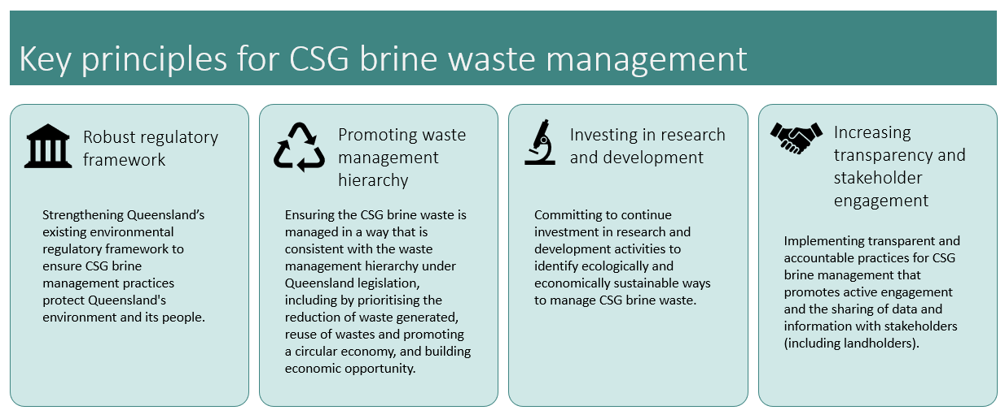
A number of studies into alternative waste options have informed this Action Plan.
Currently, the most feasible option is encapsulation of brine waste (similar to a lined landfill). However, this Action Plan promotes the continued research and investigation of alternative options for brine management in keeping with circular economy principles within the CSG resources sector.
A number of actions to be delivered by both government and industry are outlined in this plan including
- Require reporting of salt volumes on sites
- Undertaken Industry wide planning for salt disposal
- Invest in ongoing R&D to reduce volumes and identify reuse options and publicly report on outcomes
- Share data publicly on monitoring at any salt waste disposal facilities (eg groundwater monitoring)
- Review and update departmental guidance materials to rigorously assess and regulate salt waste disposal
This Action Plan will be reviewed over time taking into account emerging R&D including advancements in technological capability and scientific knowledge.

Overview

Background
Queensland’s abundant resources include petroleum and gas in addition to coal and minerals. Petroleum and gas resources are typically categorised by the method of extraction, with conventional oil being extracted using traditional methods of drilling down through the ‘cap’ rock and allowing petroleum to flow up to a limited number of wells in a basin, while unconventional oil requires extensive fields of multiple wells and surface infrastructure. Coal seam gas (CSG) is considered unconventional oil.
Conventional petroleum resources are oil and gas are found in several geologic reserves / basins in Queensland, including the Cooper, Eromanga, Bowen, Surat, and Adavale. Conventional petroleum reserves include crude oil, condensate and natural gas. The products that can be refined from the resource includes liquefied petroleum gas, fuel oils, petrol, diesel, kerosene and asphalt base.
Unconventional petroleum resources are oil and gas found in a variety of geologic formations of low permeability and porosity that require additional energy and investment to release the resource from the source rock as compared to conventional oil resources. Unconventional resource development usually requires extensive well fields and more surface infrastructure. Unconventional petroleum resources occur in several reserves / basins across the state, with the current industry being developed in the Surat and Bowen basins. The potential for the development of an unconventional gas industry in Queensland was first identified in the 1990s. Some examples of unconventional resources in Queensland include coal seam gas (CSG), tight gas, shale gas and shale oil. Queensland's unconventional gas reserves are now considered to be the largest source of natural gas in eastern Australia.
This Action Plan (plan) centres on the waste brine generated from CSG production activities and has been developed in collaboration with industry, conservation groups, and other stakeholders. The plan identifies a number of actions in Section 4.0 to be undertaken by Queensland Government and industry (in consultation with other stakeholders) in addressing the long-term management of CSG brine in Queensland.

What is CSG?
Coal Seam Gas (CSG) consists of gas and water that collects in the coal seam formations. CSG is produced through the initial extraction water to release the pressure in the coal seam formation and allow the gas to be collected. The CSG well provide for the water and gas to be separated for production. The water extracted from coal seams in Queensland is generally saline and may be available for a range of uses or require treatment depending on water quality limits. The following illustrates the CSG process.
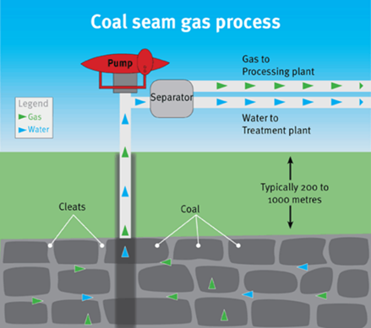
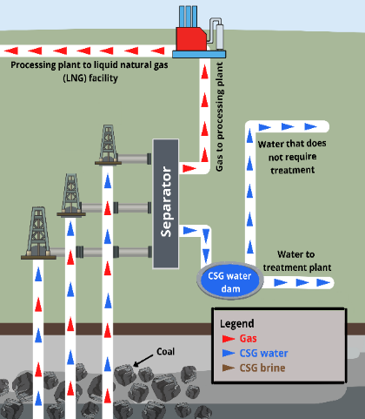
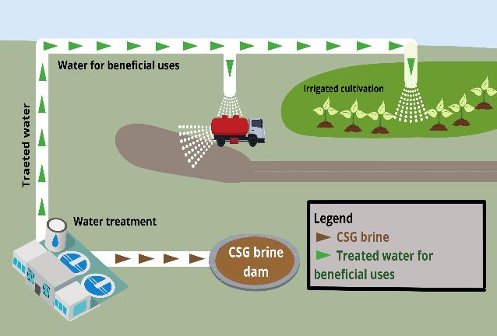

Where CSG water does not meet water quality limits, it is separated for treatment. Typical treatment consists of reverse osmosis (as illustrated below ResearchGate. The reverse osmosis process applies pressure to pass CSG water through a membrane (or several membranes) to remove impurities (salt). Depending on water quality limits, the treated water is either released for a beneficial use or separated for storage in a dedicated dam.

Reverse Osmosis process

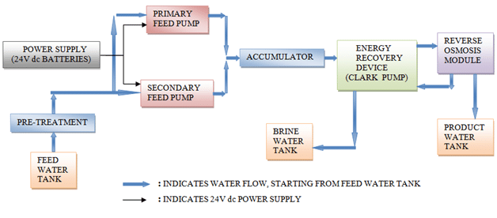

According to information provided by the Australian Petroleum Production and Exploration Association (APPEA), more than 90% of water generated from CSG activities in Queensland is made available for a range of beneficial uses such as irrigating crops, watering livestock, commercial use, public water supply, or added to watercourses¹.

What is brine and how much will be produced?
The volume and concentrations of total dissolved solids (salt) in the CSG water vary significantly across individual well fields. The department defines brine as saline water with a total dissolved solids (salt) concentration greater than 40,000 milligrams per litre (mg/L)². This concentration of salt is similar to that of ocean water. The volume of brine produced by industry is dependent on the volume of water extracted from CSG Wells and the concentrations of total dissolved solids (salt) in the water. According to Queensland Government’s Office of Groundwater Impact Assessment (OGIA)³ approximately 54,000 mega litres (ML) of water is extracted from approximately 8,600 CSG wells per year.
The volume of salt that may be generated from the brine has varied over time, with initial industry estimates of up to 15 million tonnes; however, as actual production and treatment volumes have been assessed, the volume of salt likely to be generated is 5-6 million tonnes over the life of the industry¹.

Current management of brine
Currently highly saline reject water from the reverse osmosis treatment locations is stored in dedicated dams located on resource sites. Information provided by APPEA, is that there are 42 dedicated brine dams in Queensland with an estimated storage capacity of 20,290 ML. It is estimated that 58% (11,796 ML) of the capacity in currently in use. Figure 1 provides an arial view of a typical brine storage pond.

Figure 1 – Typical brine dam
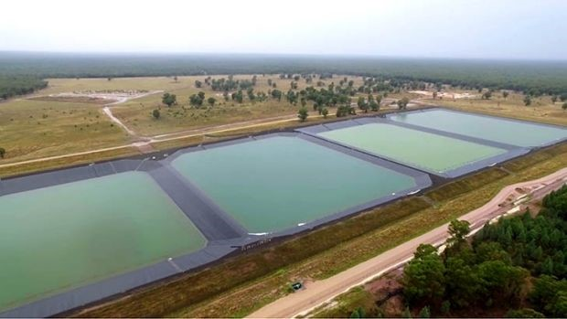

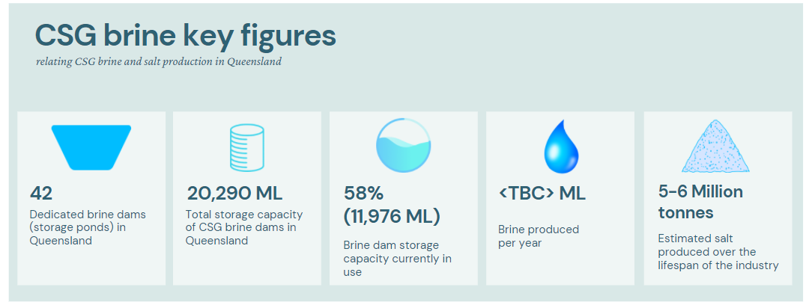

Environmental risks
Storage of brine presents several underlying risks that could result in undesirable impacts to the surrounding environment due to the high concentrations of total dissolved solids (salt), significant volume of brine, the liquid state of the brine being stored, and structural failure of the dam.
The storage of reverse osmosis reject water (brine) in dedicated dams was adopted by Queensland Government and the CSG industry as an interim management approach, until such time that an industry-wide approach could be identified and adopted.
The most likely sources of an unintended release from the brine dams includes, but is not limited to the following:
- Seepage through the dam walls;
- Overtopping of dams due to excessive rainfall event(s); and
- Release of brine due to structural failure of a dam.
Environmental risks are managed through a number of environmental authority (EA) conditions regarding monitoring and maintenance of regulated structure (dams) and overall management of water stored on site.

Long term brine management options investigated
Several potential options for the management of brine have been researched and investigated either individually or in cooperation within the CSG industry over the last decade, including:
- Selective salt recovery (SSR) (reuse)
- Ocean outfall (release)
- Salt encapsulation (disposal)
- Brine injection (disposal)
Each of the options were researched and investigated on their merits regarding environmental, economic, and social outcomes. Industry has identified salt encapsulation as the preferred option. A more detailed summary of the options investigated and recommendations is provided in section 1.2 of this Action Plan.

Queensland Government oversight
The Queensland Government as the environmental regulator of the CSG industry has over the last decade considered possible options for the management of brine within the CSG industry. In addition to considering the possible impacts to the CSG industry regarding the adoption of an approach to brine management, Queensland Government has also engaged with non-industry stakeholders (landholders, farmers, graziers) that could potentially be impacted.
APPEA, as the peak body for Australia's oil and gas industry (including the CSG industry developed a report to identify industry-wide solutions for the long-term management of brine generated from CSG activities, which was completed in 2018.
The University of Queensland (UQ) Centre for CSG (Natural Gas) was engaged by the department to undertake an independent review of the APPEA report, which was completed in 2020.
The APPEA and UQ reports are reviewed in more detail in Section 1.2 of this Action Plan.

Regulatory framework
The Queensland Government has a rigorous regulatory framework for resource or prescribed activities that includes legislation (such as the Environmental Protection Act 1994, Petroleum and Gas (Production and Safety) Act 2004, Waste Reduction and Recycling Act 2011, and the Planning Act 2019 and associated regulations), policies and guidance materials under which operators of resource or prescribed activities must implement and comply. The regulatory framework provides the operator with a number of requirements, restrictions prohibitions, and options when undertaking an activity. Section 1.3 of this plan includes a more detailed overview of the current regulatory framework.

Rehabilitation Requirements
Provisions in the Environmental Protection Act 1994 typically require environmental authorities (EA) for a number of environmentally relevant activities (ERAs) such as petroleum and gas or waste disposal to include conditions regarding the rehabilitation or remediation of land disturbed by the activity. Generally EA holders must provide financial commitments to Queensland Government to ensure a site will not become a financial burden to the State during operations or after closure. Under the current regulatory framework these financial commitments are referred to as Estimated Rehabilitation Cost (ERC) and Residual Risk (RR) payment for resource activities and Financial Assurance (FA) for prescribed activities such as waste disposal. Please see Sections 1.3 and 1.4 of the Action Plan for a more detailed description of rehabilitation conditions and requirements for resource and waste disposal activities in Queensland.

Brine Management Options

Australian Petroleum Production and Exploration Association Report
In December 2018, APPEA provided a report to the department titled Queensland Gas: end-to-end water use, supply and management (APPEA Report). The APPEA Report provides an overview of several feasibility studies that have been undertaken by industry operators individually or in collaboration with other industry operators that relate to the identification of a long-term strategy for the management of brine generated from CSG operations. These feasibility studies examined the viability of the identified options through a range of potential risks and impacts relating to environmental, economic, safety, technical, regulatory and social factors.
The report summarises the findings of the following options examined by the studies (which is described in more detail in the following sections):
- Selective salt recovery;
- Brine injection;
- Ocean outfall; and
- Salt encapsulation.

Selective salt recovery
Selective salt recovery uses technologies to produce salt products from brine for potential beneficial reuse. The selective salt recovery process commences after stored brine has been further concentrated by solar or other mechanical means. The concentrated brine is then moved via pipeline to a selective salt recovery facility to crystallise the brine into salts. Testing of the process identified crystallisation produced a number of products, such as table salt (sodium chloride) and soda ash (sodium carbonate).
The APPEA report concluded that while this solution is technically feasible there were a number of issues that preclude this approach being adopted industry-wide, including:
- Energy use - selective salt recovery is a highly energy intensive process that requires more power and gas than any other alternatives considered.
- Chemical use - selective salt recovery relies upon the use of a number of chemicals in its operation, thereby increasing safety risks for plant operations and transport of these chemicals to the selective salt recovery facility.
- Waste generation - supply of brine to a centralised processing facility through pipelines requires a pre-treatment process to be used, this pre-treatment process generates additional solid and liquid waste streams that require management and/or disposal.
- Noise generation - mechanical vapour recompression process results in significant noise generation that would require specific attenuation.
- Transportation concerns – the transportation of salt products over long distances from the CSG fields to developed transportation hubs (road, rail, ship) increases the risk of a range of transport accidents, uncontrolled release and environmental impacts.
- Certainty - selective salt recovery does not provide a level of certainty for the industry due to reliance on a single selective salt recovery facility and the proprietary nature of the technology used in the facility meaning that it could be difficult to locate a new operator if necessary.
- Market concerns - selective salt recovery from CSG industry would be entering the existing market for salt and competing with existing suppliers in a loss-making scenario which could result in significant negative impacts on the market for salt in Australia and around the world.

Brine injection
Injection wells are a well-established process which can be used for the disposal of brine waste. The process involves the placement of brine waste underground into porous geological formations. To avoid the movement of brine to other aquifers, the brine would be injected into formations between impermeable layers of rock.
The feasibility of a whole of industry solution based on brine injection into geological formations is dependent on locating a suitable geologically isolated formation which contains sufficient capacity. The potential for environmental harm would also need to be managed through targeting a geological formation that either: does not contain groundwater; or if groundwater is present the brine to be injected is of a similar or better quality then the groundwater in the formation.
The APPEA report concluded that no suitable geologic formation that could be considered appropriate for injection has been identified by the gas industry, therefore brine injection was assessed by industry as being unfeasible.

Ocean outfall
The disposal of brine via ocean outfall would involve the construction of a pipeline that connects the CSG industry’s brine ponds to a coastal outfall for discharge. This option would not only consist of the construction of a main transfer pipeline to the coast of several hundred kilometres, but also include the construction of a number of infield pipelines of an additional several hundred kilometres in total to connect to the main transfer pipeline.
The APPEA report concluded that while this solution is technically feasible there were a number of issues that limit the viability of this approach being considered, including:
- Route - the potential pipeline route could traverse over a thousand properties, including highly developed urban areas on the coast at the eastern end of the pipeline.
- Land disturbance - the construction activities would involve significant land disturbance.
- Costs - elevated costs for specifically engineered pipeline infrastructure to ensure containment and minimisation of corrosion over the lifetime of the gas industry. While suitable pipeline materials are available the costs of the pipeline would be a significant increase compared with the costs of a similar potable water or water pipeline.
- Water Quality - the ocean outfall will be required to operate over a wide range of salinity concentrations and composition and be capable of achieving the necessary diffusion of brine within a mixing zone which does not cause a negative impact.

Salt encapsulation
Salt encapsulation is a term for the disposal of crystallised brine (salt) and placement in a landfill (regulated waste) that has been sited, designed, constructed, and would be operated for the waste (salt) identified. The landfill could be sited either on the resource tenure or off tenure. The current regulatory framework considers salt as a regulated waste. The process of salt encapsulation involves the conversion of brine to a mixed salt, using a crystalliser, for long-term containment in a salt encapsulation cell.
Brine stored in brine ponds would be processed through a crystalliser to evaporate water from the brine. The crystallisation process converts the liquid brine to a solid salt. The resulting mixed salt would then be transported by a truck to a dedicated salt encapsulation cell within the regulated waste landfill for containment. The encapsulation cell would be constructed to a standard for a regulated waste landfill within any site - specific constraints identified. This approach is similar to that typically used throughout Australia and the world.
The salt placed in the landfill would need to be contained by a multi-layered liner and capping system designed and constructed to specific standards for the location. Figure 2 provides a graphical representation of a typical liner and capping system for a regulated waste landfill that is based on standards derived from materials developed and published by the department (ESR/2015/1827), these materials are available from the provided link or may be requested via the department’s public register portal.
The liner would be designed by a suitably qualified person and installed before the deposition of salt waste, and would generally consist of (from top to bottom):
- Leachate collection system;
- Barrier system composed of geosynthetic liners and a natural soil barrier;
- Leak detection system;
- Secondary barrier system;
- Final leak detection system; and
- Groundwater diversion system.
A similar multi-lined cap would be placed following the filling of the cell to connect to the sidewall liners and form a complete seal to minimise water infiltration. Revegetation soils would then be placed on top of the cell to complete the cap and provide a safe and suitable final surface. Like the liner, the cap will be designed by a suitably qualified person and would generally consist of (from top to bottom):
- Vegetative covering and topsoil;
- Filter fabric;
- Drainage layer;
- Capping liner;
- Cell capping; and
- Capping base.

Figure 2 – Capping and liner system
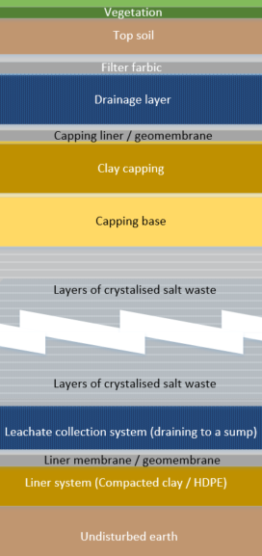

The APPEA report concluded that while initial preliminary studies identified selective salt recovery as the most suitable option for a whole of industry approach to brine management, further investigation has indicated this option is no longer considered feasible for continued progression. Following further investigations, the report concluded that the best management option (having regards to technical performance, social, environmental, economic and regulatory factors) is to crystallise the brine into salt and dispose of the salt in a dedicated salt encapsulation cell (i.e. regulated waste landfill).

University of Queensland Report
The department engaged the University of Queensland Centre for Natural Gas (UQ) to conduct an independent review of the conclusions of the APPEA report⁴. UQ was requested to determine if all practical options for brine management had been considered and provide comment on the feasibility of the identified options and conclusions. Additional advice was also sought on whether there were other practical options warranting further investigation that may not have been addressed by industry feasibility studies and any associated environmental, economic, and social risks and benefits. UQ provided a report to the department with a number of conclusions and recommendations for consideration.
The UQ Report provided that industry have reviewed all reasonable brine disposal options available at this time. While some of the investigations are dated, no new options have emerged to make the original investigations irrelevant or provide new avenues for investigation. The information provided support the industry conclusion that salt encapsulation (landfill disposal) is the most technically viable brine management option. This conclusion is based on this option being a proven technology with well-established and effective regulatory processes to manage key environmental risks.
The UQ Report provided in its recommendations that it is prudent for government and industry to plan on the basis that crystallisation of brine and construction and operation of salt encapsulation facilities provide, at least in the medium term (10 – 15 years), the best approach for the long-term management of brine waste. The review made the following recommendations:
- The requirements of the environmental assessment process toward permitting salt encapsulation facilities should be determined rapidly in order to ensure that all technical information can be provided to meet regulatory requirements and the necessary public consultation and education processes can be managed effectively.
- APPEA and the companies should place a high priority on stakeholder engagement and consultation to build the level of community acceptance required for salt encapsulation (landfill disposal) facilities. The level to which this is achieved for the first salt encapsulation facilities will affect future proposals and the ongoing social licence of the industry.
- The department determine the residual risk management requirements that will apply to the salt encapsulation facilities. This regulatory mechanism is critical in ensuring the long-term physical integrity of the sites and addressing community concerns regarding the management of the facilities beyond the lifetime of the CSG industry.
- A public reporting process be developed to provide access to all monitoring data and demonstrate that the salt encapsulation facilities are complying with all regulatory requirements and that the physical integrity of the site is maintained.
- The department should conduct 5-yearly reviews of brine/salt production management to:
  - confirm that industry planning for management and disposal options is at an appropriate scale, given the likelihood of production estimates continuing to change; and
  - review the latest research and determine if there are any relevant emerging technologies.
- The CSG industry continue to invest in research that will:
- minimise the medium and long-term risks of salt encapsulation facilities;
- reduce energy intensity and operational costs of brine management and salt disposal options; and
- investigate any emerging technologies that are identified through their own efforts or in future reviews.
The conclusions and recommendations above have been taken on board in the development of the actions provided in section 3.0 below.

Current Regulatory Framework

Environmental Protection Act 1994
The Environmental Protection Act 1994 (EP Act), Section 18, defines an environmentally relevant activity (ERA), as either an agricultural activity, an activity prescribed by a regulation, or a resource activity. These are activities that may result in environmental harm and are subject to the regulatory framework of the EP Act.
The EP Act provides a framework for assessment and licensing to allow ERAs to occur, while achieving ecologically sustainable development and ensuring all reasonable and practicable measures are taken to protect environmental values from all sources of environmental harm.
The authorising instrument under the EP Act for both prescribed ERAs and Resource ERAs is called an Environmental Authority (EA). The assessment criteria are tailored to each ERA type and application/assessment process.
Figure 3 provides an overview of the EA assessment processes applicable for an application for either waste disposal (prescribed ERAs) or resource (petroleum and gas) activities.

Figure 3: ERA types and authorities required
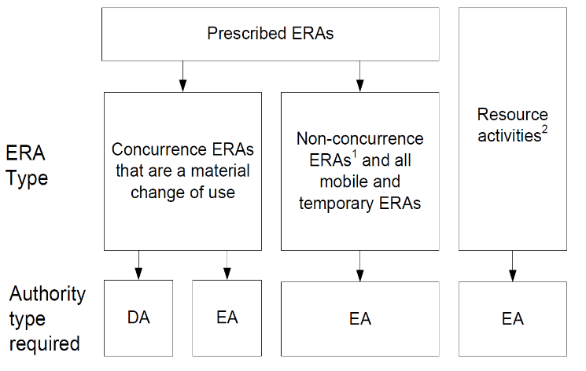
¹Including concurrence ERAs that are not a material change of use.
²A resource authority (tenure) is also required for a resource activity, but the resource authority process is not linked to the EA process.

Resource Activities
The EP Act defines a resource activity as either geothermal, greenhouse gas (GHG) storage, mining or petroleum activities. The EP Act defines each of these resource activities based on the associated tenure legislation (see Sections 108 to 111 of the EP Act).
A resource activity may include other prescribed ERAs in addition to the resource activity, which are referred to under the EP Act as an ‘ancillary’ activity. Ancillary activities are authorised as part of the resource activity and may occur under the relevant tenure legislation; however, the ancillary activity is limited to be limited to on-tenure activity (for example, on waste generated off-tenure could be disposed of on-tenure (though not always specifically mentioned under the tenure legislation).
Under the P&G Act framework, associated water generated from CSG activities is considered a waste and provides that it may be used for any purpose determined by the tenure holder, including disposal and/or transfer to another tenure (including a tenure not held by the tenure holder).
Schedule 9 of the Environmental Protection Regulation 2019 (EP Reg), identifies ‘non-toxic salts, including, for example, ‘saline effluent’ as a category 2 regulated waste. Brine and salt produced during CSG production is captured by this definition.
The on-tenure disposal of the waste salts from CSG activities meets the requirements of prescribed ERA 60 ‘Waste Disposal’, and as such could be identified on an EA for petroleum activities as an ancillary activity. For ERA60 to be undertaken as part of the resource activity, the waste to be disposed (salt) must only be that generated by the resource activity.

Prescribed Activities
A prescribed ERA is an activity that is defined under s19 of the EP Act and listed in Schedule 2 of the EP Reg.
All prescribed ERAs are required to be undertaken with an EA and may require a material change of use (MCU) under the Planning Act 2016 (Planning Act) under certain circumstances.
For the approach to brine management identified in the APPEA and UQ reports (Section 1.2) ERA60 ‘Waste Disposal’, corresponds to the most likely ERA to be conducted. Once authorised by the department an EA holder would be able to conduct the activity.

Environmentally Relevant Activity (ERA) 60 description
- Waste disposal (the relevant activity) consists of only 1 of the following –
- operating a facility for disposing of-
- only regulated waste; or
- regulated waste and any, or any combination, of the following –
- general waste;
- limited regulated waste;
- if the facility in in a scheduled area – no more than 5t of untreated clinical waste in a year;
- operating a facility for disposing of –
- only general waste; or
- general waste and either, or a combination, of the following –
- a quantity of limited regulated waste that is no more than 10% pf the total amount of waste received at the facility in a year;
- if the facility is in a scheduled area – no more than 5t of untreated clinical waste;
- operating a facility for disposing of only inert waste;
- maintaining a decommissioned waste disposal facility.
- The relevant activity does not include using clean earth as fill.

Environmental Authorities for resource activities
The application and assessment process for an EA for resource activities that includes or adds an ancillary activity (waste disposal) is undertaken entirely via the process outlined within the EP Act. The EP Act and subordinate legislation provides the regulatory requirements and criteria an application for a resource activity EA must be assessed against. An assessment for a resource activity (including ancillary activities) will require both an operational assessment and a land use assessment.

Assessment of activities
The assessment of resource activities under the Environmental Protection Act 1994 involves the following key considerations:
  - Environmental values – identify the potential environmental values affected
  - Environmental impacts – assess the risk of adversely impacting the relevant environmental values (in the short and long-term)
  - Mitigation measures – consider what controls could be implemented to minimise these risks and whether they are sufficient
  - Licence conditioning – if mitigation measures are sufficient, conditions are imposed on an operator that address operation of the activity, rehabilitation, financial obligations and post-closure activities.
As part of the assessment process the administering authority may impose conditions the proponent will be required to adhere to. As such, an EA for resource activities may contain operational and land use conditions including rehabilitation and financial guarantees.
Provisions in the EP Act also require holders of an EA for resource and certain prescribed activities to provide financial commitments to the Queensland Government to ensure a site will not become a financial burden to the state during operations or after closure. Section 1.4 of this plan provides additional detail regarding rehabilitation requirements.

Environmental Authorities for prescribed activities
The application for an EA for a prescribed ERA may follow a different assessment process depending on the ERA is to be conducted on or off a resource tenure.
Under most circumstance, off tenure activities will require both an EA under the EP Act and development approval (DA) under the Planning Act 2016.
The EP Act and subordinate legislation provides the regulatory requirements and criteria for an application for a prescribed ERA to be assessed against. An assessment for a prescribed ERA will only require an operational assessment. An application for a prescribed ERA will not include a land use assessment, as this aspect of the development is regulated under the Planning Act 2016 framework as applicable (see section 1.3).
As part of the assessment process the administering authority may impose conditions on the EA that the proponent will be required to adhere to. As such, an EA for prescribed ERAs may contain a number of operational conditions as appropriate to the risk of environmental harm due to site characteristics.

Operational conditions
Conditions may be imposed on environmental authorities for resource and waste disposal activities that:
  - Limit the waste (salt) that may be placed for disposal
  - Mitigate or manage landfill activity based on identification of environmental values and/or environmental impacts
  - Require monitoring activities to confirm proper landfill operation
  - Require rehabilitation and financial requirements as appropriate

Provisions in the EP Act may require holders of an EA for waste disposal activities to undertake rehabilitation of the site prior to surrender of the EA; in addition, Queensland Government may also require the EA holder to provide a financial guarantee to ensure a site will not become a financial burden to the state during operations – this is referred to as Financial Assurance (FA). FA for waste disposal activities is held by DES for that site and is available to rehabilitate disturbance if the EA holder is unable to meet financial obligations regarding the disturbance during operations.

Waste (Salt) Disposal – Resource Activity vs. Prescribed Activity
The application process for authorisation will for waste disposal will depend on the location of the proposed disposal site and the proposed operation/management of the facility. Regardless of which EA process is undertaken, the authorisation of waste disposal will go through the entire environmental assessment process and considerations as identified in Figure 4.
Both application pathways allow for the administering authority to impose a range of conditions regarding environmental harm, environmental values, restrictions, prohibitions, rehabilitation requirements, and financial obligations. Proposed conditions may either have been developed by the assessment officer or from guidance regarding ERA60 ‘Waste Disposal’ model operating conditions.
Model conditions are prototype conditions that may be applied to EAs and provide guidance on the administering authority’s expectations for managing risks to the environment from certain activities and help to ensure consistency across the state. DES has developed and published a number of materials regarding model conditions for a range of activities. Model conditions for petroleum and gas activities are provided in the “Guideline - Streamlined Model Conditions for Petroleum Activities” (ESR/2016/1989) and for ERA60 (Waste Disposal) in the “Model Operating Conditions ERA60 – Waste Disposal” (ESR/2015/1667).

Figure 4: ERA types, assessment process and criteria, and relevant sections of the environmental objective assessment
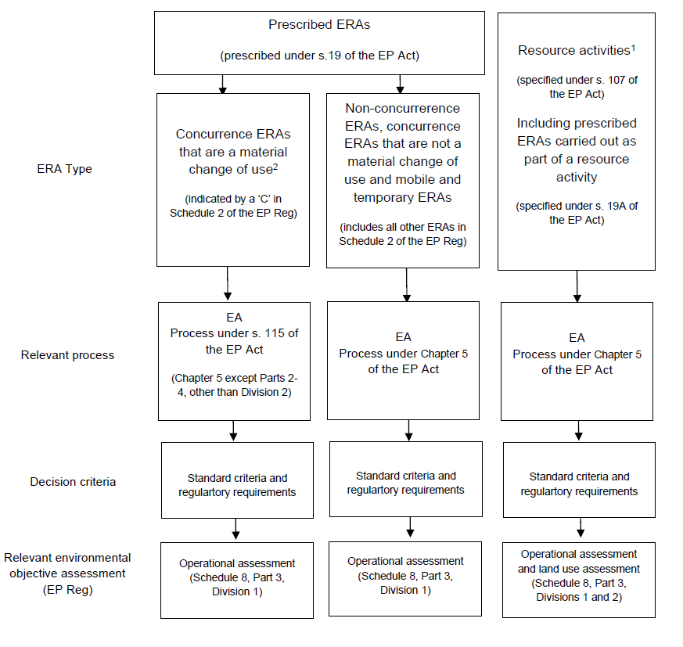
¹ A resource tenure is also required for a resource activity, but the resource tenure process is not linked to the EA process.
²A DA is required under Planning Act 2016 where there is a material changed of use. This is an additional process that is not shown in this diagram. Additional information regarding the Planning Act 2016 is provided below.

Planning Act 2016
The Planning Act 2016 provides the framework for land use assessments for prescribed ERAs. The Planning Act contains the relevant framework, provisions and planning instruments for local governments to make local planning schemes that require applicants to consider the suitability of adjacent land uses.
The Queensland Government identifies land use matters that are of state significance by developing State interest planning policies, regional plans and other State planning instruments that must be adopted during the development of local planning schemes.
The ERA component of any DA will be assessed against the State development assessment provisions. The DA will contain conditions relating to the use of the land, such as infrastructure siting.
Where a DA application includes the ERA trigger, the development application will also be assessed withing the same timeframe to an EA application.

Waste Reduction and Recycling Act 2011
The Waste Reduction and Recycling Act 2011 (WRR Act) includes a suite of measures to promote waste avoidance and reduction, reduce consumption of natural resources, and minimise the disposal of waste through recovery, reuse and recycling of waste in Queensland. Under circumstances, the legislation requires for a levy (waste levy) to be charged for the disposal of a number of wastes in Queensland. Per section 1.2 above, the waste levy may be charged for the disposal of salt from CSG activities off the resource tenure
In addition, chapters 8 and 8A of the WRR Act provide an end of waste (EOW) framework to promote resource recovery opportunities and transform the perception of waste from being seen as waste to being valued as a resource. The EOW framework provides for a waste to be approved as a resource if the department determines that it meets specified quality criteria for its specific use. It is the EA holders (waste producer) responsibility to ensure that the resource (waste) meets EOW codes and approvals prior to providing to the resource user for use. If a waste is approved as a resource under the EOW framework, it is no longer considered a waste under section 13 of the EP Act. If the resource is not used in accordance with the applicable EOW code or approval, it would then again be considered a waste under the EP Act and must be managed accordingly.
The EOW framework consists of:
- EOW codes - which specify outcomes that a registered resource producer must achieve in order for a waste to be deemed a resource. A resource producer must register to operate under an EOW code. Resource users do not need to register, unless the EOW code specifically requires notification under the conditions of the EOW code.
- EOW approvals - which on the other hand, are primarily intended to be used as a trail to demonstrate proof of concept for non-traditional waste and resource uses. An EOW approval applies solely to a single holder for the purpose of the trail. An EOW approval will be issued only for the length of time required to undertake the trial.
CSG operators may consider an EOW code for brine as the code can have the following benefits:
- less regulation for the reuse of waste, e.g. approvals relating to regulated waste are not required
- volumes of waste disposed to landfill are reduced, reducing the cost associated with disposal
- costs from using raw materials may be reduced
- reuse of the waste may have a monetary value.

CSG Water Management Policy 2012
In addition to the legislation and guidance described above, the regulatory framework includes the CSG Water Management Policy 2012 that achieves CSG water and saline waste objectives through the management utilisation of prioritisation hierarchies. These priorities are to be considered (and implemented where applicable) during CSG activity authorisation processes. The priorities are as follows:
- Managing and using CSG water
  - Priority 1 – CSG water is used for a purpose that is beneficial to one or more of the following, the environment, existing or new water users and existing or new water dependent industries
  - Priority 2 - After feasible beneficial use options have been considered, treating and disposing CSG water in a way that firstly avoids, and then minimises and mitigates, impacts on environmental values.
- Managing saline waste
  - Priority 1 - Brine or salt residues are treated to create useable products wherever feasible.
  - Priority 2 - After assessing the feasibility of treating the brine or solid salt residues to create useable and saleable products, disposing of the brine and salt residues in accordance with strict standards that protect the environment.

Rehabilitation Requirements
Provisions in the Environmental Protection Act 1994 require EA holders for a number of environmentally relevant activities such as petroleum and gas and waste disposal to rehabilitate the land disturbed from the activity to a safe, stable, non-polluting state that is able to support a sustainable post activity land use. Typically, rehabilitation requirements for petroleum and gas and waste disposal activities would be imposed as conditions on the EA. For example, a CSG activity would be required to rehabilitate well pads, dams, and tracks, etc. to a state that would allow the landowner to again use the land for cropping. Guidance published by the department is available for applicants, EA holders, and departmental assessment officers to determine the relevant rehabilitation conditions for the activity; however, site specific issues may require site specific conditions to be imposed on the EA.
To ensure the rehabilitation requirements are met and the sites do not become a financial burden to Queensland Government, the EP Act requires resource and many waste disposal activities to provide financial commitments to the State. These requirements most frequently apply during the operation of the activity; however, the framework does provide for a residual risk payment to be made to Queensland Government under certain circumstances. Under the current regulatory framework these financial commitments may be in the form of:
Estimated Rehabilitation Cost (ERC)
  - Resource activities (petroleum and gas) under the Environmental Protection Regulation 2019, including prescribed environmentally relevant activities (ERAs) conducted as part of the resource activity
  - ERC is calculated (see below) by multiplying the extent of the disturbance by the cost of rehabilitation.
  - ERC is held by the scheme manager (Treasury) for that site to rehabilitate disturbance if EA holder is unable to meet financial obligations regarding disturbance that occurs during operation of the resource activity
Residual Risk (RR)
  - Resource activities (petroleum and gas) under the Environmental Protection Regulation 2019, including prescribed environmentally relevant activities (ERAs) conducted as part of the resource activity
  - RR is calculated (see below) for those risks to the land remaining from credible risk events or on-going monitoring and maintenance activities after the surrender of the EA
  - RR is calculated by multiplying the size of the site feature by the cost for remediation or monitoring and maintenance by the level of risk
  - RR payments are to be held by the scheme manager (Treasury) in a pooled fund for use on surrendered sites across the state as appropriate.
Financial Assurance (FA)
  - Prescribed ERA (waste disposal) under the Environmental Protection Regulation 2019
  - Calculated (see below) by multiplying the extent of disturbance by the cost of rehabilitation
  - FA is available for DES to rehabilitate disturbance at the site if the EA holder is unable to meet financial obligations regarding disturbance during operation of the ERA
The department provides additional guidance to applicants or EA holders regarding the calculation of ERC, RR, or FA as appropriate. For consistency of the calculations, applicants and EA holders must use the relevant calculator developed by the Department. The ERC and RR calculators include costs for waste facilities (including those that are dedicated for salt). Currently there is no dedicated calculator for FA; however, prescribed activities that may require calculation of FA such as waste disposal are recommended to use a cost estimation calculator developed for resource activities (e.g. the ERC calculator) to ensure cost estimates are consistent for the proposed activity.
The regulatory framework requires resource activities and in many circumstances prescribed (waste disposal) activities to undertake rehabilitation and provide financial commitments to the State to ensure they do not become a financial burden to the State .

Key Principles for CSG brine management
Identification of an industry-wide approach to the long-term management of brine generated from CSG activities is a complex undertaking. Management of brine consists of a range of elements including but not limited to water management, waste management, water quality, site characteristics, environmental impacts, and economic consideration.
To achieve the best outcome regarding the management of brine, the department has identified a number of principles to be considered in moving forward. These include the following:

2.1 Robust regulatory framework
CSG activities are regulated under a number of acts, regulations, policies, and guidance that operators must comply with to conduct the activity in Queensland.
The framework for CSG activities is generally administered by the Department of Environment and Science and Department of Resources; however, under certain circumstances, may in addition to be regulated by the Department of State Development and Department of Agriculture and Fisheries.
There is opportunity within the existing framework to strengthen the robustness of this framework by providing greater clarity around the departments expectations when applications are made, and consistency in decision outcomes.
For more information regarding the CSG regulatory framework, please see Sections 1.3 and 1.4 of this Action Plan.

Waste management hierarchy
The Queensland waste and resource management hierarchy is a framework that guides the order of preference for managing waste, such as brine. As a first priority, waste should be avoided, after which options for reuse and recycling should be explored.
The recovery options for fuel and energy, or disposal should be reserved for residual waste that is unsuitable for higher order options.
The management hierarchy (below) shapes the framework’s priorities and provides the basis for the development of actions.

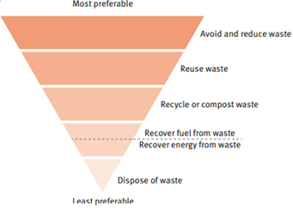

Three strategic priorities within the Queensland waste management hierarchy have been identified to help drive a fundamental shift in the way waste is managed in Queensland. The priorities include:
• Reducing the impact of waste on the environment and communities.
• Transitioning towards a circular economy for waste.
• Building economic opportunity
A number of actions will need to be undertaken to facilitate the change required to deliver on the strategic waste management hierarchy priorities. The following priorities regarding waste management were identified through extensive consultation with stakeholders; however, it should be noted that not all of the priorities identified may be relevant to the management of waste brine:
- A strong legislative and policy framework will provide certainty, consistency and a clear policy direction that industries can use to inform proactive decision-making.
- Good governance will ensure that opportunities and barriers to change can be managed transparently to deliver optimal waste management outcomes.
- Effective compliance management that requires and encourages waste generators to not only comply with the prevailing law but aspire to best practice.
- Robust partnerships and collaboration with industry and stakeholders, and a sound knowledge platform, will drive innovation, investment, information sharing and the uptake of opportunities.
The development of an approach to the management of CSG waste using a more circular model rather than a linear model to reduce, reuse, and recycle products that continue to circulate in the economy for as long as possible is a preferred outcome. At this time a circular model for CSG brine waste may not achievable due to a number of environmental, economic, and social circumstances; however, continued research and investigation by industry and academia may identify ptions that support a more circular waste management model for CSG waste generally, and / or CSG brine waste specifically in the future.

Research and development investment
The UQ independent review of the APPEA report detailed in Section 1.2 of this plan proposed a number of recommendations, including the on-going research and investigation of alternative options for the management of brine generated by CSG activities.
Ongoing research and development should primarily focus on technologies and methods to reduce the volume of brine waste produced, then carbon neutral reuse opportunities.

Stakeholder Engagement
CSG companies / EA holders are expected to engage with local community about proposed salt waste facilities. It is also anticipated that for major amendments or new EAs (eg for waste facilities) there would be a process of public notification.
Community groups should also be engaged in relation to R&D outcomes and future opportunities for re-use.
There should also be a principle of transparency in relation to sharing information and data in relation to waste volumes and waste facility operations and impacts.

Actions
The following summary of the actions are proposed to support the identification, adoption, implementation, and continued investigation of a long-term solution to the management of brine (waste) generated from CSG activities. The table indicates timeframes by which these actions are to be completed and the party responsible for undertaking the action.

Action | Item | Timeframe | Responsibility
1 | Establish a process for the ongoing reporting (e.g. annual) of brine and salt volumes stored on resource sites. | 2023 | DES¹ and Industry²
2 | Undertake a review/gap analysis of Queensland’s existing regulatory framework including legislation, policy, and supporting documentation in relation to the disposal of salt waste that:  - determines the requirements of the environmental assessment process for permitting salt encapsulation facilities;  - identifies where industry, landholders and the department would benefit from further information/guidance; and  - identifies options for improving regulatory consistency.  Matters to be considered include for example, facility siting and design, calculation and application of financial obligations (Estimated Rehabilitation Cost and Financial Assurance) and end of life/rehabilitation requirements. | 2023 | DES
3 | Update department guidance materials regarding waste disposal considering the outcomes of the review from Action 6.  This may include, for example:  - developing model conditions for environmental authorities;  - updating existing landfill siting and design guidance; and  updating the department’s Coal Seam Gas Water Management Policy 2012. | 2023 | DES
4 | Investigate options for providing public access to data and information relating to any potential impacts of salt waste disposal facilities (e.g. groundwater monitoring data). | 2023 | DES and Industry
5 | Where salt disposal options are being considered, undertake actions to ensure a strategic co-ordinated effort throughout industry that aims to minimise the footprint of disposal facilities and potential for environmental impacts. | Ongoing | Industry
6 | Invest in research and development (R&D) that focuses on:  - reducing brine volumes produced;  - reuse opportunities for brine and salt;  - reducing energy intensity and operational costs of brine management and salt disposal options; and  - minimising the medium and long-term risks of salt encapsulation facilities. | Ongoing | Industry
7 | Publicly report on:  - R&D priorities for the next 5 years;  - the progress of R&D over the previous 5 years; and  - any beneficial application of learnings from R&D to industry operations. | 5 yearly – first report commencing in 2023 | Industry

¹Department of Environment and Science
²Australian Petroleum Production and Exploration Association (APPEA)

Moving forward – monitoring and review of the Action Plan
The Action Plan will be in effect for 10 years from commencement. The department will continue to work with stakeholders to monitor the progress and development of CSG brine management practices, noting that adaptive management may be required that considers advancements in technological capability and scientific knowledge.
In addition to undertaking the actions identified within the Action Plan, the department will conduct periodic reviews of the Action Plan to:
- ensure currency over the 10 year timeframe
- monitor that identified actions are undertaken and progressed in a timely manner
- ensure that alternative actions and/or timeframes are considered, developed and implemented in a transparent manner
- ensure that stakeholders are provided with timely updates and consultation opportunities as appropriate
- monitor that outcomes are being achieved

Glossary

Brine – Saline water with a total dissolved solid concentration greater than 40,000 milligrams per litre.
Coal Seam Gas – Coal seam gas is natural gas found in coal deposits that is held in place by water pressure. To produce the Coal seam gas, water is extracted to reduce the water pressure to allow the gas to be captured.
Crystallisation – The process of removing liquid from a substance to create a solid. Liquid may be removed through a range of methods, with heat typically being applied to remove water. For example, crystallising brine to form salt.
Dams – A land-based structure or a void that contains, diverts or controls flowable substances, and
includes any substances that are thereby contained, diverted or controlled by that land-based structure or void and associated works. For the purpose of this Action Plan, a dam may also be referred to as a regulated structure, storage pond, or similar.

Salt – a general term to describe the solid form of total dissolved solids in brine from treated coal seam gas water.

Total dissolved solids (TDS) – measure of the dissolved combined content of all inorganic and organic substances present in a liquid in molecular, ionized, or micro-granular (colloidal sol) suspended form. For coal seam gas, TDS concentrations are also referred to as salt.

References
¹Australian Petroleum Production and Exploration Association (APPEA) December 2018 - “Queensland Gas: end-to-end water use, supply and management” P. 33 (https://environment.des.qld.gov.au/__data/assets/pdf_file/0016/240316/appea-end-to-end-water-management-report.pdf)
²Department of Environment and Science (Queensland Government) - Coal Seam Gas Water Management Policy 2012 (https://environment.des.qld.gov.au/__data/assets/pdf_file/0034/89386/rs-po-csg-water-management-policy.pdf)
³Office of Groundwater Impact Assessment (Queensland Government) - Underground Water Impact Report (Consultation draft) for the Surat Cumulative Management Area October 2021 (Underground Water Impact Report 2021 for the Surat Cumulative Management Area (rdmw.qld.gov.au)
⁴University of Queensland (Centre for Natural Gas) February 2020 - Independent review: Brine and salt management (Section 6, Queensland Gas: end-to-end water use, supply and management) (UQ Report).

