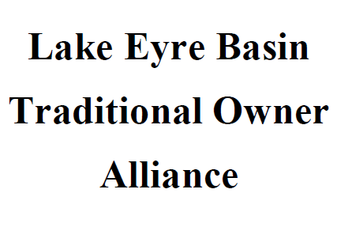

16 March 2023
Hon. Annastacia Palaszczuk
Premier of Queensland

Dear Premier,
As members of the Lake Eyre Basin Stakeholder Advisory Group (LEB-SAG) we collectively call on the Queensland government to release the Regulatory Impact Statement (RIS) for public consultation without further delay.
LEB-SAG meetings to inform the development of the RIS were an extensive good-faith process involving significant commitment from all parties. The process concluded in July 2022.
It is of vital importance that the RIS be urgently released, allowing the community to be consulted on the policy options and the matter resolved to provide certainty to all stakeholders.

Sincerely,

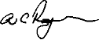
Anthony Rayner
Chair
RAPAD
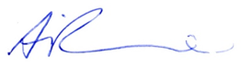
0418 961 372

Andrew Picone
Queensland Manager
The Pew Charitable Trusts
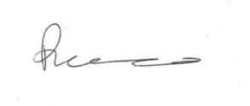
0457 798 359

Riley Rocco
Coordinator
Western Rivers Alliance
0415 568 247
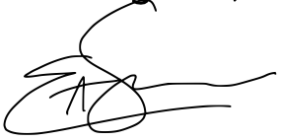
Ellie Smith
Queensland Coordinator
Lock the Gate
0448335452

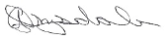
Andrew Drysdale
Chair
Desert Channels Group
0407 634 224

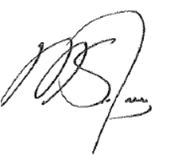
Michael Guerin
CEO
Agforce
0488 002 092
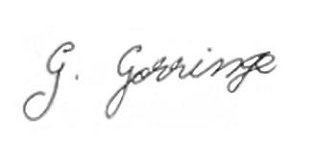
George Gorringe
Executive Member
Lake Eyre Basin Traditional Owners Alliance
0455 751 337

Joint Statement

14 March 2023

As members of the Lake Eyre Basin Stakeholder Advisory Group (LEB-SAG) we collectively call on the Queensland government to release the Regulatory Impact Statement (RIS) for public consultation without further delay.
LEB-SAG meetings to inform the development of the RIS were an extensive good-faith process involving significant commitment from all parties. The process concluded in July 2022.
It is of vital importance that the RIS be urgently released, allowing the community to be consulted on the policy options and the matter resolved to provide certainty to all stakeholders.

For comment:

Anthony Rayner
Chair
RAPAD
0418 961 372

Andrew Picone
Queensland Manager
The Pew Charitable Trusts
0457 798 359

Riley Rocco
Coordinator
Western Rivers Alliance
0415 568 247
Ellie Smith
Queensland Coordinator
Lock the Gate
0448335452

Andrew Drysdale
Chair
Desert Channels Group
0407 634 224

Michael Guerin
CEO
Agforce
0488 002 092
George Gorringe
Executive Member
Lake Eyre Basin Traditional Owners Alliance
0455 751 337

