
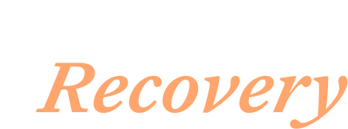

Recovery Month Social Media Toolkit Powering Recovery Campaign Amplification for Participating Patient Advocacy Organizations

Introducing Powering Recovery for National Recovery Month
Every September, National Recovery Month provides an opportunity to celebrate those in recovery as well as the families, caregivers, providers, and communities who support them. It is also a chance to highlight the evidence-based care and resources that can help make long-term recovery possible for individuals impacted by substance use disorders and opioid use disorder.
That is why we are proud to introduce you to Powering Recovery, Indivior’s new campaign launched on September 1st that elevates individual stories to show the real ups and downs of the recovery journey. Our hope is that by shedding light on the untold stories of those living with opioid use disorder (OUD), we can help remove the access barriers and stigma that are still preventing so many people from getting the care they need. On the new campaign landing page, you can hear hopeful stories from Ryan, Dave, and Adrian — three individuals who had their lives changed through a combination of community support and evidence-based treatment. By sharing trusted information and elevating the lived experiences of people in recovery, we can help build understanding that recovery is possible.

Amplifying Powering Recovery on Your Social Media Channels
Should you choose to amplify the Powering Recovery campaign on your organization’s social handles, you can find pre-drafted post copy, hashtags, and graphics in the following social media toolkit. Indivior’s handles are linked below, should you choose to add tags. We encourage you to adapt the language to your organization’s preferred voice.

Hashtags
Be sure to use #PoweringRecovery and #RecoveryMonth to connect your posts to the broader conversation and help spread the message.

Indivior’s Social Channels
- LinkedIn
- Instagram
- X/Twitter

URL to Drive To
Powering Recovery Page

Pre-Drafted Posts
Platform / Post Topic | Post Copy | Creative Asset
Facebook, LinkedIn  National Recovery Month | September marks #RecoveryMonth, a time to recognize people living with #SubstanceUseDisorders or #OpioidUseDisorder and how they move forward in their recovery journeys one step at a time.  This month, we invite you to celebrate the individuals in recovery, as well as the families, communities and providers supporting them. Together, we can help tear down the stigma around these diseases.  Follow along with the #PoweringRecovery initiative to hear directly from those in recovery and learn more about evidence-based treatment options: bit.ly/4xDLGAM  #RecoveryIsPossible #RoadToRecovery #EvidenceBasedTreatment | Download Image  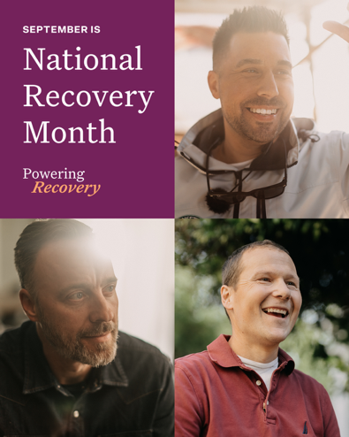
Instagram  National Recovery Month | September marks #RecoveryMonth, a time to recognize people living with #SubstanceUseDisorders or #OpioidUseDisorder and how they move forward in their recovery journeys one step at a time.  This month, we invite you to celebrate the individuals in recovery, as well as the families, communities and providers supporting them. Together, we can help tear down the stigma around these diseases.  Follow along with the #PoweringRecovery initiative to hear directly from those in recovery and learn more about evidence-based treatment options.
X (formerly Twitter)  National Recovery Month | September is #RecoveryMonth, a time to recognize those living with #SubstanceUseDisorders and how they move forward in recovery.  This month, we invite you to celebrate those in recovery, help end stigma, and follow the #PoweringRecovery initiative: bit.ly/4xDLGAM
Facebook, LinkedIn  Animation: Words to Talk about OUD to reduce stigma ​ | The language used to speak about #SubstanceUseDisorders or #OpioidUseDisorder can either hinder recovery, or it can help.  By changing how we talk about these diseases and recognizing them as treatable brain diseases, we can reduce stigma and foster an environment where more people feel supported in seeking and sustaining #recovery. Learn more: bit.ly/4xDLGAM  #EndTheStigma #PoweringRecovery #RecoveryMonth | Download Animation  Animation Frames:  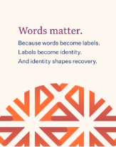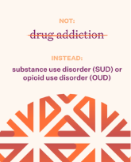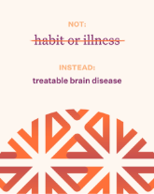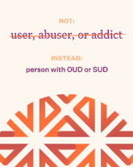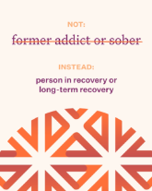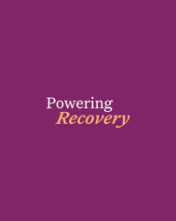
Instagram  Animation: Words to Talk about OUD | The language used to speak about #SubstanceUseDisorders or #OpioidUseDisorder can either hinder recovery, or it can help.  By changing how we talk about these diseases and recognizing them as treatable brain diseases, we can reduce stigma and foster an environment where more people feel supported in seeking and sustaining #recovery.  #EndTheStigma #PoweringRecovery #RecoveryMonth
X (formerly Twitter)  Animation: Words to Talk about OUD | By changing how we talk about #SubstanceUseDisorders and #OpioidUseDisorder, we can help #EndTheStigma and foster an environment where people feel supported in seeking and sustaining #recovery. Learn more: bit.ly/4xDLGAM  #PoweringRecovery #RecoveryMonth
Instagram, Facebook, LinkedIn  September 20, National Addiction Professionals Day | On National Addiction Professionals Day, we recognize the people who bring expertise, commitment, and compassion to individuals living with #SubstanceUseDisorders or #OpioidUseDisorder.  Today, remember to thank the #AddictionProfessionals who play a critical role in helping patients access evidence-based treatment on their #RoadToRecovery.  #EvidenceBasedCare #RecoveryMonth #PoweringRecovery #OUD | Download Image  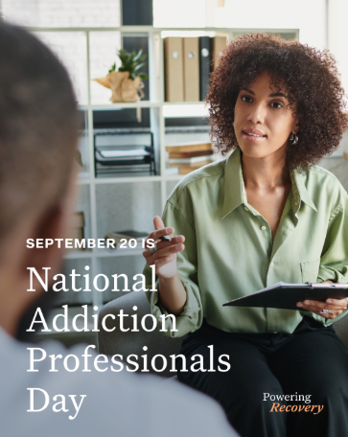
X (formerly Twitter)  September 20, National Addiction Professionals Day | On National #AddictionProfessionals Day, we recognize those who bring expertise, commitment, and compassion to individuals living with #SubstanceUseDisorders. You play a critical role in helping people living with SUDs on their #RoadToRecovery.  #RecoveryMonth #PoweringRecovery

