887 Visa Campaign Toolkit
Campaign Graphics
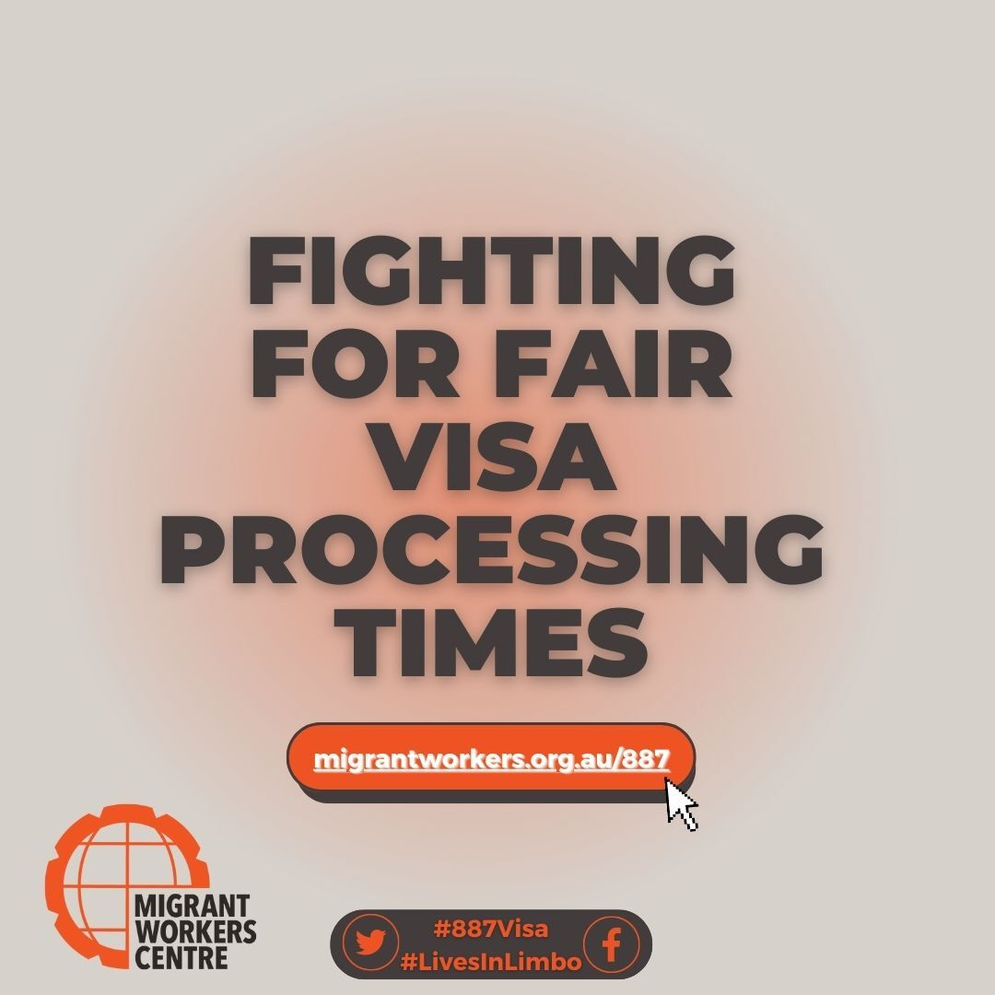
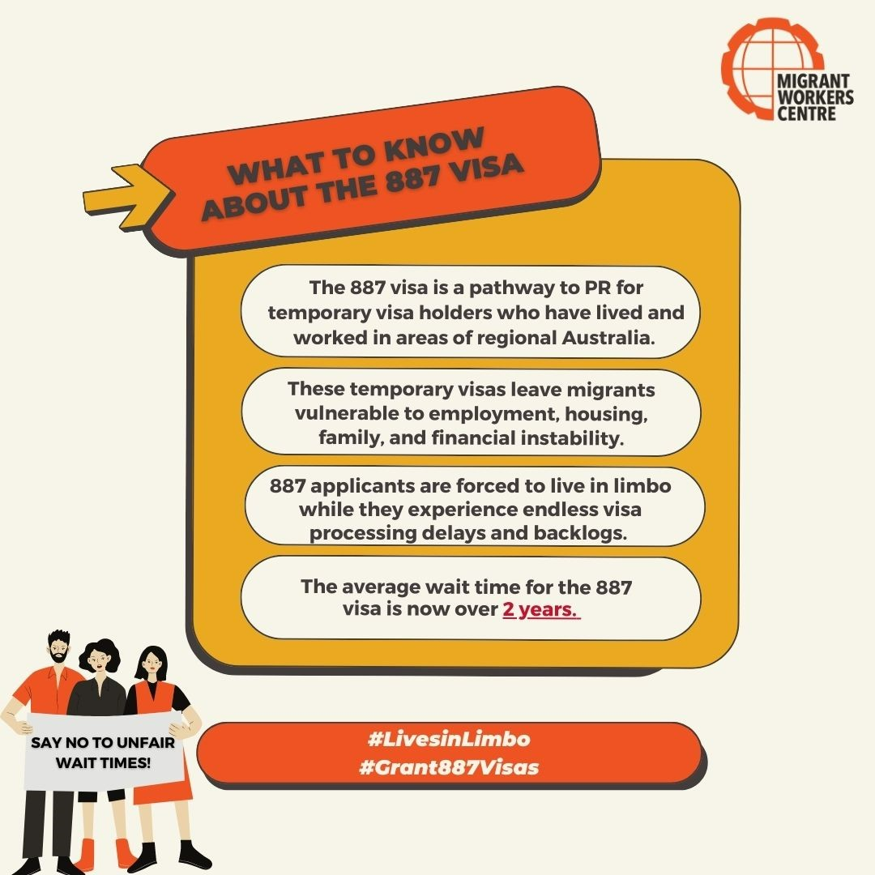
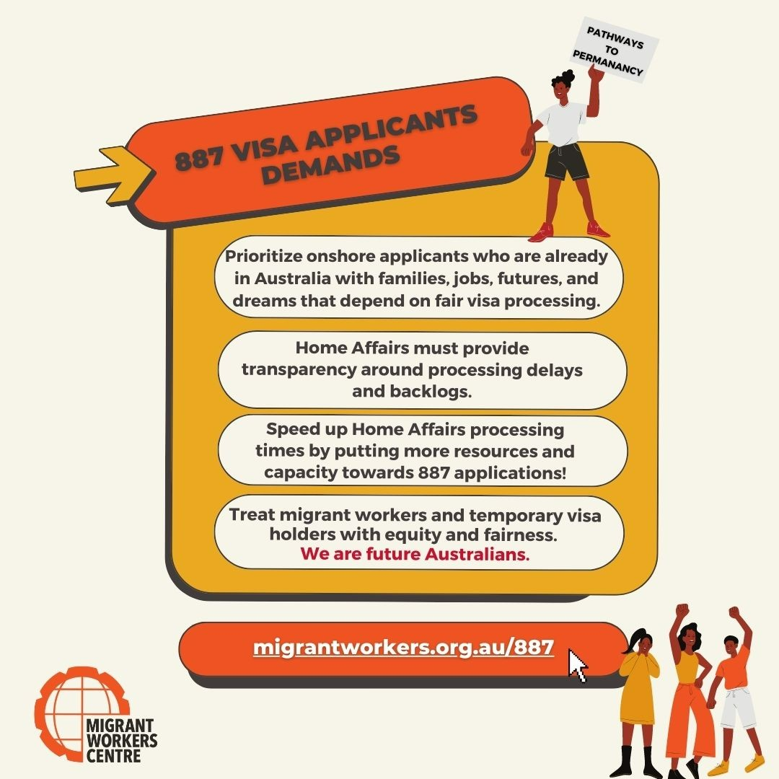
Petitions
How to write make petitions that have impact
- Use petition platforms like Megaphone
  - About Us | Megaphone
- Share your petitions around social media to gain traction and signatures
- Get your petition to Parliament
  - Petition the House Infosheet 11 - Petitions – Parliament of Australia (aph.gov.au)
    - Petition the Senate How to petition the Senate – Parliament of Australia (aph.gov.au)
- 887 visa petitions:
  - e-petitions – Parliament of Australia (aph.gov.au) (House presented)
  - e-petitions – Parliament of Australia (aph.gov.au) (House presented)
  - e-petitions – Parliament of Australia (aph.gov.au) (House responded)
    - EN2791 - Min response - Immigration.pdf
  - Petition · Reduce processing time for 887 PR visa to 7 months · Change.org
Legal action
Fast forward to the 15:00 minute mark of this video (a recording of our June 887 Visa Campaign meeting) to hear the legal strategy for 887 visa holders from a migration lawyer.
Events
How to hold changemaking events
How to hold a rally in your community
- Advocacy - Help Sheet: Holding a March or Rally: the step by step guide ourcommunity.com.au
Media
Using media to share your campaign story
Storytelling 101
- 887 storytelling resource.pdf
- Know your Rights - Migrant Workers Centre (nationbuilder.com)
Media release Template:
- Microsoft Word - ProgressNetworkMediaReleaseTemplate.docx (nationbuilder.com)
Media release guides
- Distributing_a_media_release.pdf (nationbuilder.com)
- Microsoft Word - ProgressNetworkStuffonMediaReleases.docx (nationbuilder.com)
Media Contacts:
- vic_mediacontacts.xlsx (live.com)
Spread the word on social media
How to get the internet to care about your cause
Use hashtags that clearly identify your cause
Keep them short and catchy. You want people to remember your campaign in as few words as possible
Catchy or captivating hashtags are more likely to pick up traction in online movements
887 Visa Campaign Hashtags
- #Grant887Visas
- #887Visa
- #LivesinLimbo
- #FairVisaTimes
Contact your MP
How to write persuasive letters to politicians and changemakers
- Introduce yourself as a concerned member of the public or as a representative of your service
- Clearly state the purpose of your letter for example: ‘I am writing to urge your support for/opposition to…’ OR ‘I am writing to ask you to support/ oppose …’
- Focus on one issue Explain your concerns and how they impact the wider community and you as a voter. Support your personal views and experiences with facts. Don’t allow your letter to become longwinded. Stay focused and stick to your main points.
- Sample letters, postcard campaigns and emails are usually considered to be less effective than a handwritten or printed and signed Personalise sample letters to portray your own views and experience, and always use your own words.
- Ask for a response to your letter
- Let the MP know if you have met, voted for, or assisted with their election campaign
- Never be rude, condescending or always be polite and courteous.
- Don’t forget to include your name, address, contact telephone number and email address
- Encourage others who feel strongly about the issue to write to their local MP as well
- Encourage local MPs who support your position with thankyou letter
- Write to the appropriate MP and not all of them
- Address your letter using the MP’s correct name and title
How to address letters to politicians
Letters to Members of the House of Representatives in Canberra should be addressed to:
The Honourable (full formal name) OR Mr, Ms, Dr (full formal name)
House of Representatives Parliament House
PO Box 6022
CANBERRA ACT 2600
Dear Mr, Ms, Dr (last name only)

Letters to Senators, unless otherwise stated, should be addressed to:
The Honourable (full formal name) OR Senator OR Mr, Ms, Dr (full formal name)
The Department of the Senate
Parliament House
PO Box 6100
CANBERRA ACT 2600
Dear Mr, Ms, Dr (last name only)

Unless otherwise stated, letters to NSW State Parliament Members, should be addressed to:
The Honourable (full formal name) OR Mr, Ms, Dr (full formal name)
Level 33 Governor Macquarie Tower
1Farrer Place
SYDNEY NSW 2000
Dear Mr, Ms, Dr (last name only)

Speakers of the House, Chairs of a Committee and Presidents of Councils should also be addressed appropriately.
For example:
Mr/Madam Speaker
Mr Chairman
Madam Chairwoman
Mr/Madam President

PRO FORMA LETTER (you’re highly encouraged to write your own but if not, you may use this one to send to relevant politicians)

The Honourable (full formal name) OR Mr, Ms, Dr (full formal name)
House of Representatives Parliament House
PO Box 6022
CANBERRA ACT 2600

Dear Mr, Ms, Dr [last name only]
I am writing to you to request that you encourage the Prime Minister and Minister for Immigration to prioritize the speedy processing of 887 visas. There are nearly 10,000 applicants across Australia who are pleading for your consideration to reduce the wait times which are currently exceeding 2 years. After spending years in regional Australia, working through Covid, being unable to see our families and friends overseas, struggling to put our children through university due to international student fees and struggling to find stable housing or purchase a home of our own, our lives depend on 887 visa grants.
These long wait times have caused 887 applicants a great deal of mental anguish and anxiety. The stress of not knowing where our futures lie and for how long we must carry on with our lives in limbo has led to endless familial and financial struggles. We have struggled to find work in our fields due to being on temporary or bridging visas. We have struggled to raise our children with no clear pathway to permanency. Yet, we continue to act as resilient and productive members of our communities because Australia is our home, and we will not give up on our dreams.
[Ms, Mrs, Mr professional title], we urge you to advocate for a solution to Australia’s immigration problem. We need clearer pathways to permanency, fair visa processing times, transparency, and fairness. We need the Minister for Immigration to acknowledge the plight of temporary visa holders and commit to processing 887 applications as soon as possible. No longer can we continue to struggle and question our futures in this country. We are members of your community. We are your co-workers, friends, associates. We are future Australians.
I would encourage you to share with the Prime Minister and Minister for Immigration this request to expedite backlogged 887 visas and reduce the processing time to 6 months. Give the nearly 10,000 applicants nationwide a fair shake at achieving the hopes and dreams we all migrated to the country in search of. And most importantly, please prioritise the onshore applicants whose lives, families, homes, communities, and careers are already on Australian shores. Thank you for your consideration, and I look forward to your reply.
Yours faithfully,
[Name and contact information]

