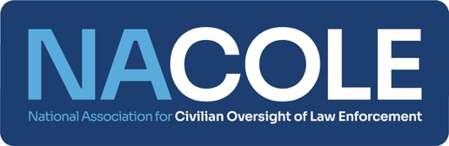

NACOLE Candidate Election Questionnaire

Name:

Position Sought:

Geographic Location:

Current Employment:

1. How long have you been involved with NACOLE, and how did you initially become involved?
2. Which NACOLE Committees have you served on? Have you had other involvement in NACOLE as a volunteer?
3. Please share highlights of your background/experience in law enforcement oversight.
4. Why do you want to serve on NACOLE's Board? What makes NACOLE’s mission important to you?
5. What skills/qualities do you expect to contribute as a Board member?
6. What goals do you have for your service on the NACOLE Board, what would you most like to accomplish as a Board member?