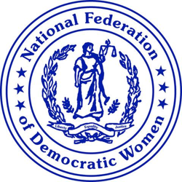
National Federation of Democratic Women Resolution on Centennial Affirmation of the Validity of the Equal Rights Amendment (ERA)

WHEREAS, 2023 marks the centennial of the introduction of the first ERA into Congress in 1923 and the continued denial of affirmation of an ERA to the United States (US) Constitution guaranteeing equal rights under the law without regard to sex; and

WHEREAS, the United States of America is the only industrialized country that does not explicitly recognize the equality of women in its constitution, and 94% of constitutions adopted since 1970 include a rule establishing the equality of women. However, women continue to confront workplace discrimination; wage inequities; health care inequities; higher rates of poverty, rape and domestic violence assaults; a lack of political parity; and other forms of sex-based discrimination; and

WHEREAS, Article 5 of the U.S. Constitution sets out two requirements for amendments: approval by two-thirds of both chambers of Congress, and ratification by 3⁄4 (38) of the states, and on January 27, 2020, the Equal Rights Amendment (ERA) finally achieved both requirements, but an Office of Legal Counsel (OLC) opinion issued under the Trump administration was used to block the certification and publication of the amendment; and

WHEREAS, on January 27 2022, President Biden issued a statement calling on Congress to act immediately to pass a resolution recognizing ratification of the ERA following a new OLC opinion that the previous opinion was not an obstacle to Congressional action on ratification.

THEREFORE, BE IT RESOLVED the National Federation of Democratic Women recognizes this historic centennial struggle for civil rights and reaffirms its strong support for strategic efforts to validate the passage of the ERA to guarantee that “equality of rights under the law shall not be denied or abridged by the United States or by any State on account of sex.”

