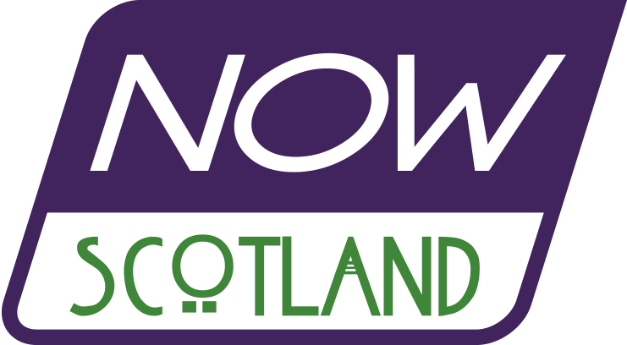
It’s Our Right to Decide - Indyref2 NOW!
We the undersigned believe the people of Scotland have the right to decide their own future in a democratic vote on Scottish independence. The decision to become an independent country rests solely with the people of Scotland and the Scottish Parliament. Authority for this decision does not lie with Westminster.
We believe that a majority vote for Pro-Independence political parties in the Holyrood election gives the Scottish Government a democratic mandate to hold a referendum on independence.
We pledge to campaign for Independence and support the demand for Indyref2. Not later, but NOW
Name | Address | email
Please return to ; Now Scotland, c/o Edinburgh Yes Hub, 31, Lasswade Road, Edinburgh EH16 6TD Produced by Now Scotland www.nowscotland.scot

