9th November 2025

Health New Zealand Taranaki District
Jon Gullidge
Chief Nurse / Lead Contingency Planner
0273475851
Jon.Gullidge@TDHB.org.nz

New Zealand Nurses Organisation (NZNO)
John Crocker
Organiser
John.Crocker@nzno.org.nz

RE: Adjudication for Life Preserving Services (LPS) at Taranaki

Kia ora Jon and John,
Thank you again for your time and for clearly outlining your respective positions both in person and in writing regarding the provision of Life-Preserving Services (LPS) at Taranaki Base Hospital during the proposed NZNO nursing strike, scheduled from 00:01 on 17 November to 23:59 on 30 November.
This determination is issued in my capacity as adjudicator under Clause 13 of Schedule 1B of the Code of Good Faith for the Public Health Sector, pursuant to the Employment Relations Act 2000.

Health New Zealand – Taranaki District has referred this matter for adjudication on the following grounds:
- A formal request was made to NZNO under Clause 12(2) of the Code, seeking union member assistance in maintaining LPS.
- Despite good faith negotiations, agreement could not be reached on the scope and staffing of LPS.
- Taranaki seeks adjudication to:
  - the extent of the life preserving service necessary to provide for patient safety during the industrial action;
  - support a contingency plan relating to that life preserving service; and
  - agree support we require from union members.

Supporting documentation included the Taranaki LPS schedule, a union submission regarding LPS, correspondence between NZNO and HNZ, including input from other districts and today’s kōrero with local union delegates, yourselves and myself. During the discussion today I appreciated the views and perspective on a proposal to establish a pool of on-call, off-site staff from part-time specialist area staff to support LPS provision. This concept reflects the goodwill arrangements that we frequently rely on. However, my role is to assess whether a clinically safe and operationally reliable plan can be implemented within the timeframe provided.

Upon review of the submissions and discussions, I find that:
- The request for adjudication meets the criteria under Clause 13, following genuine efforts to reach agreement.
- Taranaki District has taken reasonable and practicable steps to plan for patient safety without relying on union member involvement.
- Key areas of disagreement include:
  - Redeployment vs. on-call staffing
  - Definition and scope of LPS duties (e.g., handover, extended shifts, ward coordination)
  - Validity of emergency protocols
- The nature of the industrial action presents a material risk to patient safety, particularly in high-acuity and specialty areas.
- The District’s request for access to union members for LPS, including emergency escalation under Clause 12(5)(c), is justified and proportionate.

I hereby determine the following:
- The areas of disagreement identified during the adjudication process remain within the scope of the LPS agreement and will be subject to ongoing review and operational management.
- Union member assistance shall be granted for the provision of LPS as outlined in the Taranaki District’s submitted LPS schedule, subject to:
  - Notification to union delegates of any request to trigger LPS.
  - Taranaki District undertaking efforts to reinforce scheduling protocols to minimise reliance on extended shifts.
- Clause 12(5)(c) emergency protocols may be activated by the District during the strike period, with immediate notification to NZNO.
- A log of all requests shall be maintained and shared to ensure transparency.
- Both parties shall continue to engage in good faith throughout the strike period.

This determination is made in accordance with the principles of the Code of Good Faith for the Public Health Sector, with the overriding priority being the safety and wellbeing of patients and staff. I commend both parties for their professionalism and encourage ongoing collaboration during the industrial action.

Ngā mihi,

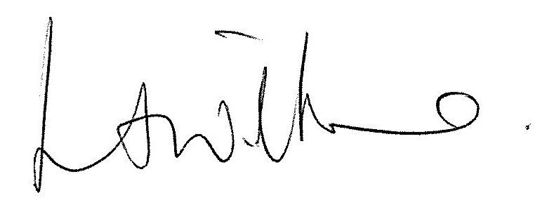

Mrs Lisa A Williams
Chief Medical Officer Taranaki

Copy to Anne Aitcheson, National Contingency Planner

