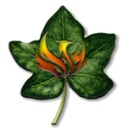
Manhattan Chamber Players Concert and Alumni Reception

On Saturday, March 28, 2026, the Phoenix Ivy Council is partnering with the Phoenix Chamber Music Society to offer you and your guests a private reception with members of the Manhattan Chamber Players, prior to their chamber music concert performance at the Camelback Bible Church.

﻿The Manhattan Chamber Players' repertoire will include: Scéne Andalouse, Op. 7 by Joaquín Turina; a Piano Quintet in Eb major, Op. 44 by Robert Schumann; and a Concerto for Violin, Piano, and String Quartet in D major, Op. 21 by Ernest Chausson. The Manhattan Chamber Players is a chamber music collective of New York-based musicians who share the common aim of performing the greatest works in the chamber repertoire at the highest level.

“Manhattan Chamber Players' musicianship was stunning, their energy was palpable, and the sheer joy they brought to the stage was truly special. This ensemble represents some of the best in chamber music playing today.” — Minnesota Beethoven Festival.

The private Phoenix Ivy Council reception preceding the concert will be held at the Family Life Center of the Camelback Bible Church from 5:45 pm to 7:15 pm. At the reception, the Manhattan Chamber Players members will speak to our alumni about their performance and meet with our members. The private reception will provide platters of crackers, cheeses, crudités, hummus, snacks and beverages.

﻿Come experience an unforgettable night of beautiful music and an opportunity to connect with fellow alumni!

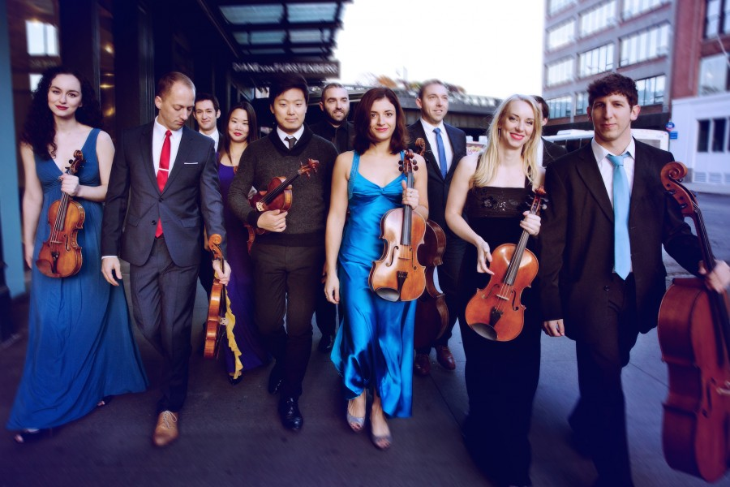

Date: Saturday, March 28, 2026

5:45 pm to 7:15 pm
Phoenix Ivy Council Alumni Reception with Light Appetizers and Beverages
Presentations by Performing Artists

7:30 pm
Manhattan Chamber Players Concert
Concert Program
﻿Scéne Andalouse, Op. 7 by Joaquín Turina;
Piano Quintet in Eb major, Op. 44 by Robert Schumann;
﻿Concerto for Violin, Piano, and String Quartet in D major, Op. 21 by Ernest Chausson.

Manhattan Chamber Players Performers
Katie Hyun, Violin
Ruben Rengel, Violin
Robin Scott Violin
Luke Fleming, Viola
Andrew Janss, Cello
Kwam Yi, Piano

Camelback Bible Church
3900 E. Stanford Drive
Paradise Valley, AZ 85253

Cost: In order to purchase tickets and register for the pre-concert reception, please click on both links below.
﻿
The cost for the Phoenix Ivy Council pre-concert reception is only $30 per person. Please use the reception link below
https://lp.constantcontactpages.com/ev/reg/prbt3zm

In order to purchase the Manhattan Chamber Player concert tickets, please purchase tickets online using the Phoenix Chamber Music Society link below.

https://www.phoenixchambermusicsociety.org/manhattanchamberplayers

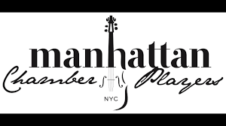
Phoenix Symphony: Shostakovich Symphony No 5
and Private Alumni Reception

On Saturday, April 25, 2026, the Phoenix Ivy Council is partnering with the Phoenix Symphony to offer our members discounted tickets to Shostakovich's renowned and beloved 5th Symphony. Several artists will join us for a private Phoenix Ivy Council cocktail reception preceding the concert. The artists will speak to our alumni about the performance and meet with our members. At the private alumni reception, we will provide dessert boards and platters of cookies, brownie bites, macarons, mixed nuts, fruits, beverages and a no-host cocktail bar.

The private Phoenix Ivy Council reception will be followed by three masterworks that have enthralled audiences for generations. Conductor Case Scaglione will lead this program that will include Rachmaninoff’s Rhapsody on a Theme of Paganini, famed for its romantic 18th variation, and that will feature pianist Federico Colli. Next is John Adams’ Short Ride in a Fast Machine, a thrilling orchestral sprint and the concert finishes with Dmitri Shostakovich’s Symphony No. 5, one of the most gripping and supreme works of the 20th century, a soul-refreshing inspiration. You will not want to miss this grand musical spectacle!

This promises to be an outstanding event to connect in person with other alumni, while enjoying the musical offerings of one of our city's premier cultural institutions.

Please secure your registration in advance since this event has a limited capacity of only 100 alumni and guests.

Date: Saturday, April 25, 2026

6:00 pm to 7:10 pm
Phoenix Ivy Council Alumni Reception
﻿with Light Appetizers and Beverages
Presentations by Performing Artists
Food and Beverage Services by Aventura Caterers
Symphony Hall, East Terrace Reception Area
75 N. 2nd Street, Phoenix, AZ 85004

7:30 pm
Phoenix Symphony Concert
Case Scaglione, conductor
Federico Colli, piano

Concert Program
John Adams: Short Ride in a Fast Machine
Sergei Rachmaninoff: Rhapsody on a Theme of Paganini
Dmitri Shostakovich: Symphony No. 5

Cost: In order to purchase tickets and register for the pre-concert reception, please click on both of the two links below.
﻿
The cost for the Phoenix Ivy Council pre-concert reception is only $30 per person. Please register by clicking on the pre-concert reception link below:
The cost for the Phoenix Ivy Council pre-concert reception is only $30 per person. Please register by clicking on the pre-concert reception link below:
https://lp.constantcontactpages.com/ev/reg/grjz9br

The Phoenix Ivy Council members and their guests will receive a special 20% discounted price for any seat in the Symphony Hall with the exception of the loges with the promo code IVYCOUNCIL26. The promo code is only available online.

https://tickets.phoenixsymphony.org/Online/default.asp

Restrictions: Not applicable on previous purchases. There is a limit of 4 tickets per household. This offer is only applicable to the Phoenix Symphony’s Shostakovich Symphony No. 5 on April 25, 2026. This offer expires 4/25/26 5pm. All ticket sales are final. No refunds. This code is only redeemable online. Excludes the Loge and the lowest price. Standard ticket fees apply and are not discounted. The Phoenix Symphony reserves the right to cancel the offer at any time.

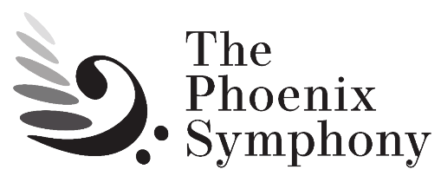

Questions contact: Jon Hall at (602) 469-1460 or jhall@dreambrands.com

Phoenix Ivy Council Alumni Clubs
Amherst, Barnard, Bates, Bowdoin, Brown, Bryn Mawr, University of Chicago, Colby, Columbia, Connecticut College, Cornell, Dartmouth, Hamilton, Harvard, Haverford, Middlebury, MIT, Mount Holyoke, Northwestern, University of Pennsylvania, Princeton, Smith, Stanford, Swarthmore, Trinity, Tufts, Vassar, Washington University in St. Louis, Wellesley, Wesleyan, Williams, and Yale

