State Committee Meeting
2/20/2023
8:00 PM

Attending Officers
Christian Fyke—Interim State Chair of Pennsylvania
Benjamin Valimont—Interim Secretary
Brian McMurray—Interim Regional Chair of Western Pennsylvania
Bill Jones

Absent Officers
Kyle DeMarino—Interim Regional Chair of Eastern Pennsylvania
Héctor Diaz—Interim Regional Chair of Central Pennsylvania

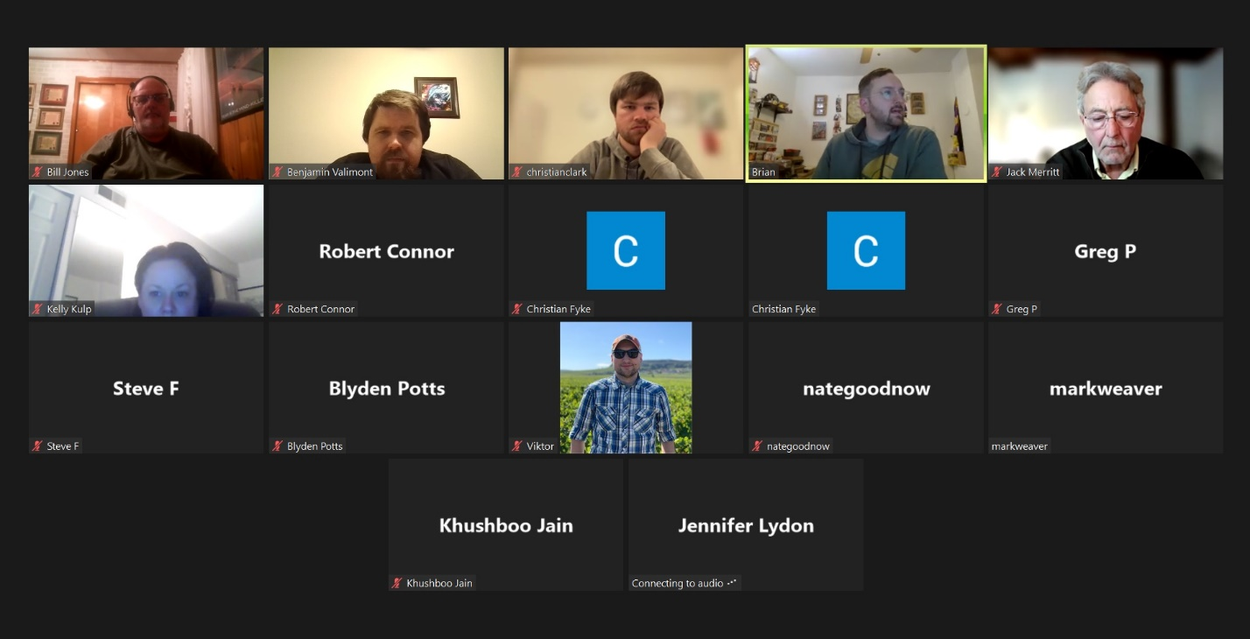

- Welcome & Introductions

Because Chairman Fyke was in a place using public WIFI, Chair McMurray took over in leading this month’s meeting. In a short discussion at the start of the meeting, Chair McMurray discussed the newly named CEO of the nation Forward Party—Lindsey Williams Drath (Not to be confused with our state Senator Lindsey Williams—SD 38). She comes from Republican politics where she had previously worked for Michael Steele & former Speaker John Boehner. A couple of years ago she left the Republican Party & joined up with Unite America & later the Forward Party. The best way to learn more about her would be to watch her interview on Andrew Yang’s podcast (https://youtu.be/uRfqen-l6f4).

- Month in review
The Pennsylvania Forward Party had another exciting month. We got involved with the special elections in Allegheny County by having a meetup where we discussed the several candidates who were running. We had seven to ten people show up for this event.

- Candidate Training

We are moving forward with our candidate training series. This is scheduled to begin on Wednesday March 8th at 7:00 PM. The first session will be hosted by Ethan Demme. If you or someone you know is thinking about possibly running for office in the next few years, we are encouraging you to attend these training sessions.

- Bylaws

Secretary Valimont stated that we had a workshop session in January & will be scheduling a third session to finish up the preliminary draft before we finalize it at the summit the leadership team is planning.

- Summit

As Secretary Valimont noted with the Bylaws, Chair McMurray made the formal announcement of the summit happening in May(ish). We just begun the planning of this event & we are still looking at locations, dates, & what all we would be doing at the summit.

At the leadership meeting on Tuesday, February 21, it was decided that the Summit will take place in Gettysburg on the weekend of May 19 & 20th. More details to come.

- Team Reports

Research

For the special election we made score cards for the Democrat & Republican candidates. We have also started to go through the scorecards from last year to update them starting with the Senate. We are also working on compiling election results from the past few years. These will help us determine where we can run someone.

Jack Merritt posed the question as to what the end game is for all of this research. Secretary Valimont responded that the score cards are to inform us who our potential allies are & who are not. We can then cross reference the scorecards with the election results to further inform us which of our antagonists are most vulnerable so that we can put a Forwardist on the ballot.

Mr. Merritt continued by asking if we would have something usable by the summit. If so, we could create potential sub-teams to go out help our allies & start actively recruiting to run next year. This caused Secretary Valimont to remember that he sat in on the March on Harrisburg Ranked Choice Vote bi-weekly meeting (https://www.mohpa.org/ranked-choice-voting). They have already started lobbying allies in the General Assembly, like Senator Williams & Representative Solomon. They are hoping to get Senator Williams to introduce a municipal RCV bill soon. Even more important is legislation that would open our primary process up.

It was further asked if we are allowed to lobby in Harrisburg. At the time Secretary Valimont was unsure of the law regarding when someone needs to register as a lobbyist.

Since that time, Secretary Valimont looked up who is considered a lobbyist in Pennsylvania. According 65 P.S. Section 13A03, a lobbyist is any individual, association, corporation, partnership, business trust or other entity that engages in lobbying on behalf of a principal for economic consideration. The term includes an attorney at law while engaged in lobbying. In Section 13A04, a lobbyist, lobbying firm or a principal must register with the department electronically using the computerized filing system developed by the department that is consistent with the purposes of this chapter within ten days of acting in any capacity as a lobbyist, lobbying firm or principal. Registration shall be biennial and shall begin January 1, 2007. Title 65 Chapter 13A Lobbying Disclosure

Chair McMurray moved the discussion to talk about the questionnaire he had sent out the candidates in the special elections. They were asked three questions: where do they stand on opening our closed primaries; what is their stance on Ranked Choice Voting; would support changes to the rules regarding third parties running candidates here in Pennsylvania. Only one of the candidates responded.

Secretary Valimont stressed that one of the things March on Harrisburg found to be important were letters to the editors of newspapers. Secretary Valimont further invited the members of the Pennsylvania Forward Party to write about a 200-word letter to their local newspaper’s editor.

Communications

Christian Clarke stated that there was not a ton to report on this front. There was a person who was seeking to interview someone in the Pennsylvania Forward Party. He wondered if it would be a good a idea to create a press release role for someone to handle. Chair McMurray stated that National does have a media training course that someone can go through.

Finance Team

Bill Jones stated that he had finally made contact with the person that Ethan Demme suggested that could give him training to be our future treasurer. Bill will be meeting with him tomorrow morning & will have a better idea of the role afterwards.

Jack Merritt stated that going forward it might be better to think of fundraising as a division under Bill when he becomes Treasurer. Once they know the rules of getting money in and taking money out, they can produce a budget. Until then National is here to help & the best way to support us to donate to them.

- Summit

Jack Merritt suggested that we open up the discussion for us to members about what we should cover during the summit. He further suggested we could send e-mails containing polls as well. Chair McMurray noted that he liked the Rank My Vote site to conduct RCV polls.

An attendee, named Ron, asked what the purpose of the summit was. The bylaws and several other organizational items that will require the leadership team to meet in person to finalize. This summit is going to be our opportunity to do so. We also want to have a public facing in-person event as well. Secretary Valimont also mentioned that we are looking to hold the summit around Franklin, or close to it, so that we could include some time to campaign for a candidate we will be supporting this year. We still need to plan what this event will look like.

Ron further stated that he was just looking into the Forward Party and was wondering where he could find our platform. Chair McMurray answered by stating that the Forward Party is different in that we do not dictate policy onto the candidates. We let the candidates figure out their own policies so long as they can be related back to our principles. Our goal is to put democracy back into the hands of the people.

Blyden also raised a concern that with a tentative date in May, were we going to have enough time to plan it out. Secretary Valimont responded that leadership team is scheduled to meet tomorrow where we are going to work out most of those issues.

