How to Create a Facebook Fundraiser
on Behalf of ROCO
A step-by-step guide to help you raise support for our Community Center
Creating a personal fundraiser for ROCO on Facebook is a powerful way to engage your network and help sustain the community center you love. This guide walks you through every step — use it alongside the screenshots provided to get your fundraiser live in just a few minutes.

Step 1: Log Into Facebook
Open Facebook on your desktop browser or mobile app and make sure you are signed into your personal account.

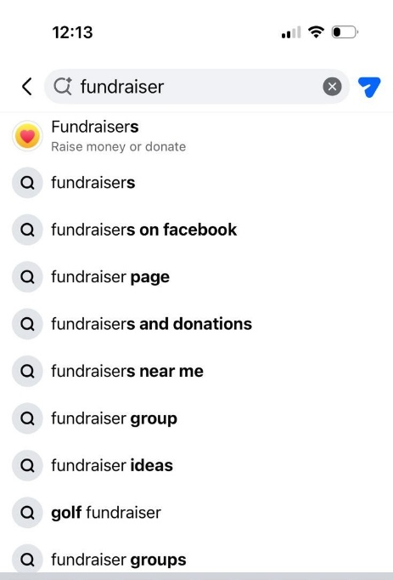
Step 2: Navigate to Fundraisers
Find the Fundraisers section:
- Go to the search box and type Fundraiser

Step 3: Start a New Fundraiser
On the Fundraisers page, click the "+ Create Fundraiser" or "Raise Money" button. This is usually located in the upper-left corner of the page.

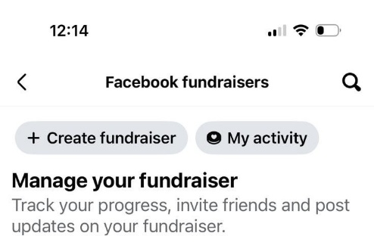

Step 4: Choose "Nonprofit" and Find ROCO
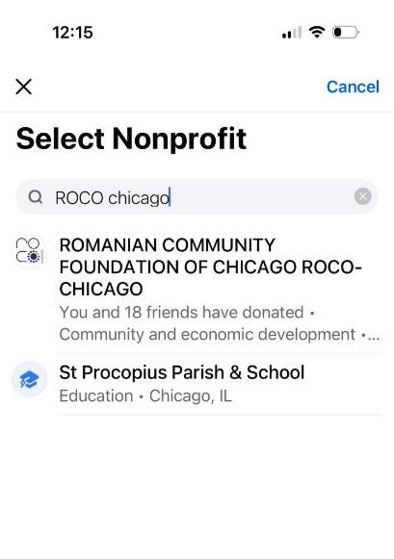
When prompted to select a fundraiser type:
- Select "Nonprofit" as the fundraiser type
- In the search bar, type "ROCO" or the full name: ROMANIAN COMMUNITY FOUNDATION OF CHICAGO - ROCO CHICAGO
- Select ROCO from the search results — confirm it shows the correct logo and page name

Step 2 - 4 on a Desktop: Start on the ROCO’s Facebook page
Find the ROCO’s facebook page:
- Select "More" from the menu options
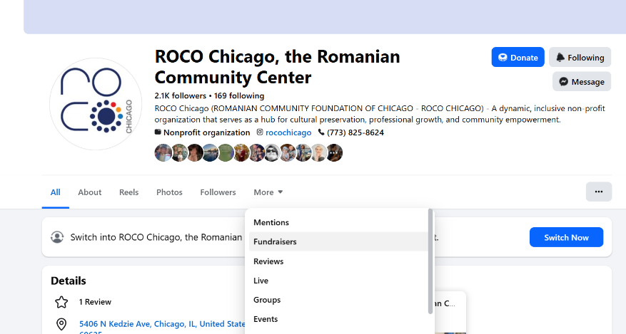
- Choose “Fundraisers”

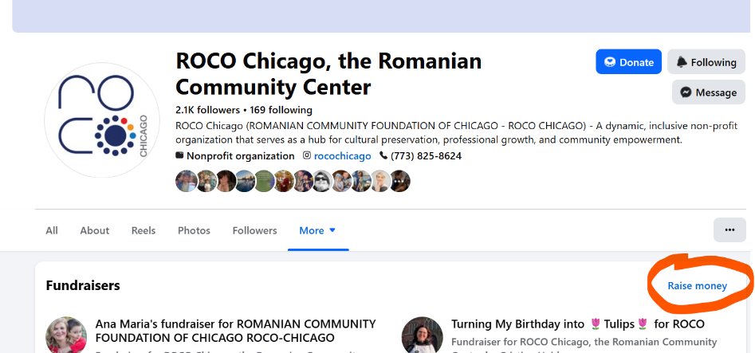
- Click on the “Raise money” link

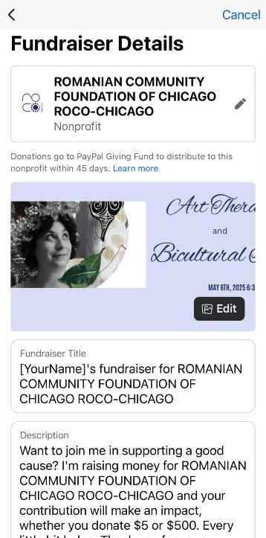
Step 5: Fill In Your Fundraiser Details
Complete the following fields:
- Goal Amount – Set a fundraising target (e.g., $250, $500, $1,000)
- End Date – Choose when your fundraiser will close
- Title – Give it a personal name (e.g., "Support ROCO with me!")
- Description – Write a short note about why ROCO matters to you personally. Personal stories raise more money!

Step 6: Add a Cover Photo (Optional but Recommended)
Upload a photo to make your fundraiser stand out. Great options include a personal photo from a ROCO event, or any images ROCO has shared for this purpose. A compelling image can significantly increase donations.

Step 7: Publish Your Fundraiser
Click "Create" to launch your fundraiser. You will be taken to your live fundraiser page where you can see the progress bar, share options, and donation activity.

Step 8: Share It!
Now it's time to spread the word:
- Click "Share" to post directly to your timeline
- Copy the link and send it via Messenger, text, or email to friends and family
- Post it in Facebook groups or add it to your Story for extra visibility
- Tag ROCO's Facebook page so their followers can find your fundraiser too

Tips for a Successful Fundraiser

- Personalize your story — fundraisers with a personal message raise significantly more donations
- Share multiple times — post an update when you hit 50% of your goal, and again in the final days
- Thank your donors — leave a comment on the fundraiser when someone gives; it encourages others
- Start with your own donation — even a small amount signals momentum to others
- Set a realistic goal — you can always raise it later once you hit it!
Thank you for supporting ROCO!
Questions? Reach us at rocochicago.org

