November 30, 2025
Update to VADSA Supporters

Since voluntary assisted dying (VAD) commenced in South Australia on January 31, 2023, SA Health has issued 728 VAD Permits. This means that 728 people in South Australia have been assessed by two separate VAD trained doctors as eligible to use the VAD substance to end their suffering. They have a disease, illness or medical condition which is incurable and is likely to cause their death within six months, or 12 months for a neurodegenerative disease such as MND. The person must have decision making capacity at every stage. Three quarters of the people had cancer, 60% self administered the VAD substance and 27% of the people who had a VAD Permit died without using the VAD substance.

In publishing the 2024-25 Annual Report, the VAD Review Board shows that VAD deaths accounted for 1.6% of deaths in South Australia in the last 12 months.

There has been an increase in awareness of VAD with 406 people being issued with a VAD Permit during the year, compared with 254 in 2023-24. Of the 353 people with a VAD Permit who died during the year, 251 died using the VAD substance, 200 through self administration and 51 through practitioner administration; 102 of those people (29%) who had a VAD Permit died without using the VAD substance.

The cover artwork of the report is a beautiful painting by Badimia-Noongar-Yamatji
artist Nerolie Bynder with her interpretation of voluntary assisted dying. The artwork was commissioned by the Board Presiding Member, Assoc Prof Melanie Turner.

Comprehensive VAD data for 2024-25
The Board is keen to provide transparency and accountability in its oversight of voluntary assisted dying in South Australia and provides an enormous amount of data on the operation of VAD in SA. The report contains many helpful charts, tables and graphs summarising the data. One of the most comprehensive tables is shown below. (report available here)
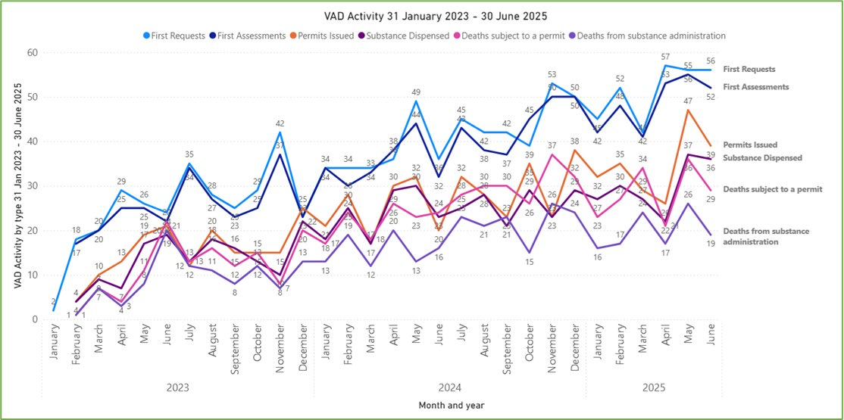
Some of this data shows
- An average of 46 first assessments were carried out each month (32 the previous year)
- An average of 34 VAD Permit applications were processed each month (23 the previous year)
- 3,464 forms were submitted through the VAD Portal
- 1% of registered medical practitioners in SA have completed the VAD training (83)
- The six and 12 month prognosis is an unreliable criteria with some people dying over 400 days after first being assessed as eligible
- 57% of applicants were male and 43% were female
- 38 people (11%) died in a residential aged care facility
- 8 people (2%) died in a private hospital
- 261 people (74%) had cancer
- a typical applicant is male, in their 70s, Australian-born, living in a private residence in metropolitan Adelaide, and receiving palliative care for terminal cancer.

Given the discussion about opposition by some religious institutions to VAD, data on where people died using VAD is of interest. (Note that some of those people would have received their VAD Permit in 2023-24.)

Of the 353 people with a VAD Permit who died in 2024-25:

  - 157 (44%) died in a private residence
  - 120 (34%) died in a public hospital
  - 38 (11%) died in a residential aged care facility
  - 28 (8%) died in a hospice or palliative care unit within a public hospital
  - 8 (2%) died in a private hospital
  - 2 died in other locations.
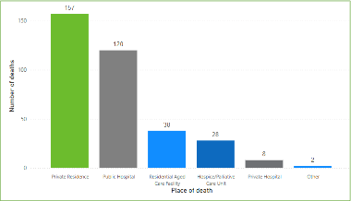
Note that under Commonwealth law, residential aged care is defined as your own home. In your own home you choose your own medical team and care, which can include VAD.

Time between receiving a VAD Permit and death
Of particular interest in the 2024-25 Annual Report is the data showing the time lag between the issue of a VAD Permit and the person’s death. The data shows a median number (half above and half below), and the range. To receive a VAD Permit, the person must have been assessed as having less than six or 12 months to live. Some people are dying up to 15 months after the issue of the VAD Permit. (See p23)
Table 5 - Timeframes on the VAD pathway
Median calendar days and range for deaths in 2024-25
- Date of first request for VAD to date of permit decision 18 (2-427)
- Date of permit issue to date of death from self administration 13 (0-446)
- Date of permit issue to date of death from practitioner administration 3 (0-318)
- Date of permit issue to date of death without administration 26 (0-458)

VADSA has always taken the view that the time limited prognosis is an unreliable safeguard. The time frames of six and 12 months are not based on medical evidence. The six month limitation was first adopted in the first USA VAD legislation in Oregon in 1994, because that was when a person became eligible for hospice funding. Victoria, the first state in Australia to pass VAD legislation, copied the Oregon model and added a 12 month time limit for a neurodegenerative disease. Other states then followed the Victorian model.
It is noteworthy that Victoria has now removed the six month time limit and made their legislation the same as Queensland, which has a 12 month time limit on all diseases and illnesses.

The ACT, where VAD commenced on November 3, has no time limit. The ACT criteria is that the person’s illness must be advanced and progressive and will cause the person’s death.
The Board reflects on some of the ongoing challenges of the legislation in South Australia, such as the “gag” clause where, once the Victorian amendments commence, SA will be the only state which prohibits a health professional from mentioning VAD as an end of life choice until the person themselves asks about it, and the Commonwealth ban on using telehealth for consultations on using the VAD substance – the “telehealth ban”.

The report notes that one person was denied VAD because they had not been a resident in SA for the required 12 months and there is no avenue for appeal on the basis of residency.
A summary of the annual SA VAD statistics is provided in Factsheet 49 on our VADSA website, vadsa.org.au/resources/factsheets.

VADSA recognises that we are fortunate in South Australia to have such a comprehensive and informative set of data published about the operation of VAD in our state. We attribute this to the leadership of the VAD Review Board by Assoc Prof Melanie Turner and the Minister of Health, Hon Chris Picton, MP.

